Accountability Report Transmittal Form

Agency Name: Public Service Activities – Clemson University

Date of Submission: August 31, 2001

Agency Director: Dr. John W. Kelly

Agency Contact Person: Dr. Neil Ogg

Agency Contact’s Telephone Number: 864-646-2120

Accountability Report

Clemson University
Public Service Activities

2000-2001

Section I – Executive Summary 1
Section I-1 Major Achievements from Past Year 1
Section I-2 Mission and Values 2
Section I-3 Key Strategic Goals for Present and Future Years 2
Section I-4 Opportunities and barriers … 3
Section II – Business Overview 5
Section II-2 Operation Location: 5
Figure II-1 6
Section II-3 Expenditure/Appropriations Chart 6
Figure II-2 7
Section II-4 Key Customers 7
Section II-5 Key Suppliers 7
Section II-6 Major Products and Services 8
Specific examples include the implementation of school-based violence prevention programs, technical assistance rendered to grassroot groups and non-profit organizations, and the evaluation of social services. 9
Section II-7 Organizational Structure 9
Figure II-3 10
Section III – Elements of Malcolm Baldridge Award Criteria 12
Section III-1 Leadership 12
Section III-1-1 How do senior leaders set, deploy and communicate? 13
Section III-1-2 How do senior leaders establish and promote a focus on customers? 13
Section III-1-3 What key performance measures are regularly reviewed by your senior leaders? (Actual results are to be reported in Category 7). 13
Section III-1-4 How do senior leaders use organizational performance review findings and employee feedback to improve their own leadership effectiveness and the effectiveness of management throughout the organization? 13
(Table III-1) 14
Section III-1-5 How does organization address the current and potential impact on the public of its products, programs, services, facilities and operations, including associated risks? 14
Section III-1-6 How does senior leadership set and communicate key organizational priorities for improvement? 14
Section III-1-7 How does senior leadership and the agency actively support and strengthen the community? Include how you identify and determine areas of emphasis. 15
Section III-2 Strategic Planning 15
(Graph III-2) 16
Section III-3 Customer Focus 17
Section III-3-1 Identify key customers and stakeholders. 17
Section III-3-2 How do you determine who your customers are and what are their key requirements? 18
Section III-3-3 How do you keep your listening and learning methods current with changing customer/business needs? 18
Section III-3-4 How do you use information from customers/stakeholders to improve services or programs? 18
Section III-3-5 How do you measure customer/stakeholder satisfaction? 19
Section III-3-6 How do you build positive relationships with customers and stakeholders? Indicate any key distinctions between different customer groups. 19
Section III-4 Information and Analysis 20
Section III-4-1 How do you decide operations, processes and systems to measure? 20
Section III-4-2 How do you ensure data quality, reliability, completeness and availability for decision-making? 20
Section III-4-3 How do you use data/information analysis to provide effective support for decision-making? 21
Section III-4-4 How do you select and use comparative data and information? 21
Section III-5 Human Resources 21
Section III-5-1. How do you and your managers/supervisors encourage and motivate employees (formally and/or informally) to develop and utilize their full potential? 22
Section III-5-2. How do you identify and address key developmental and training needs, including job skills training, performance excellence training, diversity training, management/leadership development, new employee orientation and safety training? 22
Section III-5-3 How does your employee performance management system, including feedback to and from employees, support high performance? 23
Section III-5-4 What formal and/or informal assessment methods and measures do you use to determine employee well being, satisfaction, and motivation? 23
Section III-5-5. How do you maintain a safe and healthy work environment? 23
Section III-5-6. What is the extent of your involvement in the community? 24
Section III-6 Process Management 25
Section III-6-1 What are your key design and delivery processes for products/services, and how do you incorporate new technology, changing customer and mission-related requirements, into these design and delivery processes and systems? 25
Section III-6-2. How does your day-to-day operation of key production/delivery processes ensure meeting key performance requirements? 25
Section III-6-3. What are your key support processes, and how do you improve and update these processes to achieve better performance? 25
Section III-6-4. How do you manage and support your key supplier/contractor/partner interactions and processes to improve performance? 26
Section III-7 Results 26
Section III-7-1 What are your performance levels and trends for the key measures of customer satisfaction? 26
Section III-7-2 What are your performance levels and trends for the key measures of mission accomplishment? 26
Section III-7-3 What are your performance levels and trends for the key measures of employee satisfaction, involvement and development? 26
Section III-7-4 What are your performance levels and trends for the key measures of supplier/contractor/partner performance? 27
Section III-7-5 What are your performance levels and trends for the key measures of regulatory/legal compliance and citizenship? 27
Section III-7-6 What are your current levels and trends of financial performance? 27
Results by PSA Unit 27
A. Cooperative Extension Service 27
(Graph III-2) 29
(Graphic Series III-3) 30
(Table III-2) 31
(Table III-3) 31
(Table III-4) 32
B. Belle W. Baruch Institute of Coastal Ecology and Forest Science 32
C. Livestock and Poultry Health 32
D. Strom Thurmond Institute 34
E. Regulatory and Public Service Programs 35
(Graph Series III-4)(Table III-5) 37
(Table III-5) 38
F. Agriculture and Forestry Research 39
(Graph Series III-5) 40
G. Institute on Family and Neighborhood Life (IFNL) 41

Section I – Executive Summary

Section I-1 Major Achievements from Past Year
Public Service Activities at Clemson play a significant role in maintaining and improving the quality of life of South Carolinians. The impact of educational programs, regulatory programs, research projects and public policy events goes far beyond the immediate recipient. As education and research results are applied, better public policy decisions are made, the impact is multiplied far beyond the initial audience, and citizens live in a state where the environment and food supply are monitored and secure.

The achievements listed below only present part of the picture. The Palmetto Leadership Program, for example, is systematically building leadership skills in communities across the state, now including Marion County. These long-term investments yield tremendous long-term benefits. The research initiative on Changing Land Use and the Environment, one of the 300 currently underway, is addressing the stress that urban sprawl is placing on the state’s environment. Preparations to deal with the potential threat of Foot and Mouth and Mad Cow Disease to the state’s health and food supply, is absolutely critical. South Carolina’s booming nursery and greenhouse industry must have pest free certification in order to sell their products. Unbiased forums on public policy create dialogue rather than deadlock, and lead to better decisions on pubic issues. The future of families and neighborhoods impacts every person in this state, and Public Service Activities provides the seed funds at Clemson for research and education in that area.

Public Service Activities are in every corner of South Carolina, a part of the very fabric of our society after more than 100 years of service.

- Public Service Activities (PSA) served more than 780,000 people in South Carolina last year.
- 15,000 educational programs were presented in South Carolina’s 46 counties.
- 300 research projects are in progress of which 44 were new in FY 2001 with 8 of the 300 being regional projects in which our scientists are working in collaboration with scientists at other institutions.
- 4 new plant varieties were released and six patents were awarded.
- $4,900,000 in grant funding was obtained to leverage, support and expand PSA activities.
- One hundred and eight meat and poultry processing plants in the state were inspected on a regular basis.
- 4,462 health and environmental inspections, 2,412 fertilizer samples, 5,862 peach tree plum pox virus samples, 8,516 acres of seed crops were inspected, and 2,449 Tropical Soda Apple Plants were destroyed.
- There were more than 100 public policy issue presentations which were available to the public.
- Sixty-nine policy related radio programs aired.
- More than 250 publications were released and distributed.
- The PSA Bulletin Room distributed 336,684 individual items on request to customers across the state.
- The PSA publications web site received 15,485 hits, or an average of 289 per day.
- The 20 most in demand digital publications were downloaded more than 12,100 times.
- More than 200 news releases were distributed across the state.
- More than 300 publications are available on-line in digital format.
- The entire Pest Management Handbook is available on-line in HTML format.

Section I-2 Mission and Values
The mission of Public Service Activities at Clemson is built around five goal areas that are reflected in the university’s ten-year goals, in the Southern Association of Colleges and Schools (SACS) assessment procedures and in the five-year plan of work, which is negotiated with the U.S. Department of Agriculture.

These PSA goals are to promote:
- Agrisystems Productivity and Profitability
- Economic and Community Development
- Environmental Conservation
- Food Safety and Nutrition
- Youth Development

All of the units within PSA have aligned their programming, funding, evaluation and accountability functions around these five goal areas.

Section I-3 Key Strategic Goals for Present and Future Years
- Expand PSA’s customer base in South Carolina and improve the quality of all program initiatives. Make information increasingly available to customers using the most effective and cost efficient mediums.

- Continue to provide unbiased information to South Carolina citizens on plant and animal based agriculture, natural resource management, and sustainable and profitable agriculture.

- Foster the development of youth through the 4-H & Youth Program by providing educational programs.

- Strengthen families and communities through the research and service work of the Institute on Family & Neighborhood Life.

- Enhance community and economic growth, leadership and volunteer development through education and provide sound information to voters and decision-makers on public policy and social issues.

- Become a recognized leader in providing information and assistance to citizens groups, business and special interest groups and governmental organizations at the local and regional level.

- Move towards project-based funding in research to maximize the investment in research, increase accountability methods and increase faculty participation in building project budgets.

- Become a national and international leader in bio-based technology development.

- Fully implement the Clemson University Activities Information Management System (CUAIMS) to provide state of the art public access to PSA program initiatives, accountability and program management tools.

- Continue major initiatives in ornamentals, turf, aquaculture, biotechnology and the environment.

- Work towards a balanced effort in the five established performance areas.

- Increase emphasis on food safety and bio-security.

- Determine the impacts of an increasing population on water quality and quantity, wildlife habitat, and use of currently accepted land management practices.

- Conduct research on the management of the coastal plain land resources as an integrated unit through landscape ecology research.

- Study impacts of wetland impoundment and community-wide management of natural resources in environmentally conscious housing developments.

- Become a recognized leader in providing information and assistance to citizen groups, business and special interest groups and governmental organizations at the local and regional level.

- Initiate research and public service programs to enhance civic awareness of public policy issues and improve the quality of national, state and local government.

- Maintain exceptional regulatory and service programs by educationally enforcing legislative mandates in Agrichemicals, Plant Industry, Seed Certification and Livestock and Poultry Health.

Section I-4 Opportunities and barriers …
Clemson University has significant infrastructure (capital improvement) needs in excess of $35 million. Many of these needs negatively impact the safety of the work and research environment, and could have the potential to negatively impact PSA’s ability to attract grants and federal funds.

Extension has teams of agents and subject matter specialists who provide direction for the major thrust or initiative areas within the organization through the development of programs, trainings, and education materials. To provide the best possible educational programs for the citizens of South Carolina, these teams seek opportunities to develop partnerships both within state and also at the regional and national levels. The recent reorganization of administration within the College of Agriculture, Forestry, and Life Sciences will allow each of the Public Service Activities goals to have a director. These directors will focus and organize efforts through the development of partnerships that will enhance educational opportunities offered to the citizens of South Carolina.

The primary barrier that inhibits the Extension Service from achieving its mission and goals is decreased staffing. The organization has lost 31 faculty and field staff positions since 1995. With the aging of the existing staff and extensive retirements even more position losses are expected over the next several years. Budgetary constraints prohibit the organization from
replacing all of these staffing losses. In addition, loss of the knowledge and experience by the retirement of these professionals cannot easily be replaced by the hiring of recent graduates.

The ability to respond to staffing needs resulting from successful grant and contract efforts is often limited and delayed by restrictive state personnel policies. A reassessment of options for bringing talented people in for short term assignments in all areas of PSA would be valuable and enhance the ability to leverage funds.

Uncertainty of funding to invest in research makes it increasingly difficult to attract and maintain highly qualified and well-trained faculty and technicians to conduct research. The ability to attract grant funds is also negatively impacted by actual or anticipated budget reductions. The difficulty in securing and maintaining state of the art research equipment also impacts the ability to attract talent and to actually carry on research projects and programs. PSA is poised to become an international leader in genomics.

Research projects and programs run in three to five year cycles, and the quality of research and sometimes the ability to complete a research project and present the results is severely restricted when funding is reduced while research is underway.

Research facilities must be maintained and improved periodically to meet state and federal standards and to be competitive for outside grant funding. The unstable budget environment adversely affects preventative maintenance and long-term facilities improvement plans.

An increase in funding is necessary to accomplish Regulatory and Public Service Program (RPSP) strategies. If RPSP is unsuccessful in obtaining the needed increased funding, South Carolina’s ecology will irreparably change for the worse, as invasive species will continue to be introduced; the threat of pesticide misuse will increase and the quality of soil nutrients will decline. One of the bright spots in South Carolina agricultural production, the nursery and greenhouse industry, is dependent on pest-free certification for sales of plant materials, which the Department of Plant Industry must provide.

Livestock and Poultry Health (LPH) must maintain American Association of Veterinary Laboratory Diagnosticians (AAVLD) accreditation of our laboratory in order to provide all testing necessary to support food safety, meet standards of disease surveillance for domestic programs and export partners. We must provide both physical and educational support to assure the public and clientele of LPH providing every feasible effort to protect our animal population and provide necessary public health initiatives that relate to zoonoses, human pathogens and assurance of an adequate food supply. We have been, and expect to continue to be, a leader in these efforts. The consequences of failure are obvious. We protect a billion dollar animal industry and failure on any disease eradication and control program will cause major economic and emotional crises.

Our consumption of food products of animal origin, and expectations of a safe and fresh supply are monitored daily by this agency. It is essential that we meet, or exceed federal standards for food safety. Failure to provide this essential service could allow consumption of products that cause major illness and death. Failure to meet federal standards would also cause loss of a 50-50 match of funds for Meat and Poultry Inspection, and our 110⁺ processors could not market products.

Section II – Business Overview

Section II-1 Number of Employees: 1,108 PSA employees in 910 FTE’s

Section II-2 Operation Location:

Public Service Activities has at least one operation in every county in the state, in Extension offices, which are provided by the respective county government through a cooperative agreement. Operations are also carried out on Clemson University campus as well as on locations in the immediate vicinity and the following sites:

Aiken County Long Leadership Center
Barnwell County Edisto Research and Education Center
Charleston County Coastal Research and Education Center
Clarendon County R.M. Cooper Leadership Center
Florence County Pee Dee Research and Education Center
Georgetown County Belle W. Baruch Institute of Coastal Ecology and
Forest Science
Richland County Sandhill Research and Education Center
Livestock and Poultry Health
York County Matthews Environmental Center
Dominica, West Indies Archbold Tropical Research and Education Center

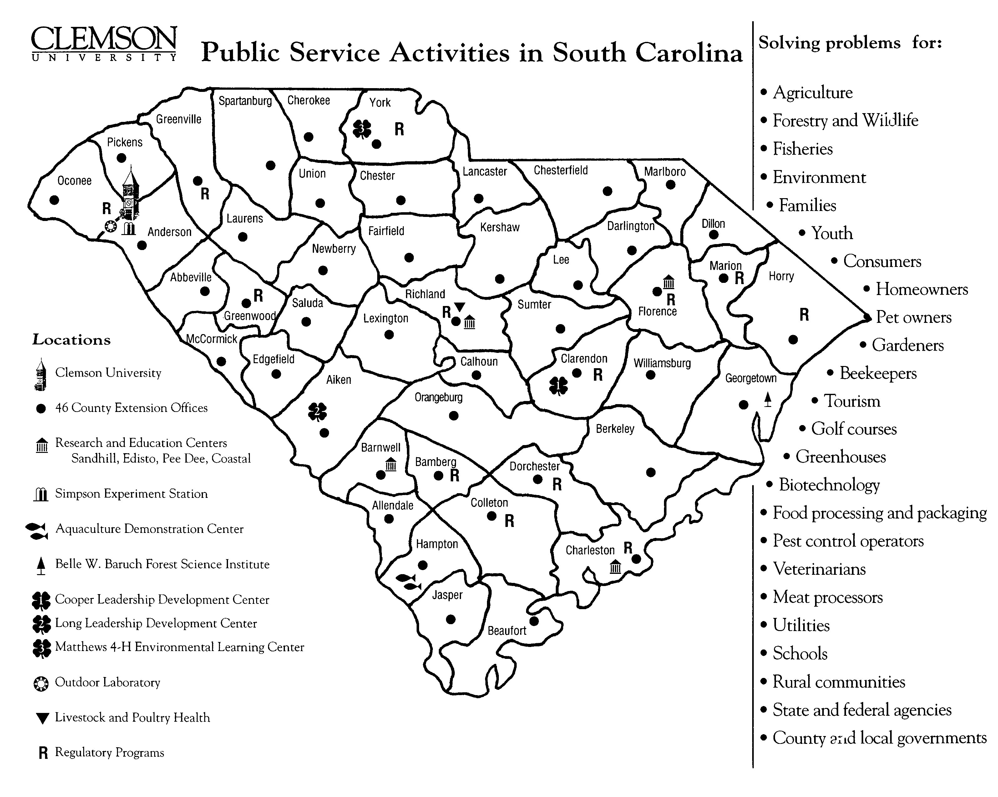
Figure II-1

Section II-3 Expenditure/Appropriations Chart
See Figure II-2 for expenditures/appropriations chart for PSA. It should be noted that PSA received a 9.7% funding cut from appropriations in FY 2001-02. This resulted in the loss of the ability to fund 37 PSA FTEs. Because Clemson’s leadership promotes a "One Clemson" philosophy, a match was made between the loss of portions of 67 people with full or partial PSA appointments and the teaching skills of these PSA employees with the need for new teaching staff. Therefore those 37 FTE were moved to the teaching side of Clemson University. While this will enrich the education of our students, those positions and their services are forever a loss for PSA and the citizens of South Carolina.

PSA leadership is focused on meeting the vision of Clemson University and will continue to increase its quest for new resources and collaborators.

 | 99-00 Actual Expenditures |  | 00-01 Actual Expenditures |  | 01-02 Appropriations Act
Major Budget Categories | Total  Funds | General  Funds | Total  Funds | General  Funds | Total  Funds | General  Funds
Personal Services | 44,716,116 | 37,044,725 | 45,636,309 | 35,272,974 | 43,536,635 | 36,842,307
Other Operating | 17,828,766 | 5,660,898 | 21,621,099 | 9,747,844 | 13,137,760 | 3,004,562
Special Items | 164,160 | 164,160 | 164,160 | 164,160 | 164,160 | 164,160
Permanent Improvements | 0 | 0 | 0 | 0 | 0 | 0
Case Studies | 0 | 0 | 0 | 0 | 0 | 0
Distributions to Sub-Divisions | 293,000 | 293,000 | -297,406 | -297,406 | -268,498 | -268,498
Fringe Benefits | 10,276,074 | 9,144,320 | 11,007,182 | 8,346,268 | 11,668,583 | 9,075,590
Non-recurring | 1,890,000 | 1,890,000 | 563,592 | 563,592 | 0 | 0
Total | 74,582,116 | 53,611,103 | 78,694,936 | 53,797,432 | 68,238,640 | 48,818,121

Figure II-2
Note: For Fiscal Years 1999-00 and 2000-01, there were no expenditures from Supplemental Funds, Capital Reserve Funds, or Bonds.

Section II-4 Key Customers
The key customers are the citizens of South Carolina. The programs conducted by PSA are open to all people. The mission and goals of the organization lend themselves to people who are associated with agriculture, agricultural and forest products, business and industry, landowners and managers of natural resources, families and youth, limited resource families, and rural and community leaders.

Customers also include pesticide and fertilizer sales and users, those who produce certified and enhanced seeds and plants, practicing veterinarians, county and local governments, business and industry, agencies who work in the areas of economic development, health, conservation, the environment, wildlife, water resources, technical education and youth and families.

Section II-5 Key Suppliers
The term “suppliers” is being used to describe agencies organizations, groups of individuals and classifications of individuals who support PSA programs with funding, matching or in kind support. Advisory boards provide invaluable support that is used to “build” program initiatives so they are included here as well.
- Federal (USDA—CSREES), State, and Local Government
- Agriculture Council
- Agriculture Industry Associations – i.e. Soybean, Corn, Cotton Growers Associations
- Cooperatives – SC Cooperative Council
- 4-H Donors
- Farm Bureau
- Green Industries
- Livestock Breed Associations
- Private Industry
- Foundations
- Private Non-Profit Corporations.
- SC Poultry Federation
- State and Local Fairs
- County Advisory Boards
- Advisory Boards and Centers

Section II-6 Major Products and Services
Programs, workshops, tours, newsletters and demonstrations are methods utilized by agents and specialists of the Cooperative Extension Service to convey information to the public. Mass media is also utilized extensively. Local newspaper and radio in addition to statewide public radio and the Educational Television Network (ETV) program Making It Grow are seen and heard by thousands of individuals each week. The Media Relations Unit produced 182 news releases with information from specialists, agents, scientists, and volunteers. The organization has an extensive collection of publications that are free or sold for a nominal fee. The current inventory of Extension publications is 1,476 titles. The state Extension newsletter and Extension Answers, are issued quarterly with a distribution of approximately 9,500 copies per issue and an estimated readership of 47,500. The Home and Garden Information Center is another means of information distribution and can be accessed by phone or the web. It contains information on 601 topics in the areas of landscape, garden & indoor plants; insects, diseases & other problems; and food safety and preservation.

The Web is being used extensively to distribute information. In addition to the Home and Garden Information Center, web pages are maintained which contain general information about the organization, extension offices, and each department on the Clemson University campus. These websites contain thousands of pages of information. This information ranges from tree identification to soybean production, to recipes on using pumpkins. The number of publications available on-line in digital format is over 300. The entire Pest Management Handbook is available on-line in HTML format. Besides all these, faculty and agents have published and/or presented their programmatic efforts and outcomes in a variety of journals, conference proceedings, and other regional, national, and international conferences/meetings. (http://www.clemson.edu/extension/)

The Strom Thurmond Institute (STI) is an information and expertise service center. Products include: reports on policy issues; data analysis; guidance in policy planning related to issues of community, education, and environment; maps and graphs. The Institute conducts applied research and service in public policy areas, drawing on the expertise of Clemson University faculty, staff and students. The Institute also enhances awareness of current public policy issues on the campus and throughout the state and region through informal and formal educational programs. Featured programs include: Community and Economic Development; Decision and Communications Technology, which houses our GIS Lab, FASTMap and Charleston Urban Growth Project; Environmental Science and Policy; Literacy and Community Service Networks; the South Carolina Water Resources Center; Programs and Public Affairs; Regional Development; and Retirement and Intergenerational Studies.
Regulatory and Public Services works to ensure safe and legal use of pesticides; the quality of fertilizer and lime; the prevention and control of introduced plant pests and pests of honey bees; the certification of seed purity/germination; the certification of freedom from plant pests in nursery, greenhouse & transplants; and to administer such programs as quality assurance and identity preserved for transgenic crops, pesticide container recycling, integrated pest management in public schools, boll weevil eradication, etc.

Agriculture and Forestry Research is currently operating more than 300 research projects focused in the five goal areas. The results of this research are transferred by the Extension Service across the state and through electronic mediums and publications across the country and around the world. Patents and new variety releases resulting from the research benefit producers and citizens alike. The solutions to problems are found through research.

Agriculture and Forestry Research is working in national forums and on the Clemson Campus to develop strategies to become a national leader in the high tech biotech field and develop bio-based technologies

The Belle W. Baruch Institute’s research and education programs focus on problems faced by the forest industry, landowners, regulatory agencies, sate and federal agencies tasked with managing one or more of the coast’s natural resources. Projects address water resource issues, water quality impacts of management practices, harvesting and regeneration of forests, wetland productivity, ecology and management, endangered species management and regulation, tree improvement and biodiversity of the forest, and training forest managers.

The Institute on Family and Neighborhood life generates, shares and applies the knowledge needed to strengthen ties between families and communities. Regardless of the context, the Institute engages in research and public service related to these broad topics:
- The nature of everyday life in families and neighborhoods;
- The development maintenance, and enhancement of community institutions;
- Current and alternative public policies supportive of family and neighborhood life.

Specific examples include the implementation of school-based violence prevention programs, technical assistance rendered to grassroot groups and non-profit organizations, and the evaluation of social services.

Section II-7 Organizational Structure
During 1995, Clemson University was reorganized. In this restructuring, nine colleges were merged into five. PSA was separated from academics; pulling research, extension, regulatory and STI together, becoming a unique State agency while maintaining its identity as an entity of Clemson University (as shown in Figure II-3).

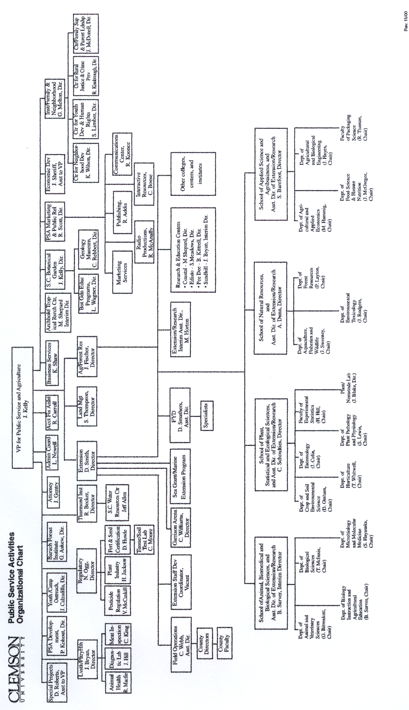Figure II-3
The 1995 reorganization placed the following units in PSA: Agriculture and Forestry Research, the Strom Thurmond Institute, Livestock and Poultry Health, and Regulatory and Public Service Programs. Additional units moved to PSA were Land Resource Management and the South Carolina Botanical Garden. Additional units added or refined over the ensuing years were, the Belle W. Baruch Institute for Coastal Ecology and Forest Science, the Institute on Family and Neighborhood Life, and PSA Marketing and public relations.

Section III – Elements of Malcolm Baldridge Award Criteria

Section III-1 Leadership
Clemson University, under the leadership of President James Barker, has established new Vision, Mission, and 10-Year Goals. The vision is for Clemson University is to become a nationally ranked top 20 public institution. Public Service Activities, under the leadership of Vice President John Kelly, embraces the vision, mission, and goals. The President, Vice Presidents, Deans, Directors and every faculty and staff member will be evaluated by their contribution to those goals.

The new 10-year goals of Clemson University that most closely relate to PSA are: setting the standard for relevant public service; increasing research programs to exceed $100 million per year; and fostering Clemson's academic reputation through strong academic programs, mission-driven research, relevant public service and highly regarded faculty and staff. Performance measures to accomplish these, and other appropriate, 10-Year Goals have been incorporated into the performance review criteria for of PSA’s employees.

PSA goals are to promote:
- Agrisystems Productivity and Profitability, PSA Goal 1
- Economic and Community Development, PSA Goal 2
- Environmental Conservation, PSA Goal 3
- Food Safety and Nutrition, PSA Goal 4
- Youth Development, PSA Goal 5.

The PSA leadership team is responsible for implementing programs, initiatives and activities under the five goals. The team consists of the following key leaders:
- Vice President for Public Service and Agriculture
- Deans for Agriculture and Forestry Research and the Cooperative Extension
Service
- Director of Regulatory and Public Service Programs
- Livestock and Poultry Health
- Strom Thurmond Institute
- Belle W. Baruch Institute for Coastal Ecology and Forest Science
- Institute on Family and Neighborhood Life
- PSA Marketing and Public Relations
- Assistant Directors of Cooperative Extension Service and Agriculture and Forestry Research

These leaders regularly receive input from advisory groups, industry leaders and vice presidents and deans at Clemson, which is applied to guide PSA in setting organizational values, directions, and performance expectations and accomplishing the vision and mission of PSA.

Section III-1-1 How do senior leaders set, deploy and communicate?
Senior leaders empower employees in a university setting and through feedback mechanisms in staff meetings and reverse evaluations of supervisors. Professional development is offered formally in retreats or structured learning professional programs and in attendance in professional meetings, where funding allows. Ethical behavior for all Clemson employees is identified in the University's Fiscal Policies and Procedures and Personnel Policies and Procedures Manual.

Section III-1-2 How do senior leaders establish and promote a focus on customers?
The commitment to customer service is reflected in the mission and goals of PSA, and is supported by a sophisticated and long-standing network of advisory boards and committees. The focus on customer service is an element of each leadership team meeting.

Section III-1-3 What key performance measures are regularly reviewed by your senior leaders? (Actual results are to be reported in Category 7).
The key performance measures, which are regularly reviewed by senior leaders, are the five goals and those that are cumulatively reflected as accomplishments in Section I, 1. The primary criteria for instituting new programs, projects or initiatives are relevance, capacity and impact. These criteria follow with the activity as performance measures.

Section III-1-4 How do senior leaders use organizational performance review findings and employee feedback to improve their own leadership effectiveness and the effectiveness of management throughout the organization?
Employee feedback is used, along with an ongoing review of key performance areas to improve leadership and management effectiveness. In a recent PSA Self-Study, PSA employees were asked to rank the effectiveness of PSA senior leaders. The ranking options were given from very poor, poor, neutral, good, to very good. The following chart demonstrates the confidence in PSA leadership.

Section: Leadership in PSA
A13=PSA leadership at the VP level is . . .
A14=The Director of Cooperative Extension Service's leadership is . . .
A15= The Director of Agriculture and Forestry Research's leadership is . . .
A16= The Director of Livestock and Poultry Health's leadership is . . .
A17= The Director of Regulatory and Public Service Program's leadership is . . .
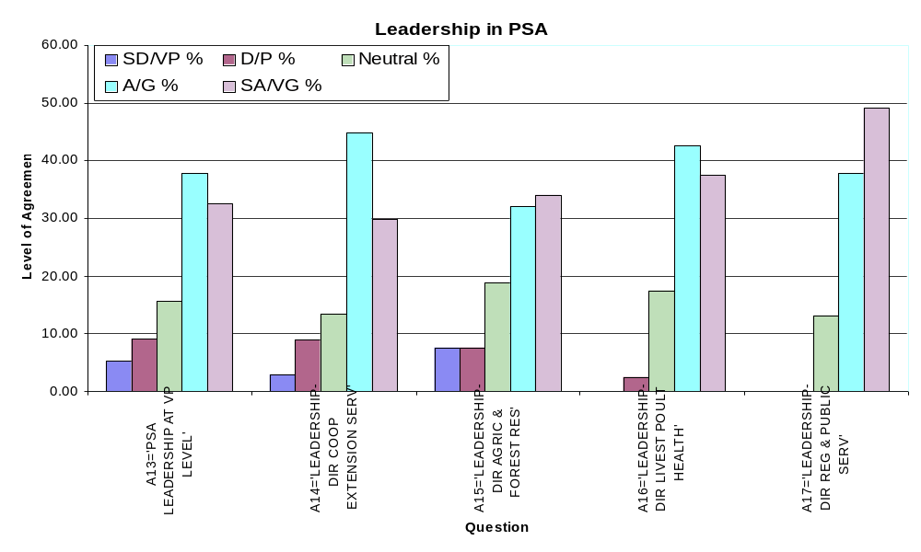(Graph III-1)

 | SD/VP | D/P | Neutral | A/G | SA/VG
 | % | % | % | % | %
A13='PSA LEADERSHIP AT VP LEVEL' | 5.19 | 9.09 | 15.58 | 37.66 | 32.47
A14='LEADERSHIP-DIR COOP EXTENSION SERV' | 2.99 | 8.96 | 13.43 | 44.78 | 29.85
A15='LEADERSHIP-DIR AGRIC & FOREST RES' | 7.55 | 7.55 | 18.87 | 32.08 | 33.96
A16='LEADERSHIP-DIR LIVEST POULT HEALTH' | 0.00 | 2.50 | 17.50 | 42.50 | 37.50
A17='LEADERSHIP-DIR REG & PUBLIC SERV' | 0.00 | 0.00 | 13.21 | 37.74 | 49.05

(Table III-1)
Note: Leadership at the Vice President’s level was perceived as very favorable with a 85.71% approval rating. Similar high ratings were given to the other PSA Directors. (Note: The Deans of SCAFRS and CES were rated as “Directors” in this Self-Study.)

Section III-1-5 How does organization address the current and potential impact on the public of its products, programs, services, facilities and operations, including associated risks?
Customer satisfaction surveys are conducted regularly and are detailed in Category 3-Customer Focus. These surveys along with more informal information gathering techniques provide a continual source of feedback. This feedback is used to address the current and potential impact of PSA activities on the public.

Section III-1-6 How does senior leadership set and communicate key organizational priorities for improvement?
Key organizational priorities are tied to the five PSA goals. Senior management works with the unit leaders to insure that they are focusing their efforts on achieving a balance of effort between the goal areas and that they communicate detailed implementation plans to their respective faculty and staff.

Section III-1-7 How does senior leadership and the agency actively support and strengthen the community? Include how you identify and determine areas of emphasis.
Senior leadership supports each PSA unit in their efforts to actively support and strengthen the community. These efforts are presented in Category 3, Customer Focus.

Section III-2 Strategic Planning

PSA is committed to taking a leadership role in addressing challenges and realizing opportunities in South Carolina. PSA is poised for the future with its five strategic goals aimed at meeting the needs of South Carolina citizens and achieving the highest levels of scholarly excellence in research, outreach, and service. The five goals are: 1) Agrisystems Productivity and Profitability, 2) Economic and Community Development, 3) Environmental Conservation 4) Food Safety and Nutrition, and 5) Youth Development.

The seven PSA units collectively provide input to the strategic planning process. In addition, the strategic planning takes place within these seven units with a focus on what is best for each unit, PSA, Clemson University and the state of South Carolina. In so doing, it has addressed several key issues in developing the plan. These include: recognition and clarification of mission, environmental scanning, identification and selection of issues, development of goals, and strategies, implementation of plans, past strategic plans, national directions (USDA--CSREES), state initiatives and monitoring of results. Stakeholder input was critical to our strategic planning process and as such input was sought from a variety of stakeholders that included researchers, scientists, faculty, extension agents and specialists, program staff, advisory committee members, program participants, customers, business and industry representatives, funding agencies, local and state government officials, public health officials, local leaders, legislators, and administrators. The information team collected relevant data via interviews, surveys, and personal contacts. Nominal group technique was also used at the county level to garner stakeholder input. Demographic data from all the counties through an environmental scan was also conducted. Customer needs, financial, societal and other risks, human resource capabilities and needs, operational capabilities and needs, and suppliers, contractors, partners capabilities and needs, were all considered in the planning process (see figure next page).
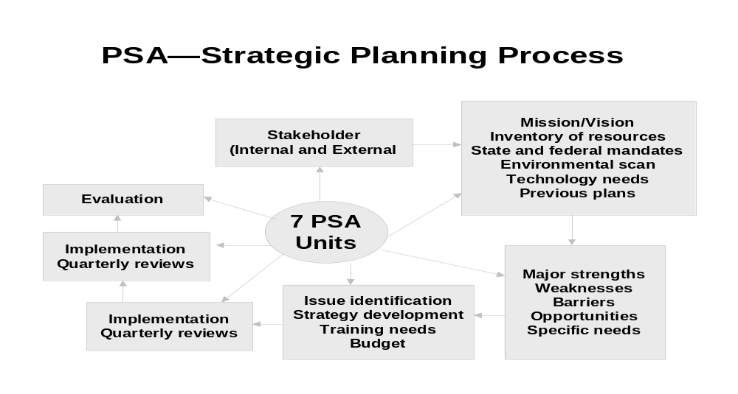

(Graph III-2)

Each of the seven units continually examines operational capabilities and needs. Then, each unit’s needs are communicated to the leadership so that appropriate budgetary and support can be requested. Normally, each unit forecasts what it will need in the next 3-5 years. In addition, capabilities and needs are reviewed based on market trends, needs of new personnel hired and what is happening in and around similar institutions.

The success of programs, projects, and services, to a great extent, depends on the ability of employees to do the job and the extent to which they are up-to-date on the subject matter. PSA’s goal is to enhance the human resources by aggressively hiring outstanding faculty, researchers, agents, and support staff; invest in their professional development, and provide a supportive work environment. Several training and professional development opportunities are available to employees to improve their skills. The heads of PSA’s seven units annually review the needs of each employee and then identify professional development opportunities for them. Clemson University’s Human Resource Office and Clemson Extension’s Staff Development Unit offers a variety of training programs relative to subject matter, professional development, and technology. During the time of the annual performance review of each employee, unit heads reinforce the roles and responsibilities of employees in fulfilling the personal and organizational goals.

A variety of action plans are in place depending on the functions of each unit. Periodic reviews are conducted within each unit to review key strategic objectives of programs, projects, and other services. These reviews help gauge performance and determine what areas need improvement. These reviews are regularly communicated within each unit and to the PSA leadership, faculty, staff, county administration and individual employees, so that necessary actions can be taken. For example, a Web-based reporting system (Clemson University Management Information System—CUMIS) is in place to track and evaluate progress made in extension programs. CUMIS system provides information relative to time spent, programs conducted, number completing programs, knowledge gain and adoption of practice as a result of participation. Similarly, other units also have internal mechanisms to assess progress made in key strategic areas. Clemson Extension benchmarked its customer satisfaction activity with other Extension Services in the southern region.

PSA has an excellent mechanism to communicate strategic objectives. PSA leadership team that consists of the vice president and all the seven unit heads meet on a weekly basis to communicate and deploy strategic objectives, action plans, and performance measures. Directors of each unit provide briefings of their unit’s performance and discuss strategies for improvement. The decisions made at the leadership meeting are communicated to the individual units. In addition, e-mail and formal letters are also used to communicate plans and strategic objectives.

The five PSA goals embedded in the strategic plan have provided a sense of direction and focus to Public Service and Agriculture activities at Clemson University. Constituents, the people of South Carolina who communicate what they need to improve their lives, define program activities. Strategic planning, continuous quality improvement, and the impact of our programs and services on our clientele, help us gauge our success in accomplishing the mission and goals.

Section III-3 Customer Focus

Section III-3-1 Identify key customers and stakeholders.
PSA’s key customers and stakeholders are the citizens of South Carolina.

PSA customers include South Carolina growers or any plant or animal commodity, citizens, consumers, government agencies, other universities, gardeners, youth, agribusiness, businesses and persons relating to any context of our research education and regulatory functions to include, commodity groups, residents of communities, cities, and rural areas. Included also are legislators, alumni, families, meat packing establishments, agri-chemical users, unidentified users of PSA electronic printed, and broadcast information, and people who support the wide range of PSA units and their program activities.

A more specific listing of customers which is not inclusive includes the following:
- Hispanic migrant workers
- Citizens of South Carolina that: sell or use fertilizer, lime, soil amendments, pesticides; provide structural pest control, sell or buy certified seed, or nursery/greenhouse plants.
- People who provide support so that they can meet their customers’ needs, and groups who distribute information to others.
- Owners of food and companion animals.
- Processors of food product of animal origin.
- Individuals involved in sale, movement or general health of animals.
- Customers are identified in many cases through laws and regulations that we enforce.

Section III-3-2 How do you determine who your customers are and what are their key requirements?
Contact data clearly identifies customers and their needs. In FY 2000-01, more than 750,000 people in South Carolina were contacted by the PSA units to determine their requirements. They represent a variety of people from all walks of life. These people are integral to programs and initiatives and provide valuable feedback performance. A majority of these contacts (76%) were programmatic, meaning that customers came to programs or submitted requests to receive information based on an identified need. Telephone calls, office visits, farm and home visits, participation in workshops, demonstrations, and seminars are some of the methods employed to provide information and at the same time determine customers needs and wants. In addition, print media such as brochures, pamphlets and, how-to-do guidebooks have also been published and distributed to the customers. Many needs are defined by mandated health requirements.

When a research need is identified, such as the appearance of a new pest or disease, a critical social or environmental phenomena or a production concern, the customers that have the information need are contacted and the problems are discussed along with potential methods of obtaining the information that is needed to solve them. Our proposals show them our capacity and how we are able to meet their needs.

Section III-3-3 How do you keep your listening and learning methods current with changing customer/business needs?
The annual nature of surveys and contact data gathering, coupled with the fact the PSA has at least one service unit in each county of the state, and the staff at the local level are in constant contact with state legislators, local elected officials and citizens who are served daily. The unanticipated occurrence of a new plant pest, such as Tropical Soda apple which impacts pasture land and the environment or Plum Pox disease, which impacts peach production, keys the various units in PSA to respond in a coordinated fashion with customers. The potential threat of Foot and Mouth Disease in livestock and wildlife sets a different series of processes in motion which are preventative in nature. New procedures for bio security is one example.

Section III-3-4 How do you use information from customers/stakeholders to improve services or programs?
Reviewing and updating of testing and reporting. Periodic meetings with advisory boards, local leaders, and other stakeholders provide feedback on how programs and initiatives are meeting their needs. Information from these meetings will be conveyed to appropriate to take necessary action. Extension Advisory Boards have played a significant role in providing input and feedback to PSA programs. Focus groups discuss how work can be more meaningful to the group being served. We try to learn from customer feedback is used as a learning tool to increase the quality of programs and assistance.

Section III-3-5 How do you measure customer/stakeholder satisfaction?
PSA has put a plan in place to measure the quality of services provided by Extension staff in all the 46 counties of the state. A customer satisfaction survey (CSS) has been developed to collect data from the customers. The goal of CSS is to help county staff find ways to improve program quality, information delivery, and more important, to assist in the accountability process. Four indicators were identified to assess the quality and satisfaction of services provided by extension. These include: 1) up-to-date, useful, relevant and easy to understand information, 2) the extent to which recipients had the opportunity to use the information, 3) the extent to which they have shared the information with others, and 4) the extent to which they are satisfied with the services provided. The following success criteria was also established: 1) 80% of the survey participants will report positively to all the questions, 2) 50% will report that they have used information, 3) 70% will report that they have shared extension information with their friends and neighbors, and 4) 80% will report that they are satisfied with the services provided.

Forty-two of the 46 counties participated in the survey. A team comprised of extension agents, county extension directors, and secretarial staff conducted over 1,068 interviews with customers to collect data. These 1,068 responded to 14 questions covering the four criteria indicated above. The results of the survey are provided in the business results of this report.

The CSS findings were benchmarked with two other states in the southern region as standards of measurement. The results of CSS have been used by county staff in budget decisions, in showcasing program accomplishments and in legislature days. Such use has shown that Extension can make a difference. This survey will be conducted again in 2001-2002. As we look to the future, the needs and expectations of our customers should be paramount. Periodic assessment of customer satisfaction will provide focus and direction to our programs and in meeting the needs of customers we serve.

Participating in industry meetings and obtaining feedback is a valuable source of customer satisfaction information for Livestock and Poultry Health. Customer satisfaction is determined by customer response and willingness to purchase. It is also measured by the extent that other groups want information about the work.

Section III-3-6 How do you build positive relationships with customers and stakeholders? Indicate any key distinctions between different customer groups.
Daily interaction, made possible by the location of PSA resources and personnel in every county, coupled with the delivery of information that is accurate, timely and usable are the keys to positive relationships with customers and stakeholders. Industries, large business operations and local governments require different levels of assistance than many citizens who have a very specific need for information. Large commercial growers, for example, will very often need assistance from a number of disciplines and specialists, and sometimes contract for very specific deliverables. Clemson PSA serves a broad range of customers and the distinctions between the customer groups is a function of the amount and nature of the information they require. We build positive relationships with customers when our work profits them. The distinctions between different customer groups comes in the different fashions their satisfaction takes. Profits for customers can include: money they saved; they are made to look favorable to their customers; they gain insights; or they can confront or advocate their positions more effectively.

Section III-4 Information and Analysis

Section III-4-1 How do you decide operations, processes and systems to measure?
Everything we do must fit within the five PSA goals as well as meet the individual goals/objectives of the individual divisions within PSA. These divisions have their own established process to determine whether they are addressing the needs of their customers/stakeholders. This process could be peer review committees, focus groups, surveys, and personal contacts. Regardless, decisions are made that direct the division in directions that best suits that division’s relevance, capacity and impact (example of criteria used for research).

Once this is determined, the division upper administration determines the activities that must be measured and that best reflects and measures the performance of that division.

As mentioned earlier in this report, Public Service Activities is currently implementing a system-wide accountability system called CU-AIMS (Clemson University Activity Information System) that looks at all aspects of the organization. Once in place, the system will measure and inform to the various levels of the organization the types of data being collected, the results of the data, and the direction the organization is moving as a result of this data.

Section III-4-2 How do you ensure data quality, reliability, completeness and availability for decision-making?
Good decision making requires good data. Data that is reliable, complete and available. CU-AIMS is PSA’s system that will ensure this. CU-AIMS takes data from numerous sources and delivers it to three levels of PSA: the stakeholders, the users, and the decision makers. The stakeholders are informed of activities within PSA through the web-based system called “South Carolina Growing”. This system shows the general public, legislature, media, scientists, and other interested parties the current problem-areas being addressed by PSA, the solutions being discovered by PSA, the information being disseminated from these discoveries, and the future areas that PSA will be pursing in the future. By informing the public (as identified earlier), we are encouraging feedback from our stakeholders to insure that we are working in the correct areas and addressing the critical needs and delivering the proper information. In essence, this is our window to the world where we can pass information to and from our stakeholders.

The Professional Home Page (PHP) component of CU-AIMS is our connection to the expertise within our organization i.e. the scientists, the technicians, the staff, and other professionals that allow us to solve the problems and deliver the information to our stakeholders. By keeping them informed we can further insure that they know what is being asked of them (through our performance measurement subsystems), and showing them what their colleges are doing (encouraging collaborative efforts), and giving them a process to communicate with the administration any discrepancies or misrepresentation of the data (electronic report transfer).

The final component of CU-AIMS is the Information Management System. It is the umbrella or the “core” of CU-AIMS. This is where all the data is stored and delivered to the administration. This system does high-level analysis of how the organization is working. It looks at spending trends, performance measurement, time analysis, account discrepancies, goal progress, and market analysis. This is the true decision making tool for the administration.

Section III-4-3 How do you use data/information analysis to provide effective support for decision-making?
As has been stated above, various processes are currently doing data/information analysis. CU-AIMS will centralize that process into a truly integrated system that will insure better decision-making and process tracking and performance measurement. The information will be funneled through the CU-AIMS, which has built in “decision-assist” processes that will report the various activities being conducted within PSA.
Depending on the type, importance and scope of the decision, the CU-AIMS data will allow the decision makers to meet and discuss the issues using concise, accurate and relevant information associated with the problem.

Section III-4-4 How do you select and use comparative data and information?
CU-AIMS brings in information from all aspects of PSA. Much of this data is grouped into predefined areas that allows for comparing performance between departments, or stations, or problem areas (programs) or between individuals. These predefined areas have certain criteria or performance measures that can allow for these comparisons to be made.

Because CU-AIMS connects to numerous data sources, comparisons can be made between ourselves here at Clemson and with other “like” institutions across the country. This not only allows us to see how we are doing (performance measures) but also sees if we need to encourage collaborate efforts with “sister” institutions. Once CU-AIMS connects to commodity databases within the state, we will be able to compare our efforts to that of industry and income. This will assure that we investing in areas that will best benefit the actual needs of the state – not in areas that are just not suited to our states climate or resources.

Section III-5 Human Resources

Public Service Activities Business Services works together with Clemson University Human Resources for all PSA employees.

Section III-5-1. How do you and your managers/supervisors encourage and motivate employees (formally and/or informally) to develop and utilize their full potential?
Employees are encouraged and motivated to develop and utilize their full potential through the following.
- Effective planning using the Employee Personnel Management System can encourage employees to develop their skills and abilities.
- Providing opportunities for employees to continue their education, at little or no cost through the following.
  - Clemson University tuition assistance - 4 credit hours per semester/summer session.
  - A partnership between Clemson and Tri County Technical College provides a secretarial degree program and Commercial Driver's License (CDL) training. Another program under proposal is a Journeyman Program in electricity or plumbing.
  - Partnership with Pickens County Adult Education for acquiring a GED and professional development courses offered through out the calendar year.
  - The University's Mentoring Program, which partners employees seeking an additional skill level with someone who has already attained the skills requested, with a specified time allowed for the mentoring process.
  - Computer classes from entry level keyboarding to advanced classes in website design.

PSA units offer award recognition for outstanding employees to support them within the system such as Distinguished Agent positions and award programs to promote excellence. In addition, the Clemson University Alumni Association provides awards each year for excellence in Public Service. The Certificates of Appreciation are another tool used in PSA. In one area, each staff member was issued 10 Certificates of Appreciation to be given to co-workers for outstanding work throughout the year.

Section III-5-2. How do you identify and address key developmental and training needs, including job skills training, performance excellence training, diversity training, management/leadership development, new employee orientation and safety training?
The Office of Human Resources conducts a training needs assessment survey designed for each University unit. From the information gathered, sessions are scheduled to meet the needs of the unit. OSHA training is done in accordance with regulations. New employee orientation is not mandatory at Clemson, however, each new staff member is invited to attend. All day sessions are held on the 1st and 2nd payday of each month.
A variety of professional development training programs are offered each year within PSA covering such topics as grant writing, diversity, developing partnerships, developing survey instruments, etc. Technology training is offered which cover the use of several computer programs. A training catalog containing 166 topics is available to employees.
In FY 2000-2001, more than 1,600 PSA personnel participated in-service offerings, including state-of-the art testing, HACCP initiatives and surveillance demands. Safety training is a top priority.

Section III-5-3 How does your employee performance management system, including feedback to and from employees, support high performance?
The Office of Human Resources communicates expectations during planning phase of the process - employees are allowed input into formulating the planning stage. The ratings allowed by policy in the evaluation phase include not only one for meeting the expectations, but also one for exceeding and one for substantially exceeding. The possibility of achieving a higher rating for work that is accomplished helps to support high performance. Performance pay is also tied to the EPMS - can be an incentive for higher level performance; and support of the University’s Goals as a way in part of becoming one of the Nation's top twenty public universities increases awareness of a Mission above an individual's daily duties - supporting higher performance than usual. Each employee chooses one of the Goals to be included as part of their evaluation document.
Formal written performance evaluations and interviews conducted with each faculty member to review accomplishments, weaknesses, and areas needing improvement. This information is utilized in determining the annual goals and objectives for the plan of work developed by each faculty member.

Section III-5-4 What formal and/or informal assessment methods and measures do you use to determine employee well being, satisfaction, and motivation?
A satisfaction survey was conducted for faculty in each county in 2000. The survey revealed morale issues and barriers that may inhibit the improvement of performance. Recommendations were obtained and are being implemented. Surveys, of this nature, are done periodically by various units.
Units periodically review with personnel well being, to include work level and schedule, satisfaction and expectations. Efforts are made to insure that supervisors are available at any time to discuss issues with subordinates. Employees are encouraged to make suggestions for improvements

Section III-5-5. How do you maintain a safe and healthy work environment?
The Office of Human Resources ensures compliance with the Drug Free Work Force Act by annual distribution and enforcement of the Employee Drug and Alcohol policy; compliance with the DOT regulations governing training and drug testing of employees who are required to have a commercial driver's license (CDL). (Partnership stated under the first question of the assistance provided to employees in obtaining a license after requirement has been added to an existing position.) The University Smoking Policy is in compliance with the SC Clean Indoor Air Act; Training provided annually on causes and symptoms of violence in the workplace; Employee Assistance Program provides confidential assistance/referral for employees experiencing difficulties in coping in a variety of life/work situations. (The intent of the program is to enable them to return to a more productive employee).
PSA units are inspected regularly, as required, to insure that they meet state and federal standards. The University and PSA focus on encouraging safe work environment/habits. Ergonomics specialist on staff will provide recommendations for improving workstations, etc; and the University Wellness Center provides health programs and services at little or no cost to employees. These programs include in part recommendations for weight loss, improving diet and lifestyle changes.
Individual PSA units have a variety of complementary approaches in the safety area to include training in pesticide management for employees, safety compliance officers who stress safety in laboratory areas and regular inspections of facilities and equipment.
Employees are monitored to insure that all safety measures are followed. Employees that become aware of a potential safety problem or area in need of attention are encouraged to report the need to their supervisor. Air Quality issues at the county and University, for example, were identified and action was taken to correct the problems.

Section III-5-6. What is the extent of your involvement in the community?
Off campus faculty and university faculty are encouraged to involve themselves in community activities. Personnel serve as members and officers in numerous leadership and civic organizations. Several employees are involved in their local school system, serving as members of the school board. Participation in these type activities shows the commitment of PSA personnel to their community. PSA has projects address: community volunteerism, educational improvement, civic engagement and environmental quality. PSA has developed formal networks with civic associations, volunteer training initiatives, private companies and governmental organizations.

Section III-6 Process Management

Section III-6-1 What are your key design and delivery processes for products/services, and how do you incorporate new technology, changing customer and mission-related requirements, into these design and delivery processes and systems?
The design of program initiatives is built around three primary criteria, relevance, capacity and impact. Needs assessments are targeted towards our customer base and systematically updated. An advisory board with a broad cross section of members from across South Carolina and the nation are asked to assess and provide input to the PSA leadership on the design of program initiatives and the delivery of services. Each unit within PSA is directly involved in service delivery unique to its own specific mission. The design of the delivery systems is constantly being impacted by increased demand for services, new types of services, and new means of service delivery. Budgetary constraints directly impact the ability of PSA to respond to changing customer needs. Remote delivery of service using Internet technology, satellite, two-way video, and radio are examples of innovative approaches to service delivery.

Section III-6-2. How does your day-to-day operation of key production/delivery processes ensure meeting key performance requirements?
The design and delivery of all PSA programs are built around achieving the objectives in the five PSA goals. Decisions are made in the design stage to focus research initiatives on the established goals. Spontaneous demand for service from customers is assessed in terms of PSA’s ability to deliver the service within the context of the five PSA goals. In instances where the service request is beyond PSA’s capabilities, mission or outside a goal area, efforts are made to refer the customer to other agencies, state or federal or two other land grant universities, with different specialties.

Section III-6-3. What are your key support processes, and how do you improve and update these processes to achieve better performance?
Communications is a key support process in the design, production and delivery of products to customers. PSA has a Communications Center, web page authoring and management staff, radio station, publications and graphics capabilities two-way video and satellite facilities and access on a reimbursement basis to a range of communications support from the Academic side of the university. PSA has facilities adjacent to the university and at strategic locations across the state (at least one facility in each county) (see Section II, item 2). These facilities are maintained and supported by a central unit adjacent to the campus with specific support functions housed at each installation. PSA staff is responsible for the maintenance of computers, animal and poultry health equipment as well as vehicles. Maintenance can be either on a contractual basis with the university or an outside vendor. Personnel and property management are conducted internally. Legal, land management, computer, janitorial and legislative support services are shared with the university, funded by PSA at negotiated levels.

Section III-6-4. How do you manage and support your key supplier/contractor/partner interactions and processes to improve performance?
The primary suppliers for PSA are the federal and state legislators, companies, organizations and communities that invest funds in PSA. Interactions with suppliers, contractors and partners are carried out though visits, correspondence, periodic reporting and annual reporting as represented by this document. Quality outputs and outcomes, coupled with documented customer satisfaction that are shared with suppliers, contractors and partners on a timely basis, generates valuable inputs that are used to improve performance. Advisory boards and groups are also apprised of comments from these interactions and suggestions for improving performance are generated.

Section III-7 Results

Section III-7-1 What are your performance levels and trends for the key measures of customer satisfaction?
PSA is clearly interested in maintaining the quality of the information and services it provides to customers, while expanding or at least maintaining the numbers of customers served. This goal is becoming increasingly problematic in an era of decreasing budgets. Achieving desirable performance levels will require a continuation and expansion of a trend towards electronic mediums to meet customer needs and achieve customer satisfaction.

Section III-7-2 What are your performance levels and trends for the key measures of mission accomplishment?
Outside funding must be increased to meet the performance levels set for achieving the PSA mission and accountability capabilities must be enhanced to insure the maximum return for each dollar invested. The five goals outlined earlier are each in critical economic social, environmental and public policy areas vital to South Carolina. Bio-security, for an example, is a critical part of the PSA mission that must be accomplished.

Section III-7-3 What are your performance levels and trends for the key measures of employee satisfaction, involvement and development?
Yearly evaluations and low turnover rates are key measures. In addition, we note requests from colleagues across the campus, and from other areas around the region, seeking to partner in project initiatives.

Section III-7-4 What are your performance levels and trends for the key measures of supplier/contractor/partner performance?
The ability to develop long term working relationships with granting organizations and agencies, the ability to build trust based working relationships with elected officials, and the ability to demonstrate high quality performance and service to customers represent necessary long term trends which must be maintained.

Section III-7-5 What are your performance levels and trends for the key measures of regulatory/legal compliance and citizenship?
Actual numbers of regulatory compliance events and the resulting overall quality of life in the state in related areas are indications of performance, along with the number of web site “hits” and requests for assistance from customers.

Section III-7-6 What are your current levels and trends of financial performance?
PSA has systematically undergone a series of funding reallocations, budget reductions and faculty and staff reassignments with the long-term goal of capitalizing on state and federal funding and leveraging private funds to achieve the organizations five goals and complement the university’s goals. Increasing the return on the dollar while not compromising the unbiased nature of the information and services we provide is a top financial priority

Results by PSA Unit

There are seven major and diverse organizations serving South Carolina under the umbrella organization, Public Service Activities. The organization, approach and accomplishments of each unit are equally diverse. In an effort to clearly present the contributions of Public Service Activities to the state, the responses will be aggregated by units to reflect agency organizational performance.

A. Cooperative Extension Service
Customer Focus: In 1999-2000, a total of 1,068 individuals completed a customer satisfaction survey. The survey results indicated that PSA customers are very satisfied with the information they received from Clemson Extension offices in the counties. They indicated that the information they received was accurate, up-to-date, and relevant to their situations. In addition, customers indicated that they made use of the information to solve a problem or answer a question regarding an issue or a concern. This positive use of information can be linked to not only knowledge and skills acquisition, but also inclination toward adopting a recommended practice. Customers also indicated that they have shared the information with their friends and neighbors, indicating confidence and trust they have for extension programs and the information received. The findings of this study were benchmarked with other Extension Services in the Southern region. Results were very much comparable to the surveys conducted by University of Florida and Texas A & M University.

Relevance and Quality of Information: Customers who participated in Clemson Extension programs or visited the Extension office for information were very impressed by the quality of information they received relative to food safety, water quality, crops, financial management, community development, youth development, and others. Ninety-seven percent said that the information presented was up-to-date and accurate, useful, and easy to understand. Ninety-six percent found it to be relevant to their situation.

Information Use: Eighty-two percent of the respondents indicated that they have used the information. Seventy-six percent of those who had used the information said that it had solved their problems or answered the questions. However, 21% said “don’t know” because they are still in the process of using the information they had received from extension.

As indicated earlier, the mission of extension is education—to help people help themselves by providing unbiased research-based information to our customers. Five performance measures were identified to assess program accomplishment. These include: 1) total number of contacts made, 2) number of programs/activities conducted, 3) number of people completing extension programs, 4) number reporting increased knowledge as a result of participation, and 5) number reporting adoption of a practice.

Clemson Extension continues to show positive growth in all of the five performance measures. The total number of contacts, over a four-year period, has been increasing. The number of contacts made increased from 653,599 in 1997-98 to 756,994 in 2000-01. This shows that extension is reaching more people who are in need of information to help solve their day-to-day problems or issues. A more significant measure would be to examine programmatic contacts, that is, contacts made in relation to five PSA goals. Programmatic contacts have also increased over a four-year period. On average, seven out of 10 contacts were programmatic contacts where staff presented educational programs or provided information relative to five PSA goals.

A second measure is the number of programs/activities conducted by staff. During the four-year period, the number of programs conducted ranged from a low of 15,064 in 2000-01 to a high of 18,987 in 1997-98. Many staff are working together and presenting programs to minimize travel and cost. In addition, several programs have become increasingly interdisciplinary, resulting in team effort. Despite a decline in number of programs conducted, the average number of people per program/activity has increased—11 persons per program in 1997-98 to 19 persons per program in 2000-01. Similar trends can be observed when these measures are examined by five PSA goals.

In addition to total number of contacts made and number of activities conducted, two other performance measures—total number of people completing programs and number of people reporting increased knowledge as a result of participation in extension programs--are critically important to our mission. The total number of people completing programs continues to increase with a slight decline in 2001. Similarly, knowledge gain by participants has also shown a positive trend. Seven out of ten people who completed programs increased their knowledge. Similar trends were observed for PSA goals as well.

Knowledge acquisition is critical to use information and to make decisions relative to adopting a practice. One has to remember adoption of practice do not occur overnight, it takes a while depending on the problem situation or recommended practice. Adoption of a practice may take anywhere between a week and three years. In addition, some participants may not have had the chance to use the information. Therefore, these adoption rates should be viewed with caution. The final measure, number of people adopting a practice has also increased over the years. The knowledge gain to adoption ratio has increased from 12 in 1997-98 to 46 in 2000-01. This is a significant increase when compared to national averages which range anywhere between 25 to 35 percent. Both knowledge gain and adoption of practice, more or less, showed an increasing trend for all PSA goals.
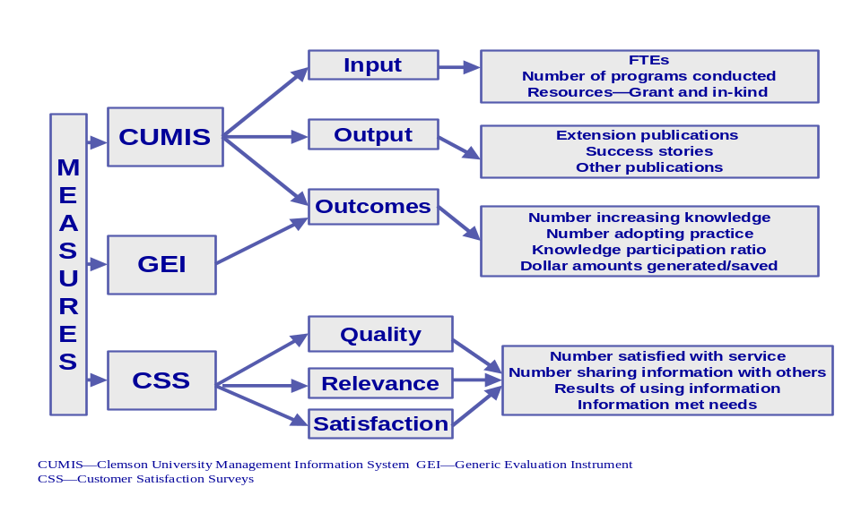

(Graph III-2)
The following graphs show trends in all the five performance measures for the five PSA goals.
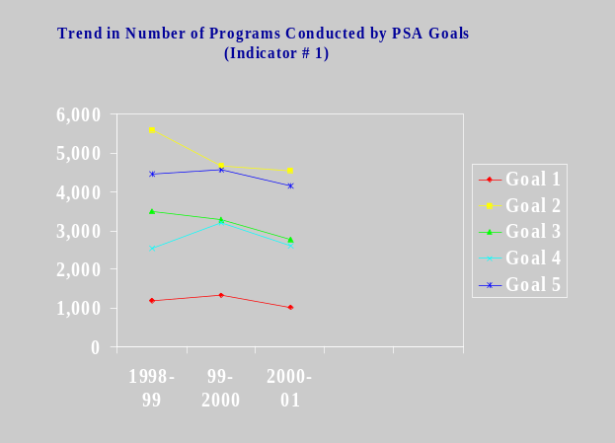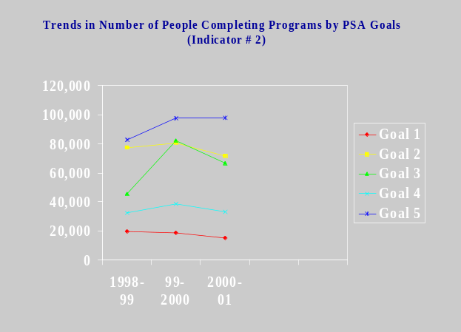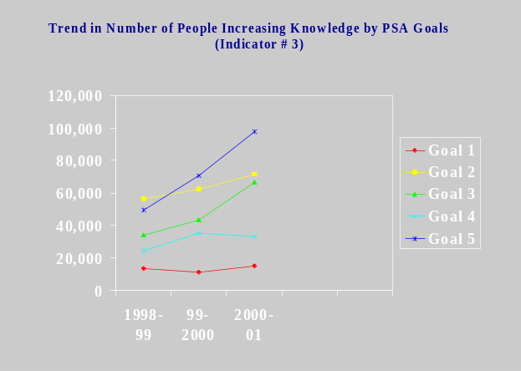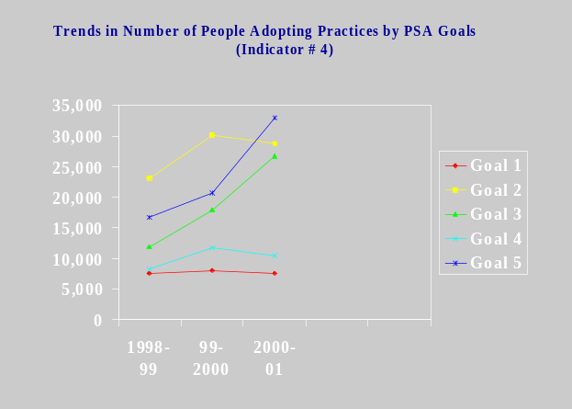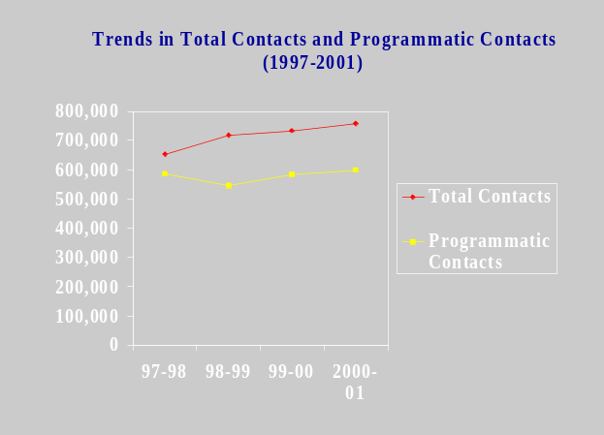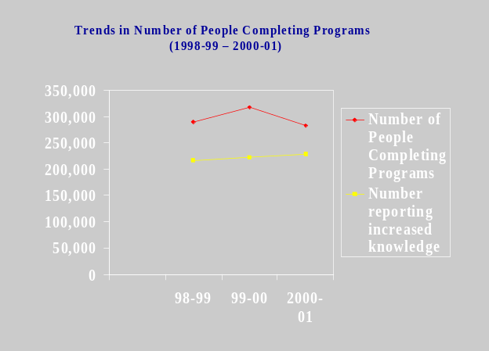

(Graphic Series III-3)

As indicated in Category four of this section, a three-prong performance measure framework was developed and implemented. Table 1 shows the results relative to five projects (one project from each of the five PSA goals) that were evaluated using the framework. Data in Table 1 clearly indicate consistent results for the same project using all three components—CUMIS, GEI and CSS. Examination of CUMIS data for the five projects reveals participation in extension programs and activities had helped participants to acquire the knowledge and skills relative to a problem or concern (project). Data also show that the awareness and knowledge acquisition has helped participants to adopt recommended practices.

Data from generic evaluation instrument (the second component of the framework) for the same projects further reinforces and validates results from the other two components (Table III-1). In addition to increasing knowledge, using information, and extension programs meeting their expectations, a majority of participants (over 50%) indicated that they saved money as a result of using extension information and recommendations.

Finally, examination of customer satisfaction data (the third component of the framework) for the same projects reveals that customers (participants) were very satisfied with the service they received from Clemson Extension Service. Customers also indicated that the information they received was up-to-date, accurate, easy to understand, and relevant to their situations. In addition, a majority of them (over 70%) had used the information to solve the problem or to answer questions they had about the problem or an issue. Data from CSS can be linked to not only knowledge and skills acquisition, but also inclination toward adopting a recommended practice. Customers have also shared information with their friends and neighbors, indicating the confidence and trust they have for extension programs and the information received. Collectively, these two indicators enhance the credibility and quality of extension programs and services provided by county extension staff.

Indicators for Evaluation Framework Components—CUMIS, GEI and CSS
Measures | Project 1 | Project 2 | Project 3 | Project 4 | Project 5
# of programs conducted | 1,026 | 1,117 | 297 | 202 | 628
# of people completing programs | 12,011 | 24,617 | 5,154 | 3,449 | 10,839
# reporting increased knowledge | 6,877 | 21,535 | 4,050 | 2,158 | 8,566
# adopting recommended practice | 2,367 | 7,149 | 1,917 | 782 | 3,867
Participation to knowledge ratio | 57 | 87 | 78 | 62 | 79
Participation to adoption ratio | 20 | 29 | 37 | 23 | 36
Knowledge increase to adoption ratio | 34 | 33 | 47 | 36 | 45

(Table III-2)
Generic Evaluation Instrument (GEI) | (n=71) | (n=36) | (n=68) | (n=138) | (n=71)
Gained knowledge | 97% | 100% | 100% | 98% | 98%
Used information | 73% | 100% | 90% | 97% | 69%
Recommended programs to others | 94% | 100% | 100% | 94% | 100%
Met expectations | 96% | 97% | 100% | 95% | 97%
Percent reporting economic gain | 53% | 54% | 69% | 59% | 88%
Willing to be followed-up | 55% | 97% | 91% | 79% | 40%

(Table III-3)

Customer Satisfaction Survey (CSS)  Extension Information is: | (n=78) | (n=77) | (n=48) | (n=30) | (n=48)
Relevant | 98% | 95% | 94% | 96% | 98%
Useful | 96% | 93% | 100% | 100% | 98%
Up-to-date and accurate | 97% | 93% | 100% | 100% | 100%
Used information provided | 83% | 84% | 72% | 70% | 89%
Shared information with someone | 74% | 71% | 78% | 70% | 93%
Satisfied with Extension Service | 98% | 98% | 100% | 100% | 99%

(Table III-4)

CUMIS: Clemson University Management Information System
Project 1: Integrated Crop Management (042)
Project 2: Consumer Education in Plant Health Management (062)
Project 3: Consumer Nutrition Education Programs Emphasizing Using Food Resources & Skill Development (073)
Project 4: Pesticide Applicator Training and Education (173)
Project 5: Community Leadership Development (160)

B. Belle W. Baruch Institute of Coastal Ecology and Forest Science
Our tangible measures of success are the number of funded projects, funding obtained from external sources, and the products resulting form the research: number of graduate students receiving degrees, number of people served by short courses, and the number of publications and seminars. These indicators are highly variable from year to year for several reasons. Faculty members with their time fully committed to all ready funded projects will not be writing grants during that period. Grant availability fluctuates from year to year and among areas of expertise. Like wise, number of publications is not necessarily an indicator of high performance. The degree of rigor and associated degree of difficulty in publishing in top-journals such as Science skews the index. A single publication in the prestigious journal Science would be considered a much higher level of performance in the scientific community than numerous publications in other journals. Likewise, our customers in the general population of South Carolina would view high performance as the ability of our research programs to improve their lives and their environment through practical answers to problems. The scientific publication and the practical problem solving are both important products of a PSA Institute but often are at odds with each other in terms of time requirements and credits on the University rewards system.

C. Livestock and Poultry Health
1. Our performance levels have been greatly enhanced in recent years by being provided quality infrastructure support to include a new facility, quality equipment and funding for highly skilled professionals to provide needed services.

We expect to deliver accurate, timely testing, surveillance and disease control support to protect industries needs in production, export and general health and well being of animals.

Our performance levels are measured daily, both internally and externally by our success or failure in meeting these needs. Levels met would be: disease-free status in all program diseases, acceptance of disease surveillance to meet export requirements, meeting of all Salmonella, E coli, Listeria and our potential human pathogen expectations of programs and adequate support of all companion animal owners.

2. Accomplishments are reflected by Disease-Free Status, meeting or exceeding federal testing requirements and adequate laboratory support on all economically feasible areas of testing and surveillance.

3. We expect to send every employee to at least one training session per year, all of our meat and poultry inspectors and personnel will have received all appropriate training. We review with personnel new expectations and trends and support further training and education. Satisfaction often relative to ones opportunity to enhance the scope of their skills and capabilities and we support, both through counseling and training, these needs. Honest evaluation of skills and determination of needs are a part of our program.
4. Performance levels with suppliers, contractors and partners are more difficult to set and review. Purchase of products under state contract, proper advertising bid process for purchases and constant review of all budget status are a part of our measurement.

Increased participation with other agencies and regular meetings with industry groups which we supply quality assurance programs reinforce the success of these efforts.

5.Our performance levels for regulating and legal compliance both for our agency and those we serve can be defined by meeting the regulatory mandates of all agencies involved. We are reviewed by USDA, FSIS on meat inspection, by the American Association of Veterinary Laboratory Diagnosticians on laboratory safety and proficiency, by USDA, APHIS on animal health compliance. We maintain all records and forms required by all agencies concerned, and try to meet the intent as well as the letter of the law.

Our acceptance of programs, requests for presentations and constant invitations to participate with civic groups, industry groups and the general public are indicators of our being good citizens. We make every effort to fulfill all of these requests.

6. Our performance and provision of services is critical to many industries.
(a) South Carolina’s Poultry Industry exports 100+ million in product per year. We provide monthly reports of poultry health status in South Carolina as required by importers from foreign countries.
(b) We provide necessary testing and surveillance to maintain Disease Free Status for Brucellosis, Tuberculosis, Pseudorabies, and many other zoonotic diseases.
(c) We provide testing for Salmonella enteritidis in laying eggs to protect market of that industry.
(d) We provide EIA testing and Certificates of Veterinary Inspection for movement of all equine and other companion animals.
(e) We provide voluntary disease eradication on control programs – Johne’s, Salmonella enteritidis and numerous other programs.
(f) We do pathology, both gross and histopathology for diagnosis of disease, classification of tumors and general health support for all companion animals. We are the only agency that provides these services in South Carolina.
(g) We provide inspection and testing to state meat and poultry processing plants without which they could not offer for sale their products.
(h) Provision of testing and diagnostics to support wild animals, and testing of imported wild animals.
(i) We protect many more animal entities and provide diagnostics for zoos and domestic pets of all kinds.
(j) We protect a billion dollar food animal industry and a pet and companion animal industry, though dollar value is hard to measure, that has a tremendous economic, emotional and esthetic value to all of South Carolina.

Our financial performance, since most of our programs are mandated to protect human health, is dependent on state and federal support.

Testing for companion animals is at cost to owners. The ability to provide the scope of testing and surveillance necessary to protect both the human and animal population of our state is a real challenge in the current funding situation.
We have done a comprehensive cost-analysis in our laboratory and made changes to help facilitate some cost recovery.

Since our agency is the Lead Agency for Emergency Preparedness for Animals, be it natural disaster, foreign animal disease like Foot and Mouth Disease, Mad Cow Disease or Avian Influenza, we have reduced personnel considerably over recent years, we are faced with the most challenging of times in meeting our mandates and expectations.

D. Strom Thurmond Institute
The Institute conducts applied research and service in public policy areas, drawing on the expertise of Clemson University faculty, staff and students. The Institute also enhances awareness of current public policy issues on the campus and throughout the state and region through informal and formal educational programs. Featured programs include: Community and Economic Development; Decision and Communications Technology, which houses our GIS Lab, FASTMap and Charleston Urban Growth Project; Environmental Science and Policy; Literacy and Community Service Networks; the South Carolina Water Resources Center; Programs and Public Affairs; Regional Development; and Retirement and Intergenerational Studies. STI is also home to the newly established Policy Studies PhD program, as well as the Jim Self Center on the Future.

Activity Contributions Toward PSA Goals

The two categories that consistently apply to the Strom Thurmond Institute are: economic and community development and environmental conservation. Recent activity
in K-12 policy assessment also contributes to the PSA goal of youth development by improving institutions that serve youth.

Economic and Community Development

Activities are exemplified by the fiscal sustainability project of the Jim Self Center on the Future; the Water Resources Center; Charleston 2030 growth simulation; the R.W. Johnson Southern Tobacco Initiative and the technical assistance provide through scores of presentation and technical consultation service for communities across the state and region.
Environmental Conservation

Activities are exemplified by the PSA Prime Lands Initiative; the NSF Biocomplexity partnership; breakthrough activities with the SPECTRO TECH partnership; the Reedy-Saluda Basin assessment; the LUCES program; and remote sensing – GIS activities. In addition to the applied research STI staff make scores of presentations to groups regarding the importance of environmental assessment and potential impacts to South Carolina water resources and prime lands.
Youth Development

Improving institutions that serve youth activities are exemplified by the Breadloaf Rural Teachers Network; the Jim Self Center on the Future’s evaluation of school performance; and the Schools Around the World Academy project.

E. Regulatory and Public Service Programs
Regulatory Services' programs principally fall under Agrisystems productivity, Goal 1 and Environmental conservation, Goal 5.

Top Regulatory Service Goals
Units within RPSP: Department of Plant Industry, Department of Pesticide Regulation, and Fertilizer and Seed Certification Services will continue to:
- Maintain exceptional regulatory and service programs by educationally enforcing legislative mandates in pesticide, fertilizer, lime, chemigation, and plant industry, while also setting a national standard for cooperative programs with federal partners in groundwater monitoring; worker protection; pesticide container recycling; IPM in public schools; witchweed and boll weevil eradication; and gypsy moth surveys.
- Administer genetic and quality standards for certification of seed and vegetatively propagated materials.
- Enforce detailed standards, which help protect structures from wood destroying organisms, and protect property and people from pesticide misuse.
- Inspect and certify the national and global movement of plant industry products, as all states and most foreign countries, require pest-free certification before nursery stock can be imported or exported.

In the future, RPSP units will also strive to:
- continue to improve electronic web-based services,
- increase funding to build up the Department of Plant Industry to –
- keep pace with the faster growing plant nursery industry, which we regulate,
- prevent invasive species from entering or spreading within South Carolina,
- provide quality assurance and identity preserved programs for enhanced crops,
- eradicate invasive species whenever feasible.

PSA units also use survey techniques to determine customer interest and satisfaction. One example is the annual consumer focus survey conducted of homeowners who contacted our agency regarding pesticide use and the pest control industry. This statistically-based survey found that over 91% of respondents were positive about the inspection, our inspectors, and the written report issued. Data show that over 92% of those consumers said that they could not have resolved their problem without our assistance and they would refer our agency to others. Over 96% of those consumers said that our agency was responsive to the public and provides a valuable service and only 33% of these same respondents stated that government agencies normally were responsive to the public.

See accompanying chart and graphics for overarching annual measures tracked and trends.
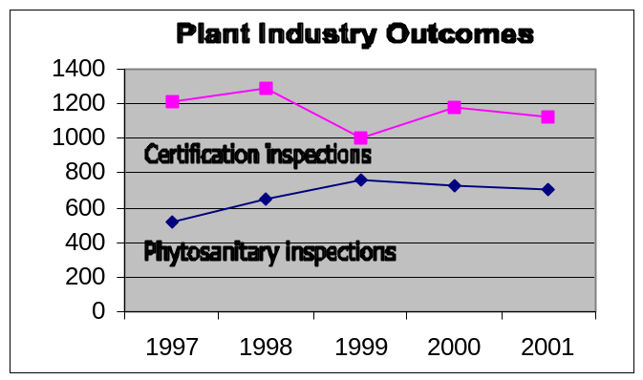

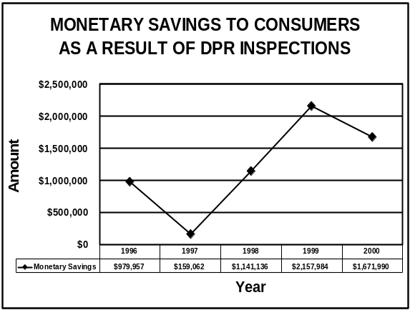

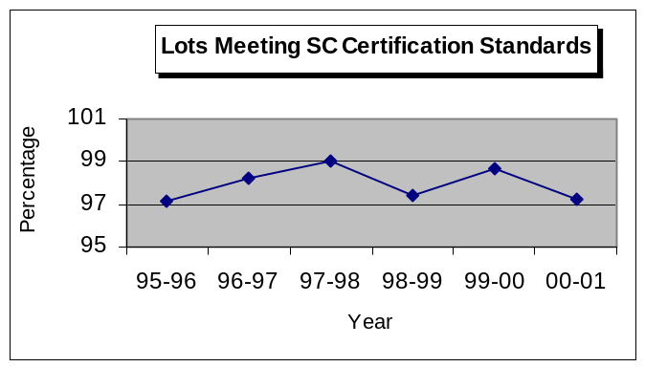

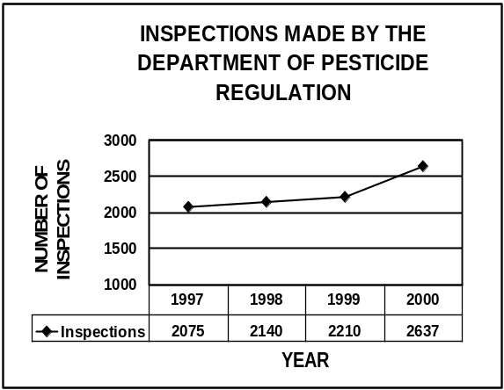

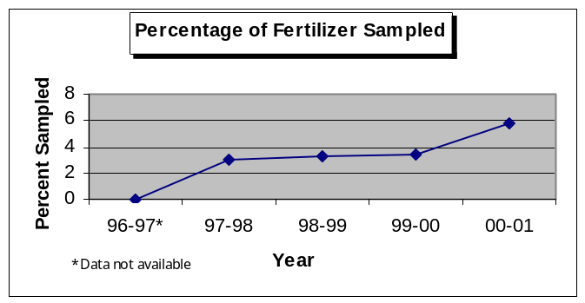

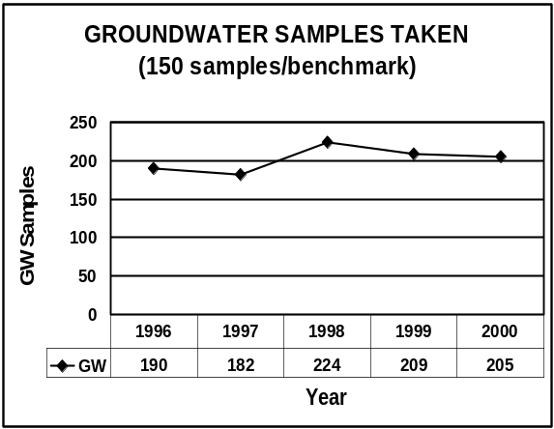

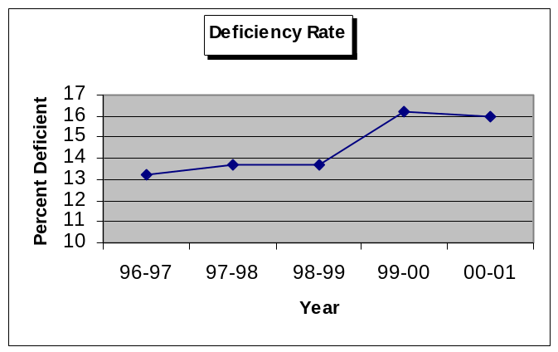

(Graph Series III-4)

(Table III-5)
 | FY 2001 Type of Measure | FY 2001Output
1 | The percentage of fertilizer lots sampled that are found to be deficient in nutrient content. Benchmark: Maintain deficiency rate of less than 20% . Result: In 2000-01, 16.0% of samples analyzed were found to be deficient. $75,143.43 refunded by fertilizer manufacturers for deficient fertilizer materials. | 2412 samples  16.0% deficiency rate
2 | The amount of fertilizer sampled as a percentage of the total fertilizer sold in SC. Benchmark: Sample at least 5% of the total tonnage sold. Result: In 2000-01, 5.81% of the total fertilizer tonnage sold was sampled | 5.81% of total tonnage sold was sampled
3 | Acres of seed production inspected for certification, and percentage of seed lots inspected that meet purity standards in laboratory tests. Benchmark: Maintain a minimum of 95 % of all seed lots inspected meeting SC Certification standards for purity. Result: In 2000-01 97.20% of seed lots inspected met SC Standards, resulting in increased productivity and profitability of crops produced from Certified seed. | 8516.2 Acres inspected  97.20% Lots met SC purity standards
4 | The number of inspections required in addition to certification inspections conducted to certify plant/commodity shipments (transplants, nursery stock, seed, lumber) intrastate, interstate, and globally. Benchmark: Respond to phytosanitary requests within a weeks’ timeframe and maintain an acceptance rate above 94%. Result: This certification fulfills certification requirements for shipment of these materials. Shipments enhance the marketing and profitability of SC agricultural business. No rejections from foreign counties of 172 federal phytosanitary certificates issued in FY 2001. | 702
5 | The number of inspections conducted of commercial greenhouses, nurseries, dealers, turf/sod farms and vegetable transplant producers for insect and disease detection. Benchmark: Conduct one inspection annually of each licensed nursery. Achieve a 95% compliance rate of nurseries meeting inspection criteria. Result: Plant material shipped and sold in SC and nationally is free of insects and disease. This enhances the horticultural industries (2nd in cash receipts in SC) productivity and provides credibility to the industry and other states of our program. | 1123 inspections  compliance rate 97.8%
6 | Invasive species surveys were conducted to detect/determine the presence of Plum Pox Virus disease in SC peach orchards and Tropical Soda Apple (invasive weed) in the state. Benchmark: Collect 5,000 peach leaf samples for analysis and survey TSA infested sites every six weeks from June 15th to killing frost to prevent mature fruit production. Result: No Plum Pox Virus found in SC’s $40 million peach industry. Allows continued shipment of peach fruit and budwood to other states and foreign counties. No TSA plants produced mature fruit at current infested sites. TSA populations are being reduced saving cattlemen and landowners thousands of dollars in production loses and control costs. | 5,862 peach leaf samples collected  2,449 TSA plants found and destroyed 2000
7 | The number of inspections conducted to assure proper pesticide use. Result: The environment and human health is protected from pesticide use. Agricultural productivity is enhanced due to continued availability of pesticides, which allow commodities production. Cancellation of those pesticides by the EPA would occur if not adequately regulated and used according to label directions. | 2,637 inspections  compliance rate varies by type of inspection
8 | The number of pounds of pesticide containers recycled. Result: Each container recycled is one less container that ends up by the roadside or in a landfill. Mature program, consistently exceeds the 150,000 container benchmark. | 200,000 containers
9 | The number of groundwater samples procured and analyzed for pesticide and nitrite contamination. Result: Less than 4% of groundwater samples are contaminated with pesticides. This regulatory and monitoring program protects SC residents’ health. Program consistently exceeds the 150 samples per year benchmark. | 205
10 | Monetary savings of consumers where the Department of Pesticide Regulation investigated structural pest control activities. | $1,671,990

F. Agriculture and Forestry Research

Specific Accomplishments
- Management of more than 300 Agriculture & Forestry research projects
- Assigned 84 technical contribution numbers
- Finalized Monsanto/Roundup Ready® soybean agreement
- Led the formal response to the AAALAC accreditation process
- Responded to on-site review by Office of Laboratory Animal Welfare/NIH
- Established a policy for private animals on CU property
- Gave leadership to development of the DNA Learning Center proposal (Initiative for Future Agriculture and Food Systems/CSREES,USDA)
- Brought key new scientists to the Genomics Institute
- Published CAST Issue Paper No. 18, “The Professional Portfolio: Beyond the Curriculum Vitae”. http://www.cast-science.org/pubs/portfolio.pdf
- Supported the Land & Legacy initiative
- Provided continued support and consultation to Palmetto 2030
- Set up collaboration sessions with Sonoco at the President’s request
- Collaborated on the USDA Plan of Work with Extension Service
- Negotiated 12 Clemson University Research & Extension (CURE) areas with Extension Service
- Coordinated and sponsored a training session on safety issues for agriculture and forestry workers
- Continued support of South Carolina Botanical Gardens
- Support for peach integrated pest management and Memorandum of Agreement with the University of Georgia, to include hiring of an IPM technician http://www.scda.state.sc.us/scpeachc.html
- Set up economic development collaboration session on biotechnology with the Greenville Chamber of Commerce
- Established a new set of management guidelines for research greenhouses
- Organized Search & Screening Committee for Unit Leader of US Geological Survey/ SC Coop. Unit
- Eco-Informa 2001 Conference, Argonne, IL. Co-chaired and organized session on “Responding to the Global Food Crisis”. Co-chair was Leslie Dornfeld, M.D. at UCLA. Argonne Laboratory and US Department of Energy sponsored Eco-Informa 2001. http://eco-informa.ead.anl.gov/
- Worked to build consensus and prepare draft documents to support organizational changes, to include draft job descriptions for the Program Director/Associate Dean concept
- Supported Sandhill REC planning process
- Supported the CUAIMS concept and unit. Discussions with faculty in departments of AVS, Horticulture, Environmental Toxicology, Entomology to promote CUAIMS
- Launched a new web page for Agriculture and Forestry Research
- Participated in multiple initiatives related to the biobased economy concept
- Wade Stackhouse Fellowship – 25 fellowships, $7,000 each, awarded for 2001-2002

AFR Patents Issued in 2000:
Composition and method for treating acne - Susan Barefoot
Method for treating male sterility to produce hybrid seed - Billy Rhodes

Patents and Licenses at Clemson University for Past Three Years – Total Received:
Fiscal Year | Disclosures |  | US Applications |  | US Patents
Fiscal Year | Received | AFR | Filed | AFR | Issued | AFR
1998 | 17 | 7 | 4 | 3 | 4 | 1
1999 | 29 | 7 | 7 | 1 | 4 | 3
2000 | 17 | 4 | 15 | 2 | 2 | 2
Projected 2001
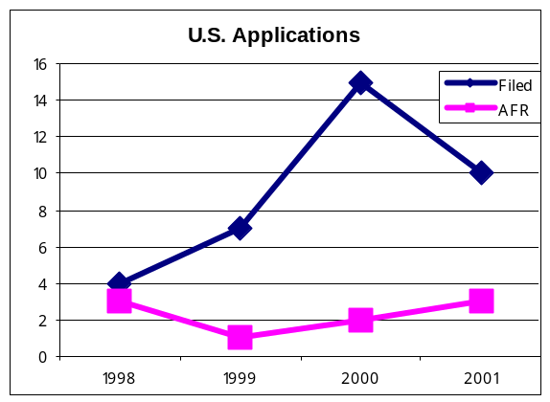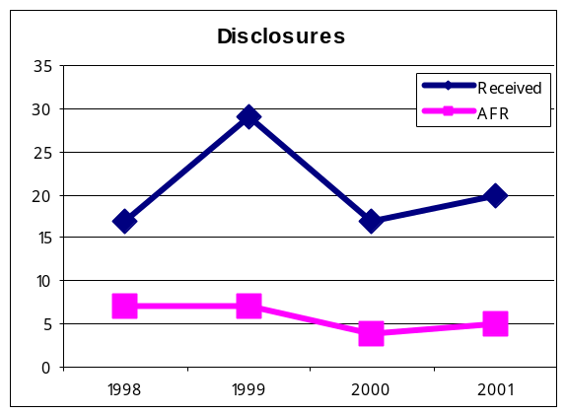

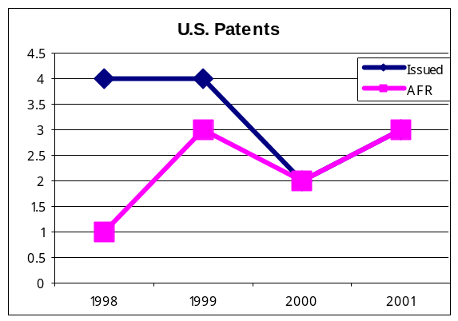

(Graph Series III-5)

G. Institute on Family and Neighborhood Life (IFNL)
During the last fiscal year, IFNL developed research, service, and evaluation programs related to poverty, juvenile delinquency, child abuse and neglect, teen pregnancy, crime prevention, children’s mental health, and youth suicide and violence prevention. To implement these programs, IFNL partnered with schools, courts, social service agencies, non-profit organizations, and grassroots groups at the local, state, national and international levels. To fund activities, IFNL generated contracts and grants from private foundations, state and federal agencies totaling $2,292,264.

To diffuse knowledge, IFNL has published approximately 50 articles, chapters, and books. Additionally, IFNL constructed and maintains its own website as well separate websites for the South Carolina Center for Grassroots Leadership and Non-profit Organizations and the National Center for Rural Justice and Crime Prevention. Through radio, IFNL produced 14 segments of “Your Day,” a public service radio show broadcast throughout the state. Regarding the broadcast media, IFNL conducted distance learning events and developed a teleconferencing network for nonprofit organizations and voluntary associations. Finally, on more personal scale, technical assistance was delivered to interested parties across the state on a variety of topics related to youth and family services (e.g., The S.C. Center on Grassroots and Nonprofit Leadership identified 40 Resource Associates and established 22 partnerships to diffuse knowledge).

Internationally, IFNL’s leadership position within Childwatch International furthered initiatives on (a) the effects of global economic and political change on children, (b) the use of child research by international organizations, (c) children’s participation in community settings, and (d) the expansion of child research institutions in developing and transitional societies.

