Offshore Drilling Ad Hoc Committee

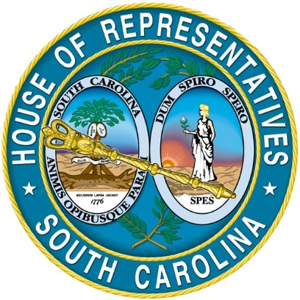

Report to the Speaker of the House

Table of Contents

Chairman’s Letter………………………………………………………………...................3
Committee Membership……………………………………………………………...……….4
Introduction………………………………………………………………………………..…...6
Background………………………………………………………………………………..…….7
Map of the Outer Continental Shelf Boundaries………………………………….…..10
Documents from Public Testimony
- David Whitaker, SC DNR……………………………………………………..…….11

- DNR Letter to BOEM…………………………………………………………………14

- DHEC Presentation…………………………………………………………………..21

- Brydon Ross (Consumer Energy Alliance)………………………………………26

- Professor Knapp (School of Earth, Ocean & Environment)…………….……30

- Ms. Peg Howell (Spokesperson for SODA)…………………………………….…45

- OCEANA…………………………………………………………………...……………61

- South Carolina Beach Advocate………………………………………………..…64

Pending House Legislation………………………………………………………..………..65
Conclusion……………………………………………………………………………..………66
References………………………………………………………………………………..…….67

South Carolina House of Representatives Offshore Drilling Ad Hoc Committee

Letter from the Chairman

February 9, 2018

Dear Speaker James H. Lucas and Members of the South Carolina House of Representatives:

On behalf of the Ad Hoc Committee members, I am pleased to enclose the final report containing the findings of the Offshore Drilling Ad Hoc Committee.

Our report reflects four months of studying and public testimony and fulfills the mission set out by Speaker Lucas to gain knowledge on a topic that could potentially have a great impact on the state of South Carolina.

Public comment was invited, both for individuals wishing to address the ad hoc committee in person, as well as those desiring to submit electronic communication. Over 30 people testified before the committee during the last hearing.

Additionally, invitations were extended to elected officials, on the coast, for their public or written testimony.

The following pages represent the work of the ad hoc committee. The diligence and enthusiasm of the ad hoc committee make me proudly say that it was a privilege to not only serve with the committee but to also be a part of a learning experience that we all shared. When you are faced with potential legislation on a topic that is foreign to most but passionate to all, it is important to work with experts who are there to educate you through the entire process but to also listen to the people who could potentially be impacted by any change. I truly believe we accomplished just that. We are more educated on the offshore drilling process and I believe our investment of time was well spent.

______________________________
Representative Bill Hixon, Chairman
Committee Membership

Representative Bill Hixon (District 83 - Aiken and Edgefield) has serve in the House of Representatives since 2011. Chairman David Hiott appointed him to serve as the Offshore Drilling Ad Hoc Committee Chair. Representative Hixon serves as the Agriculture, Natural Resources, and Environmental Affairs 2nd Vice Chair and the Wildlife Subcommittee Chairman. He also serves on the House Legislative Oversight Committee.
Representative Mike Burns (District 17 - Greenville) has served in the House of Representatives since 2013. He serves on both the House Agriculture, Natural Resources and Environmental Affairs Committee and the House Regulations and Administrative Procedures Committee. In addition to serving the Offshore Drilling Ad Hoc Committee he also serves on the Environmental Affairs Subcommittee.
Representative Bill Chumley (District 35 - Greenville/Spartanburg) has served in the House of Representatives since 2011. He serves on both the House Agriculture, Natural Resources and Environmental Affairs Committee and the House Regulations and Administrative Procedures Committee. In addition to serving the Offshore Drilling Ad Hoc Committee he also serves on the Agriculture Subcommittee.

Representative Sylleste Davis (District 100 - Berkeley) has served in the House of Representatives since 2016. Before her reappointment to the Judiciary Committee (November 20, 2017), Representative Davis served on the House Agriculture, Natural Resources, and Environmental Affairs Committee. She formerly served on the Environmental Affairs Subcommittee.
Representative Chandra Dillard (District 23 - Greenville) has served in the House of Representatives since 2009. Prior to her service in the House of Representatives she served on the Greenville City Council from 1999 to 2008. Representative Dillard is the Subcommittee Chairlady of the Environmental Affairs Subcommittee while also serving on the Offshore Drilling Ad Hoc Committee. She is the Secretary of the Ethics Committee, and also serves on the Legislative Oversight Committee.
Representative Lee Hewitt (District 108- Charleston-Georgetown) has served in the House of Representatives since 2017. Prior to his service in the House of Representatives he served on the Georgetown County Zoning Board of Appeals from 2006-2012. Representative Hewitt serves on the Environmental Affairs Subcommittee.

Representative Roger Kirby (District 61 - Florence/Marion) has served in the House of Representatives since 2014. He serves on both the House Agriculture, Natural Resources and Environmental Affairs Committee and the Rules Committee. In addition to serving the Offshore Drilling Ad Hoc Committee he also serves on the Wildlife Subcommittee.
Representative Steve Moss (District 30 - Cherokee/York) has served in the House of Representatives since 2009. Prior to his service in the House he served on the Cherokee County School Board from 1990 to 1994. In addition to the Offshore Drilling Ad Hoc Committee, Representative Moss is the Agriculture Subcommittee Chair and also the 1st Vice Chair of the Agriculture, Natural Resources, and Environmental Affairs Committee. He also serves on the Interstate Cooperation Committee.
Representative Russell Ott (District 93 - Calhoun/Lexington/Orangeburg) has served in the House of Representatives since October 29, 2013. He is the former Town Administrator for Elloree, North, and Neeses, South Carolina. In addition to serving on the Offshore Drilling Ad Hoc Committee, as well as the Agriculture Subcommittee, Representative Ott also serves as the Assistant Minority Leader.

Introduction

On May 23, 2017, Speaker James H. Lucas requested Representative David Hiott, Chairman of the House Agriculture, Natural Resources and Environmental Affairs Committee set up an Offshore Drilling Ad Hoc Committee. The Committee is comprised of nine members from the Agriculture, Natural Resources and Environmental Affairs Full Committee. Representative Hiott named Representative Bill Hixon to serve as the Offshore Drilling Ad Hoc Committee Chairman.
The Committee held three meetings during a four month period. The inaugural meeting was held on Tuesday, August 22, 2017 and two subsequent meetings were held on October 26, 2017 and November 28, 2017.
While mindful of what the ad hoc committee was tasked to do, the ad hoc committee felt it was their responsibility and due diligence to hear from all affected parties, including public input.
Proper and adequate notification was given of all the meetings. The meeting notices were posted on scstatehouse.gov and all of the meetings were televised and are currently archived on scstatehouse.gov/video/archives.
The ad hoc committee heard from the following:
- Representatives from Bureau of Ocean Energy Management (BOEM): Perry Boudreaux, John Johnson and Davie Nguyen
- Dr. James Knapp, Professor in the Department of Earth and Ocean Sciences at the University of South Carolina
- Brydon Ross, Consumer Energy Alliance
- David Whitaker, SC Department of Natural Resources (DNR)
- Elizabeth von Kolnitz, SC Department of Health and Environmental Control (DHEC)
- Margret “Peg” Howell, Stop Offshore Drilling in the Atlantic (SODA)
- Frank Knapp, Jr., SC Small Business Chamber of Commerce
- Bonnie Loomis, American Petroleum Institute
- Mayor Tim Goodwin, City of Folly Beach
- Mayor Billy Keyserling, City of Beaufort
- Mayor Tecklenburg, City of Charleston
- Mark Lazarus, Horry County Council
- Al Joseph, Georgetown City Council
- Mike Seekings, Charleston City Council
- John Thomas, Georgetown County Council
- Senator Stephen Goldfinch, Charleston, Georgetown, and Horry Counties
- Representatives from OCEANA
- Stephen Gilchrist, SC African American Chamber
- Rich Bolen, Vets 4 Energy
- Public Testimony

Background

ORDER NO. 3350

Subject: America-First Offshore Energy Strategy

Sec. 1 Purpose. This Order further implements the President’s Executive Order entitled:“Implementing an America-First Offshore Energy Strategy” (April 28, 2017); enhances opportunities for energy exploration, leasing, and development on the Outer Continental Shelf (OCS); establishes regulatory certainty for OCS activities; and enhances conservation stewardship, thereby providing jobs, energy security, and revenue for the American people.

Sec. 2 Authorities. This Order is issued under the authority of Section 2 of Reorganization Plan No. 3 of 1950 (64 Stat. 1262), as amended, and other applicable authorities, including the Outer Continental Shelf Lands Act (OCSLA), 43 U.S.C. 1331 et seq.

Sec. 3 Background. Safe and responsible development of our offshore natural resources is critical to the Nation’s environment and economy. The Bureau of Ocean Energy Management (BOEM) is responsible for administering the leasing program for oil and gas resources on the OCS and developing a five-year schedule of lease sales designed to “best meet national energy needs” for the five-year period following the schedule’s approval, as required in Section 18 of the OCSLA, 43 U.S.C. 1334. The BOEM also permits seismic surveys on the OCS and, in conjunction with the Bureau of Safety and Environmental Enforcement (BSEE), regulates leasing, exploration, and development activities on the OCS. In January 2017 the 2017 - 2022 Outer Continental Shelf Oil and Gas Leasing Program was approved excluding lease sales in the Atlantic Ocean and the Beaufort and Chukchi Seas offshore Alaska. By excluding these areas from the leasing program, the Department has forgone considering areas that potentially contain tens of billions of barrels of oil and over 100 trillion cubic feet of gas by BOEM’s own estimates of undiscovered technically recoverable oil and gas resources. In addition, through a series of Presidential Memoranda issued by the
previous Administration, huge swaths of the OCS were withdrawn from disposition by leasing along the Alaska and Atlantic coasts. In addition to existing restrictions on OCS leasing, concerns have been raised by stakeholders that certain final or proposed rules, such as BSEE’s final rule on “Oil and Gas and Sulfur Operations in the Outer Continental Shelf-Blowout Preventer Systems and Well Control” published at 81 Federal Register 25887 (April 29, 2016), unnecessarily include prescriptive measures that are not needed to ensure safe and responsible development of our OCS resources. Accordingly, a reevaluation of these rules is appropriate and necessary. On April 28, 2017, the President issued an Executive Order entitled: “Implementing an America-First Offshore Energy Strategy (Executive Order),” which reconfirmed that it is “the policy of the United States to encourage energy exploration and production, including on the Outer Continental Shelf, in order to maintain the Nation’s position as a global energy leader and foster energy security and resilience for the benefit of the American people.” The Executive Order eliminated the previous Administration’s OCS leasing withdrawals and directed the Department to take a number of actions designed to ensure robust and responsible exploration and development of our OCS resources. These directives include revising the five-year leasing program and reconsidering promulgation of enumerated final or proposed rules and guidance that impact OCS resource development. This Order is designed to implement the President’s directives and take other actions to ensure that responsible OCS exploration and development is promoted and not unnecessarily delayed or inhibited.

Sec. 4 Directive. In furtherance of the President’s Executive Order, and consistent with
principles of responsible public stewardship entrusted to the Department, with due
consideration of the critical importance of energy security, job creation, and conservation stewardship, I hereby direct the following:
a. The BOEM shall undertake the following actions:

(1) Immediately initiate development of a new “Five-Year Outer Continental
Shelf Oil and Gas Leasing Program”, with full consideration given to leasing the OCS offshore Alaska, Mid-Atlantic, South Atlantic, and the Gulf of Mexico, in conformity with the provisions of OCSLA as directed by the President’s Executive Order.

(2) In cooperation with the National Marine Fisheries Service, undertake the following activities:
(i) establish a plan to expedite consideration of Incidental Take
Authorization requests, including Incidental Harassment Authorizations and Letters of
Authorization, that may be needed for seismic survey permits and other OCS activities; and
(ii) develop and implement a streamlined permitting approach for privately-funded seismic data research and collection aimed at expeditiously determining the offshore energy resource potential of the United States.
(3) Expedite consideration of appealed, new, or resubmitted seismic
permitting applications for the Atlantic.
(4) Promptly complete BOEM’s previously announced review of Notice to
Lessees (NTL) No. 2016-N01 “Notice to Lessees and Operators of Federal Oil and Gas, and Sulfur Leases, and Holders of Pipeline Right-of-Way and Right-of-Use and Easement Grants in the Outer Continental Shelf” (September 12, 2016), and provide to the Assistant Secretary – Land and Minerals Management (ASLM), the Deputy Secretary, and Counselor to the Secretary for Energy Policy, a report describing the results of the review and options for revising or rescinding NTL No. 2016-N01. The BOEM’s previously announced extension of the implementation timelines for NTL No. 2016-N01 shall remain in effect pending completion of the review by the ASLM, Deputy Secretary, and the Counselor to the Secretar for Energy Policy, a report describing the results of the review and options for revising or rescinding NTL No. 2016-N01. The BOEM’s previously announced extension of the implementation timelines for NTL No. 2016-N01 shall remain in effect pending completion of the review by the ASLM, Deputy Secretary, and the Counselor to the Secretary for Energy Policy.
(5) Immediately cease all activities to promulgate the “Offshore Air Quality
Control, Reporting, and Compliance” Proposed Rule published at 81 Federal Register 19717 3 (April 5, 2016) and all other rules and guidance published pursuant thereto. Within 21 days of the issuance of this Order, the Director of BOEM shall provide to the ASLM, the Deputy Secretary, and Counselor to the Secretary for Energy Policy, a report explaining the effects, if any, of not issuing a new rule addressing offshore air quality, and providing options for revising or withdrawing the proposed rule consistent with the policy set forth in section 2 of the Executive Order.
(6) Within 21 days of the issuance of this Order, BOEM shall provide to the
ASLM, the Deputy Secretary, and Counselor to the Secretary for Energy Policy, a report summarizing progress on the action items 1-5 above.
b. The BSEE shall undertake the following actions:
(1) Promptly review the final rule on “Oil and Gas and Sulfur Operations in
the Outer Continental Shelf-Blowout Preventer Systems and Well Control” for consistency with the policy set forth in section 2 of the Executive Order, as well as all policies, rules,guidance, instructions, notices, or other implementing actions that have been adopted or are in the process of being developed relating thereto.
(2) Within 21 days of the issuance of this Order, provide to ASLM, Deputy
Secretary, and Counselor to the Secretary for Energy Policy a report summarizing the review and providing recommendations on whether to suspend, revise, or rescind the rule.
c. The BSEE and BOEM are also to undertake the following action: Promptly
review the final rule entitled “Oil and Gas and Sulfur Operations on the Outer Continental Shelf—Requirements for Exploratory Drilling on the Arctic Outer Continental Shelf,” 81 Federal Register 46478 (July 15, 2016), for consistency with the policy set forth in section 2 of the Executive Order and, within 21 days of the date of this Order, provide to ASLM, Deputy Secretary, and Counselor to the Secretary for Energy Policy a report summarizing the review and providing recommendations on whether to suspend, revise, or rescind the rule.
d. The Counselor to the Secretary for Energy Policy, in cooperation with the
Assistant Secretary for Fish and Wildlife and Parks (ASFWP) and ASLM, shall work with the Department of Commerce to review the National Marine Sanctuary and Monument
designations as directed by the Executive Order.

Sec. 5 Counselor to the Secretary for Energy Policy. To further promote the deliberate and active coordination of energy policy in the Department, I am, by separate Order, establishing within the Secretary’s Immediate Office the position of Counselor to the Secretary for Energy Policy. The Deputy Secretary, ASLM, and ASFWP will coordinate with the Counselor to the Secretary for Energy Policy in implementing this Order.

Sec. 6 Effect of Order. This Order is intended to improve the internal management of the Department. This Order and any resulting reports or recommendations are not intended to, and do not create any right or benefit, substantive or procedural, enforceable at law or equity by a
party against the United States, its departments, agencies, instrumentalities or entities, its 4 officers or employees, or any other person. To the extent there is any inconsistency between the provisions of this Order and any Federal laws or regulations, the laws or regulations will control. ^{i}

Map of the Outer Continental Shelf Boundaries
Provided by BOEM
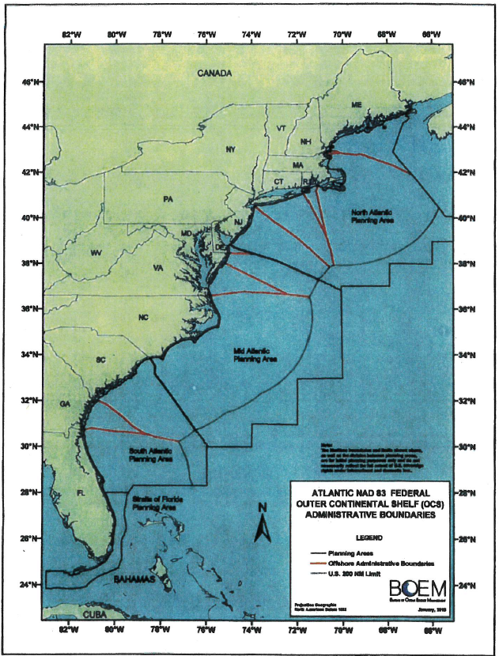

Written Testimony By: David Whitaker, DNR

Testimony to Offshore Drilling Ad Hoc Committee

24 October 2017

David Whitaker, Asst. Dep. Director, SC DNR, Marine Resources Division

Good morning Mr. Chairman and committee members. Thank you for the opportunity to speak to you today. I am David Whitaker, Asst. Dep. Director for DNR with the Marine Division. Today I will give a brief statement on potential impacts on marine animals and their habitats related to the effects of offshore exploration and drilling for oil and gas.

I would like to begin by saying that assessments of risks related to oil exploration and drilling is something we have no experience with, so we are largely dependent upon what has been learned from the Gulf of Mexico and other places. We have, however, had some significant oil spills in South Carolina, albeit relatively minor compared to the Deepwater Horizon spill. The most recent spill was
when a merchant ship accidentally discharged about 12,5OO gallons of #6 fuel oil into Charleston Harbor
in 2002. That spill resulted in oil on about 30 linear miles of shoreline including: tidal flats, fringing marshes, intertidal oyster reefs, sandy beaches and man-made structures (i.e., docks, piers, bulkheads). The oil spill also resulted in the oiling of about 175 seabirds including brown pelicans, black skimmers, terns, gulls, and wading birds, as well as resulting in a shellfish bed closure, and a temporary disruption to recreational shrimp baiting fishery.

As I said earlier, we cannot provide you with a quantitative risk analysis of oil exploration and drilling off
South Carolina, but we can provide information of resources that could potentially be impacted.
The first potential impact is related to seismic surveys used to locate oil reserves. This involves towing an air gun at about S knots with an initial sound pulse of about 230 dB. Just for reference, audible sound exists only up to 194 dB and above that it is considered a shock wave. In 328 feet of water, this signal would result in 190 dB at the bottom. For reference, a 12 gauge shotgun is 165 dB and a jet engine at
100 feet is 140 dB. Given the towing speed and a 5-second frequency of sound blasts, a stationary animal on the bottom would be exposed to many blasts. Many marine animals are sensitive to sound­ using it for communication, attracting mates, and hunting prey. Fast swimming animals that are
typically in the water column could likely flee the testing area, but we think reef dwelling species would likely dive into their habitat and stay put. We know from scientific literature, that some fish do appear to suffer damage, albeit much of it appears to be of short term effect. A recent Australian study found that tiny planktonic animals are injured or killed by air guns and these effects were observed up to 3/4
of a mile away.1 A recent review paper of all the known literature on the impact of seismic testing, said
basically that although there is evidence that some animals are definitely negatively affected, but too little is known to predict the magnitude or extent of the effects on fishes and invertebrates. 2

Should potential oil deposits be found off South Carolina, the actual drilling process would presumably have a relatively minor footprint in terms of impacting bottom habitat, although cuttings (or ground up rock from the drilling process) may accumulate around the drill head at a radius of 160 to 500ft and
may have ecological impacts up to 1000 feet away.3 Should there be a blowout of a well at depth, such
as happened in the Gulf of Mexico, then there could be immediate impacts upon habitat and animals in the area. The great majority of the oil from a blowout would rise to the surface where surface dwelling animals would be most affected. However, research has shown that some portions of the oil would remain present in the water column and can persist for some time. Some of these chemicals, at very low concentrations, have been shown to cause mortalities or damage fish eggs and larvae. Laboratory research has shown that larval fish exposed to very low concentrations of oil from the Deepwater Horizon spill for just 48 hours had reduced swimming speeds when they reached their juvenile stage thus increasing their susceptibility to predators.•

Localized damage to fishery resources would be greatest on the continental shelf which includes depths down to 490 ft and out to about 50 miles offshore. The shelf has locations we call live bottom areas characterized by rocky outcrops where soft and hard corals, sea fans, sponges and other similar fauna are abundant. These areas attract and hold important fishery species like snappers, groupers and black sea bass. Between these live bottom areas are expanses of sandy bottom which typically have much sparser concentrations of animals although species such as rock shrimp, scallops and adult flounder can be present in high numbers.

Further offshore is the continental slope with depths ranging from 490 to 9,800 feet and is about 50 to
68 miles offshore. These areas have relatively fewer fishery species although some species such as golden crab, snowy grouper, wreck fish and tilefish can be found here, often living in holes or near ledges. Ecologically important deep water corals are found on the slope (1,200- 2,600 feet). These provide habitat for many species. Also, large schools of squid are also known to be in these areas. Farther offshore, on the deeper abyssal plain, I am not aware of any bottom-living commercially important fishery resources there.

Animals of commercial and recreational significance that can be found in the water column include cobia, mackerels, tuna, sharks, billfish, dolphinfish, swordfish, as well as protected animals such as dolphins, whales, and sea turtles. These animals are usually more abundant over the shelf and slope, but may be found in any open waters.

Much of the crude oil from a blowout rises to the surface and becomes an immediate hazard to surface dwelling animals like sea turtles, dolphins and whales which must come to the surface to breath. In doing so they may breathe in oil or ingest it. A significant number of dolphin died as a result of the Deepwater Horizon accident. Surface dwelling sea birds would also be jeopardized when they become coated with surface oil. The animal community associated with the floating seaweed Sargassum would also be impacted by floating oil. This community includes many animals including young dolphinfish
(Mahi Mahi), juvenile sea turtles, and others.

An oil spill can have serious impacts upon coastal natural resources. The degree of impact has a lot to do with how far offshore the spill might be. Crude oil usually begins decomposing as soon as it is released. The closer to shore the spill is the greater the likelihood that the oil would be more toxic and cause more problems. If it reaches shore in its raw form or in an emulsified form, it will harm beach life including coastal birds and sea turtle nests. If the oil makes its way by water currents into the bays and sounds, which is highly likely given our large tides and strong tidal currents, or is spilled from a transport ship or barge inside the estuary, it can seriously impact our saltmarsh which is the nursery habitat for
our most valuable fishery species including shrimp, crabs, oysters, clams, red drum, flounder and others.

If a spill is well offshore, oil would likely be entrained in the Gulf Stream and carried rather quickly in a northeasterly direction. However, as the Gulf Stream passes Cape Hatteras it begins meandering and often forms large eddies the break off and move towards the shore, some even looping around to return
to South Carolina and Georgia.

Along with offshore drilling comes the construction of shore-based infrastructure such as docks, buildings and roadways. Studies have shown that when more than 30% of a tidal creek's watershed is comprised of hard impermeable surfaces, the creek will be negatively impacted resulting in poor water quality and fewer living resources.

Should pipelines be laid through our coastal marshes, we would lose essential functions of any channelized saltmarsh. The experience in the Gulf has shown us that this infrastructure-associated modifications have resulted in substantial loss of wetlands. There would also be effects of greatly increased industry-associated boat traffic. This could likely increase an already significant number of injuries and mortalities of sea turtles caused by propeller strikes.

Thank for giving me an opportunity to speak to you.

Associated Scientific Literature

1. Widely used marine seismic survey air gun operations negatively impact zooplankton. June
2017. Nature- ecology & evolution. Vall. Article Number 0195. By R. McCauley et al.
2. A critical review of the potential impacts of marine seismic surveys on fish & invertebrates.
2017. Marine Pollution Bulletin. 114: 9-24. A. Carrol et al. Geoscience, Australia.
3. Environmental Impacts of the deep-water oil and gas industry: a review to guide management strategies. Frontiers in Environmental Science. Vol. 4, article 58. September
2016, By D. Cordes, et al.
4. Acute embryonic or juvenile exposure to Deepwater Horizon Crude oil impairs the swimming performance of Mahi-Mahi (Coryphaena hippurus) Environmental Science and Technology. 48:7053-7061. By E. Mager et al. Univ. of Miami

Letter Submitted by DNR to BOEM:

April 28, 2015

Dr. Arie Kaller
Supervisor, Biological Sciences Unit
Bureau of Ocean Energy Management
1201 Elmwood Park Blvd. New Orleans, LA 70123

Dear Dr. Kaller:

Thank you for the opportunity to provide comments from the South Carolina Department of Natural Resources (SCDNR), Division of Marine Resources relative to several permit applications currently under consideration by the Bureau of Ocean Energy Management (BOEM) for Geological and Geophysical (G&G) seismic survey work proposed in the BOEM Mid-Atlantic and South Atlantic Plamung Areas. The comments are meant to be of a general nature regarding any proposed use of 2D or 3D airgun survey methodologies that might be employed in the waters off the coast of South Carolina. As such, we would request that these comments be considered germane to all such permit applications under review at thls time or in the near future.

As a wide-ranged, multifaceted, science-based natural resource management agency, the SCDNR clearly understands the importance of acquiring the best possible data in making decisions regarding the wise use and stewardship of all natural resources, both living and non-living, in the waters of the state as well as those located off the coast in adjacent federal waters. The agency is aware of the
current interest in exploration for possible oil and gas resources in the Atlantic Outer Continental Shelf
(OCS) Region off South Carolina, and of the importance of effective G&G seismic surveys in obtaining a clear understanding of what resources may exist in our offshore waters. However, the SCDNR has concems regarding effects of the proposed G&G airgun survey work on various living marine resources in the state's coastal and offshore waters. Of particular concern are both short term and cumulative effects of such activities on marine mammals (including the endangered Nmih Atlantic Right Whale), four species of endangered or threatened sea turtles (see Enclosure 1), several protected finfish species (including Atlantic sturgeon, shortnose sturgeon, smalltooth sawfish, and scalloped hammerhead shark), and a wide range of finfish species associated with extensive areas nearshore and offshore essential fish habitats located withln the proposed survey areas (see Enclosure 3, very hlgh resolution version available upon request).

In reviewing the BOEM Atlantic Geological and Geophysical Activities Programmatic Environmental Impact Statement (PElS) for the Mid- and South Atlantic Plamung Areas, it is apparent that a great deal of attention is given to consideration of possible impacts on endangered and protected marine

mammals and sea turtles, as well as operational considerations for minimizing and mitigating these impact. Even with such operational procedures in place, avoiding these particular resources through temporal or significant geographic separation during periods of peak abundance in South Carolina's offshore and coastal waters would be the best overall approach to ensure that these resources are protected.

The BOEM PElS does a good job of describing important fish resources and associated essential habitats in the waters of the Mid- and South Atlantic Planning Area. It should be noted that this detailed description and understanding of these resources is based significantly on work done over the past four-plus decades by SCDNR personnel, mainly associated with the Marine Resources Monitoring, Assessment, and Prediction program (MARMAP). However, in reviewing the possible impacts of seismic airgun work on these fish in general, the SCDNR disagrees with the PElS assumption that many of the demersal reef fish species located on hard and soft bottom habitats year round would "temporarily move away from noise that is affecting them" (page 4-134) and therefore avoid injury (see Enclosure 2). This particular assumption, which is not well supported in direct observations of species within this area, is central to the PElS conclusion that "impacts from airguns to fisheries resources and EFH would be minor to moderate". SCDNR is concerned that this assumption could contribute to a serious underestimation of the significance of potential sound-related impacts to these resources.

Another assumption in the PElS--that the area of seafloor affected by an individual survey effort when compared to the overall Area of lnterest (AOI) is relatively small and therefore the impacts from survey efforts would likely be minor to moderate--is a bit misleading and potentially inaccurate. Given the relatively small nature and inherent patchiness of some hard bottom reefs in offshore and nearshore waters, even one pass of an average airgun survey run could generate significant harm (physical injury and disturbance) to the resident fish community over much of the area of an individual reef. A single track line could impact multiple patches of hard bottom reef as well as large portions of hard bottom ledge areas. From estimates provided during discussions with BOEM technical staff at public meetings, it has been concluded that a typical 2D survey with an initial sound source of230 dB and a
transect speed of 5 knots over bottom at a depth of 100 m would generate an area of sound at 190 dB or greater (once every 10 to 12 seconds) over a 500 meter swath which could affect individual fish for as long as three minutes at this intense and potentially harmful level of sound. Multiple passes over a period of time from one or more survey companies could have significant cumulative impacts on the long-term health of the overall reef ecosystem.

Given the importance of these hard bottom reef communities to South Carolina's commercial and recreational fisheries, the minimal amount of mapping data available to clearly identity areas of essential fish habitat, and the lack of assurance through a large body of research that G&G seismic survey work will not harm finfish communities associated with these bottoms, the SCDNR would suggest not permitting any survey work within 50 miles of the South Carolina coast line and at depths less than 100 meters, especially in light of the BOEM's stated intent not to issue any future drilling permits with 50 miles of shore. If areas inside of 50 miles from shore or 100 meters in depth were to be surveyed, we would recommend that this only be done with careful coordination of such efforts with knowledgeable state and federal resource management entities such as the SCDNR, the South Atlantic Fishery Management Council, and the National Marine Fishery Service. We would ask that such efforts include, but not be limited to, development of a draft in-situ monitoring plan to be used during test runs in order to determine if there are or are not direct impacts to fisheries resources. At a minimum such a plan would be reviewed and designed in conjunction with the agencies noted above

and the results would be used to employ adaptive management strategies during later testing, particularly if adverse impacts are demonstrated.

The SCDNR greatly appreciates the opportunity to provide these comments on the proposed G&G seismic survey activities under consideration for the Mid-Atlantic and South Atlantic Planning Areas and particularly off the coast of South Carolina. This agency understands the importance of such work in providing an informed assessment of the potential oil and gas resources off of our coast, and as the principal steward of South Carolina's natural resources we want to make sure this work is done in a manner which minimizes risks to the extremely valuable known living natural resources off South Carolina.

We ask that you give full consideration to the above comments as you make any determinations on the issuance of permits to perform this work. We will be more than happy to work with BOEM or any entities permitted for survey work in providing additional advice on how best to minimalize impacts to our living marine resources. If you have any questions concerning these comments please contact me at (843) 953-9304 or Mel Bell at (843) 953-9007.

Sincerely,

Robert H. Boyles, Jr.
Deputy Director for Marine Resources

Enclosures:
(1) SCDNR Staff Input on Marine Turtles
(2) SCDNR Staff Input on Possible Sonic Impacts on Fish
(3) SAFMC Map Related to SC Coastal/Offshore Resources

cc: Glenn McFadden, Chairman, SCDNR Board
Alvin Taylor, Director, SCDNR
Bob Peny, Director, Office of Environmental Programs, SCDNR
Ken Rentiers, Deputy Director, Land, Water, & Conservation Districts, SCDNR Curtis Joyner, Manager, Coastal Zone Consistency Section, SCDHEC

Enclosure (I)

SCDNR-MRD Staff Comments on South Carolina Sea Turtles

Four species of federally and state protected endangered or threatened sea turtles occur in South Carolina waters; green (Chelonia mydas), kemps ridley (Lepidochelys kempii), leatherback (Dermochelys coriacea) and loggerhead (Caretta caretta).

Loggerhead sea turtle:
The loggerhead was federally listed worldwide as a threatened species on July 28, 1978 (43 FR
32800). On September 22, 2011, the single threatened species of loggerhead sea turtle was revised to nine distinct populations segments (DPSs) including the Northwest Atlantic Ocean DPS, one of four globally-declared "threatened" populations. This determination was based on genetics, tagging, satellite telemetry, demographics, and oceanographic features with each segment listed as either endangered or threatened. Within the Northwest Atlantic DPS there are five identified recovery units. Loggerhead turtles nesting in southern VA, NC, SC and GA are part of the Northern Recovery Unit (NRU). The nesting trend from daily beach surveys indicate nest numbers in the NRU declined significantly at 1.3 percent annually from 1983 to 2007 (NMFS and USFWS 2008). Nest totals from aerial nest surveys conducted by SCDNR showed a 1.9 percent decline in South Carolina from 1980-
2007(NMFS and USFWS 2008). Currently, the nesting data for the NRU show possible signs of a stabilizing trend.

Adult female loggerheads inhabit South Carolina coastal waters during the nesting season, from April to early September and nest up to an average of 4.1 times a season. During the inter-nesting period, the turtles remain inactive while they prepare for the next nesting cycle (ovulate and shell eggs, return to nesting beach). The average inter-nesting period is 14 days. After nesting, females migrate to foraging areas both north and south of their nesting beaches. Studies involving satellite telemetry, flipper tagging, and isotopic research indicate that most loggerheads from the NRU migrate to foraging grounds along continental shelf from Cape Hatteras, NC to New Jersey post-nesting, as do a sizable portion of loggerheads nesting in the Peninsular Florida Recovery Unit (Ceriani et al. 2012).

Due to sea turtles in the NRU being genetically different sub population, they cannot be replaced by others from neighboring recovery units. Nest numbers in South Carolina represent over 65% of the total number of nests for the entire NRU. The Cape Romain National Wildlife Refuge in South Carolina is the highest density nesting beach within the NRU with an annual average of 1,000 or more nests per year. It is considered the most significant Loggerhead nesting beach north of the state of Florida.

Juvenile foraging guild:
Juveniles from various subpopulations that include greens, loggerheads, and kemps mix on foraging grounds, which include estuarine, neritic and continental shelf waters on the eastern seaboard. Juvenile

loggerheads occur in South Carolina nearshore waters on a seasonal basis from early March to early
December (Arendt et at. 2012; NMFS and USFWS 2008).

Leatherback sea turtles:
Leatherbacks are predominately observed in our coastal waters from March - July with a smaller secondary peak in the fall based on stranding and leatherback aerial surveys conducted by SCDNR (Murphy et at 2006). Leatherbacks arrival and departure suggest a northward migration to foraging areas. The main prey, cannonball jellyfish, exhibits a seasonal northward population distribution along the eastern seaboard and leatherback forage on those jellyfish in that northward direction. Nest numbers in South Carolina for this species are low despite the larger numbers present in our coastal waters.

Potential effects of the proposed seismic survey activities in coastal and offshore waters off South Carolina include abandonment of habitat, disruption of mating and nesting attempts, potential vessel strikes, entanglement in debris, ingestion of marine debris and habitat contamination.

The SCDNR Marine Turtle Conservation Program would like a time area closure off the entire South
Carolina coast during the sea turtle season from 1 May- 31 October.

Literature cited:

Arendt MD, Segars AL, Byrd JI, Boynton J, Whitaker JD, Parker L, Owens DW, Blanvillain G, Quattro JM and MA Roberts (2012) Seasonal distribution patterns of juvenile loggerhead sea turtles (Caretta caretta) following capture from a shipping channel in the Northwest Atlantic Ocean. Mar Bio1159(1):127-139.

Murphy, T.M., Sally R. Murphy, DuBose B. Griffin and Charlotte P. Hope. 2006. Recent occurrence, spatial distribution and temporal variability of leatherback turtles (Dermochelys coriacea) in nearshore waters of South Carolina, USA. Chelonian Conservation and Biology 5(2): 216-224.

National Marine Fisheries Service and U.S. Fish and Widlife Service. 2008Recovery Plan for the Northwest Atlantic Population of the Loggerhead Sea Turtle (Caretta caretta), Second Revision. National Marine Fisheries Service, Silver Spring, MD.

Ceriani SA, Roth JD, Evans DR, Weishampel JF, Ehrhart LM (2012) Inferring Foraging Areas of Nesting Loggerhead Turtles Using Satellite Telemetry and Stable Isotopes. PLoS ONE 7(9): e45335. doi:10.1371/journal.pone.0045335Ceriani

Enclosure (I)

SCDNR-MRD Coastal Finfish Research Section Staff Comments on Potential effect of Seismic
Survey Activities on (reef) Fish.

Hearing is an important sense used by marine fishes. Many fish are able to derive significant information about their surrounding environment in addition to sight and other senses. Available published data on lethal and sub lethal effects of acoustic testing/surveys on reef fish are sparse. Depending on the intensity of the sounds blasts, all organs of the fish may be affected, but we expect that the swim bladder, vestibular apparatus (semicircular canal system that includes the otoliths), sound producing structure, and gonad tissues may be particularly vulnerable to damage. In addition, many species (e.g. grunts, groupers) produce sound as part of spawning and social behavior. Sound has been shown to be used by fishes for communication (Myrberg, 1980), navigation, predation, etc. While the majority of fish species can only detect sounds up to 500-1000 Hz, certain species have been shown to exhibit hearing specialization (Mann eta!. 2001). Source level sounds in excess of 230 dB have been recorded for seismic airgun arrays (Cummings, 2003). Ambient sound levels of 131 dB produced by ships alone have been shown to decrease hearing sensitivities up to 40 dB, and reduce the detectability of communication sounds for certain species of marine fishes (Vasconcelos et a!. 2007, Codarin et a!.
2009). Acoustic surveys may affect sound reception and sound production by fish and disrupt behavioral interactions.

We strongly feel that the idea that most fish will swim out of the testing area when loud sound (blasts) approaches is incorrect, even if acoustic activities are "ramped up gradually". It is possible that larger and faster swimming pelagic species may swim out of the impacted area, but it will force them to leave feeding grounds, spawning areas, or other important habitat. This may have deleterious effects on survivability and reproduction for certain species (Engas eta!., 1996). However, based on our general knowledge of fish behavior, as well as our video observations, bottom dwelling and reef species such
as groupers, Gray triggerfish, porgies, flounders, rays, and many others, will not swim away if a potential threat approaches. Reef fishes will hide near available bottom structure, uoder ledges, or in crevices. Species such as flounders, rays, shrimp, etc. will most likely try to hide by burying in the sediment if they can. Fish hiding from potential threats will likely try to stay hidden until they feel the threat is gone. This makes them extremely vulnerable for potentially damaging effects of acoustic surveys. In addition, some published information points at possible effects to larval stages. Many reef fish species undergo larval development offshore before settling on reefs that they will inhabit for the rest of their lives (McCormick 2002). Research by Tolimieri eta!. (2002) shows that these larval fish use sounds to find these reefs, and that intense offshore sounds may mask reef sounds, preventing larval fish from finding suitable reef habitat.

Given its long history with monitoring reef fish populations, including the current use of video cameras on the gear, MRRI's Reef Fish Survey (MARMAP and SEAMAP-SA) could play a significant role in investigating and monitoring the effect of this testing. We can observe fish in and around chevron traps during testing, and examining pathology of fish after testing is completed. Furthermore, our extensive long-term data-set can provide information as to the location of live-bottom and other habitat, and species composition and abundance in those habitats.

Codarin A, Wysocki LE, Ladich F, PicciulinM(2009) Effects of ambient and boat noise on hearing and communication in three fish species living in a marine protected area (Miramare, Italy). Mar Pollut Bul/58:1880--1887.

Engas, A.S., Lokkeborg, E. Ona, and A.V.Soldal. 1996. Effects of seismic shooting on local abundance and catch rates of cod (Gadus morhua) and haddock (Melanogrammus aeglefinus). Bioacoustics, 12: 313-315.

Mann, D.A., Higgs, D.M., Tavolga, W.N., Souza, M.J., and A.N. Popper. 2001. Ultrasound detection by clupeiform fishes. Journal of the Acoustical Society of America, 109: 3048-3054.

Myrberg, A.A., Jr. 1980. Ocean noise and the behavior of marine animals Bioacoustics, 12: 313-315. Popper, A.N. 2002. Effects of Anthropogenic Sounds on Fishes. Fisheries, 28(10): 24-31.
Tolimieri, N., O.Haine, J.C. Montgomery and A. Jeffs. 2002. Ambient sound as a navigational cue for larval reef fish. Bioacoustics, 12: 214-217.

Vasconcelos RO, Fonseca PJ, Amorim MCP, Ladich F. 2011. Representation of complex vocalizations in the Lusitanian toadfish auditory system: evidence of fine temporal, frequency and amplitude discrimination. Proc. Roy. Soc. Lond. B. Bioi. Sci. 278:826-834.

Other papers and potential sources of information:

Handegard, N.O., T.V. Tronstad, J. M. Hovem. (2013) Evaluating the effect of seismic surveys on fish
-the efficacy of different exposure metrics to explain disturbance. Can.J. Aquat. Sci., 2013, 70(9):
1271-1277.

Hirst, A.G., P.O. Rodhouse. (2000) Impacts of geophysical seismic surveying on fishing success. Reviews in Fish Biology and Fisheries.

Pearson, W.H., et al. (1992) Effects of sounds from a geophysical survey device on behavior of captive rockfish (Sebastes spp.). Can.J. Aquat. Sci. 49:1343-1356.

Presentation by DHEC:
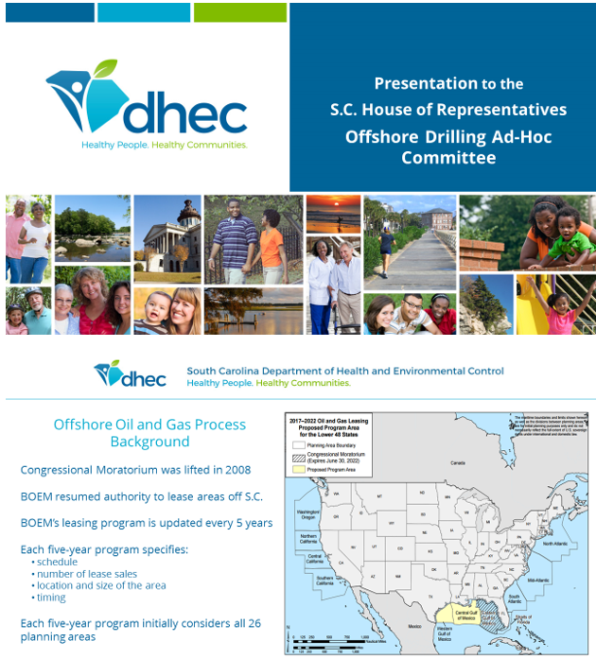

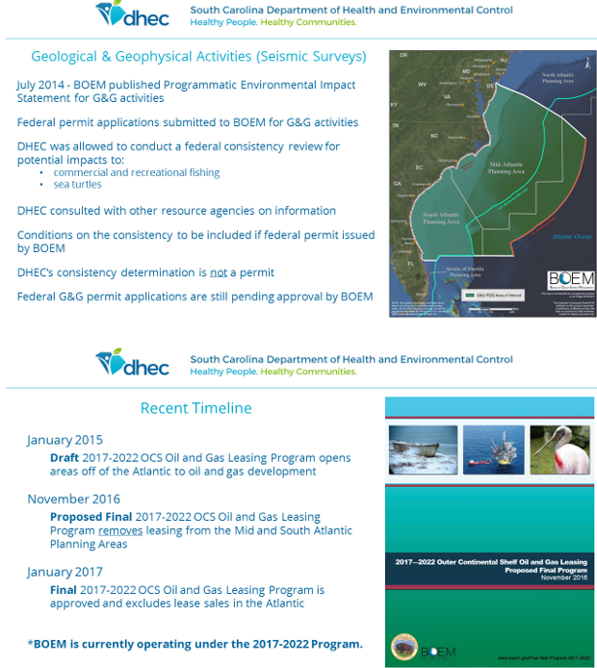

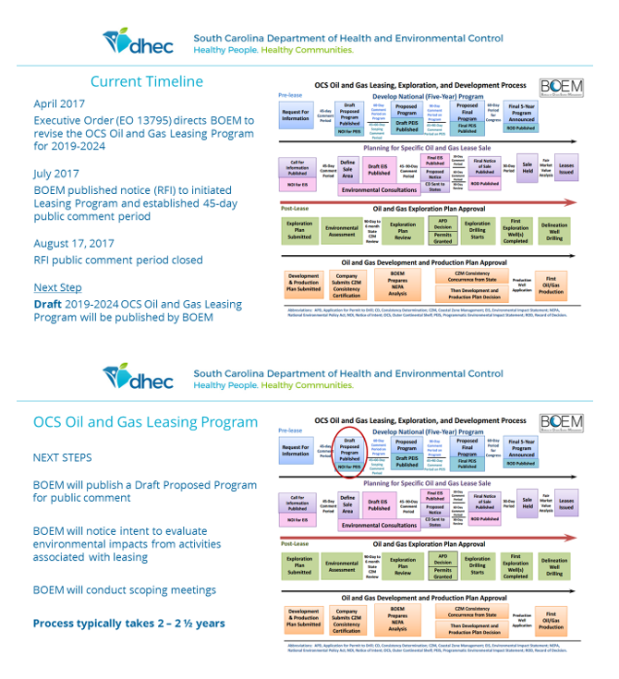

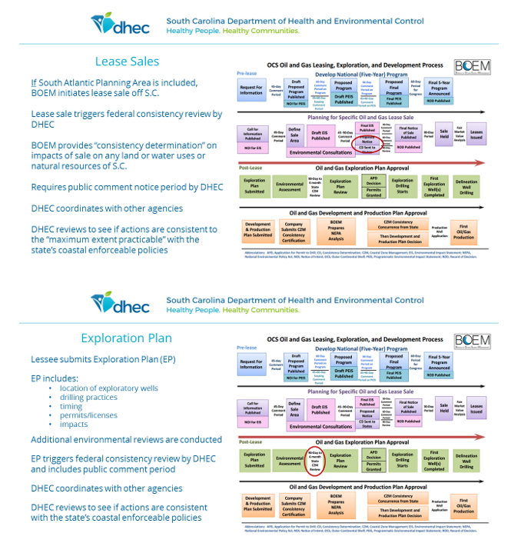

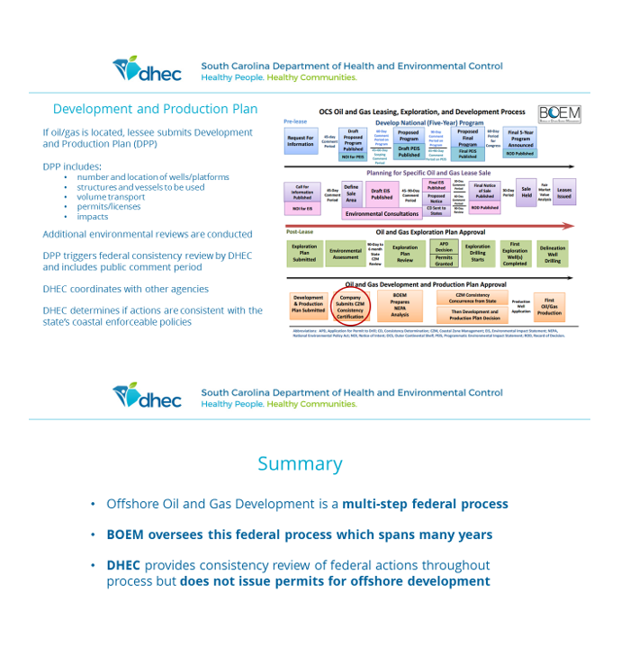

Written Testimony By: Brydon Ross
Testimony of Brydon Ross before the Offshore Drilling Ad-Hoc Committee
South Carolina House of Representatives Room 110 Blatt Office Building Columbia, SC
August 22, 2017

Chairman Hixon and Members of the Committee:

My name is Brydon Ross and I’m the Vice President of State Affairs for Consumer Energy
Alliance (CEA).

On behalf of families and businesses across South Carolina – including thousands of our individual members and affiliates – CEA appreciates the opportunity to speak before this Committee and offer its full support for expanding energy development opportunities in coastal areas of the Atlantic. We also strongly support including the South-Atlantic in the new federal offshore energy leasing program currently under development at the Department of Interior.

Hearings like this are a critically important in helping educate the public on the incredible resource opportunity we have in America that unfortunately are often too politically charged with over the top rhetoric or technical jargon that speaks past people’s basic concerns and questions.

Here’s what it boils down to, over 90 percent of our nation’s federal waters – which are resources that belong to everyone - are off limits to even considering the development of their vast oil and natural gas resources. This means the nation, states like South Carolina, and more importantly the people of South Carolina lose out on jobs, economic opportunities, and price relief and remain more beholden to other sources including hostile nations to meet our energy needs.

Families and businesses here in South Carolina understand firsthand the critical importance of new, living-wage jobs and economic development opportunities that come with the development of affordable, reliable energy. Not only are they integral in attracting and keeping energy-intensive manufacturing powerhouses like BMW and Boeing, but the price of energy is imbedded in the cost of every good and service we use. It’s how South Carolinians are able to enjoy their lives, get to work, cook meals with their family, communicate on their smart
phones, recreate in the beautiful mountains and coast of the Palmetto State and harness the revolutionary power of our digital age and the Internet. All this is made possible by having a secure energy supply.

We are fortunate to live in a time of energy abundance. Untold billions of dollars across our economy are now freed up to innovate and invest in our people rather than dealing with the
burden of high energy prices, thanks to technology revolutions that have helped unleash American energy.

This wasn’t always the case. The bad old days weren’t that long ago.

Nearly nine years ago – in September of 2008 – the average price for a gallon of regular gasoline in South Carolina was $4.12. A 15 gallon fill-up, about what my seven-year old Ford Escape holds, would cost $61.80. Since most of CEA’s members in South Carolina don’t have mass transit options to get to and from work or to drop off kids at daycare or school, they have to drive and fill up their car every week, sometimes more. At these historically high prices, our members would pay over $3,200 a year in fuel costs if they just went to the gas station once a week.

Now consider today. The average price of a gallon of regular gasoline is $2.07 in South Carolina. Using the same assumptions described above, drivers in South Carolina now pay an estimated
$31.05 to fill up their car. That’s a savings of $30.75 a week or roughly $1,600 yearly from peak pricing levels. For regular people, including your constituents, this is an incredible and meaningful difference in their lives. This could mean the difference in having to choose which utility bill to pay, making more than a bare minimum payment on a credit card and falling further behind in life, or simply just being able to take your family out to dinner or buy new clothes for the school year.

Consider the following poverty statistics in South Carolina from the Center for American
Progress:

• 16.7 percent of South Carolina’s population lives below the poverty level, which is
$24,250 for a family of four people – that ranks 40th nationwide.
• Nearly ¼ of all children in South Carolina live in families with incomes below the federal poverty level.
• 22 percent of all South Carolinians under age 65 and below 138 percent of the poverty line did not have health insurance at any time in 2015.
• Nearly 13 percent of households used high-cost, high-risk forms of credit to make ends meet during 2013. This includes payday loans, automobile title loans, refund anticipation loans, rent-to-own, and pawning – that ranks 49th nationwide based on their estimates.1

The fact is – while many parts of South Carolina are growing, the middle class and those in the bottom income bracket are struggling. The Equal Opportunity Project led by researchers at Berkley, Harvard, and Stanford performed an analysis of all 50 states and hundreds of metro areas and found that South Carolina was one of the least upwardly mobile states in the country
– only 4.8 percent of the state’s children since the 1980s have moved from the bottom fifth income bracket to the top fifth.2

Underscoring the need for an adequate supply of affordable energy, Inside Energy has noted that while economists consider “affordable” energy to equate to six percent of income, households in South Carolina with incomes below 50 percent of the federal poverty level spend about 30-35 percent of their incomes on energy, with some spending even more.3

This begs a couple of questions: why should we make energy more expensive for those who can afford it least? And why should we automatically shut the door to any new opportunity that offshore development could bring, especially since elected officials and policymakers have a tremendous role in shaping the process to be as safe as possible?

If followed through, calls to exclude the entire Atlantic from even the potential for future energy development will needlessly foreclose jobs, economic opportunities, and revenue that this state and its people so desperately want and need, and with painful consequences.

According to one study, turning our backs on South Carolina families and businesses -- especially our working class families, small businesses, and displaced agricultural workers struggling to make ends meet -- by excluding the Atlantic, would cost the state up to 35,000+ lost living-wage jobs, an estimated $2.7 billion in lost annual economic activity, more than $15 billion in foregone spending, and roughly $3.7 billion in new state revenue.

Turning our backs on the relief that Atlantic energy could bring to families, businesses, and communities across South Carolina through access to jobs, economic growth, and long-term affordable and reliable American energy is a path that we simply cannot afford to take.

Furthermore, it would create a perverse scenario where those South Carolinians who can afford to fill up their cars at the gas station, keep their lights on, and air condition and heat their
homes and businesses will be doing so by relying more than they should on costlier energy imported from other places, including from countries that produce energy with less stringent safety and environmental standards and protections than we do. Without thoughtful policy, we would also be telling those who cannot afford energy that their struggle is not our priority.

Finally, offshore energy development in the United States is safe – and is getting safer every day.

My family has long treasured the natural beauty of South Carolina’s coast. We take our children on vacations to the beach every year and enjoy the wonderful bounty of the Low Country and the communities who thrive off fishing and tourism. It is important to me – as it is to all of the residents and vacationers who visit the coast every year – that the industry and the federal government work together to ensure that any exploration and development of offshore energy resources is done without harming these national treasures.

3 http://insideenergy.org/2016/05/08/high-utility-costs-force-hard-decisions-for-the-poor/
In fact, you are hearing from technical experts today with the Bureau of Ocean Energy Management who can share how both the federal government and the offshore energy industry have made great strides in improving all aspects of offshore energy production.

Despite the claims of anti-development activists, American energy development and a healthy environment can go hand-in-hand. In addition to continued safety advances in recent years, there is a long record of safe, environmentally responsible energy development in the United States, both onshore and offshore. As the Obama Administration concluded last year, we risk greater environmental damage by NOT developing our own offshore energy.

In addition, there have been numerous, wildly inaccurate and outright false accusations made about seismic testing. Here are the words of the Obama Administration’s offshore regulators:

“There has been no documented scientific evidence of noise from air guns used in geologic or geophysical seismic activities adversely affecting marine animal populations or coastal communities.”

It defies logic that the federal government, with its litany of Byzantine and proscriptive environmental regulations and statutes would ever allow the wanton, widespread killing or harm of protected endangered species and marine life – especially in our litigious society. It also defies human experience, as seen in the Gulf of Mexico where seismic surveys have taken place for decades without any evidence of detrimental impacts and in concert with a thriving seafood industry.

The new process for potential future leasing initiated by the Department of Interior is a lengthy one. Assuming that the South Atlantic is ultimately included in the new program, additional environmental and public reviews, federal approvals, and business determinations will also have to occur before any lease sale or actual on-the-water activity takes place.

This important and comprehensive process provides ample opportunity to ensure that all issues and concerns are fully coordinated and addressed. At the same time, the fact that the process takes such a long time underscores why it is imperative that we take steps today to make sure that ample opportunities are available to meet the basic needs of South Carolina families and businesses well into the future.
Development can be made on your terms, but only by saying yes to energy. By saying yes to opportunity, we have the chance to shape the future we want in South Carolina. We lose that chance when we give into scare tactics and hyperbole and those impacted the most are those who can afford it the least. That is why Consumer Energy Alliance
strongly supports the inclusion of the South Atlantic and expanded development opportunities in the new energy leasing plan.
Written Testimony By: Dr. James Knapp
Background material
S.C. House of Representatives
Ad-Hoc Committee on Offshore Drilling
James H. Knapp, Ph.D.
22 August 2017

Background
By way of background, I am an environmentalist through my upbringing in California during the 1960s and 70s, an Earth scientist through my academic training at Stanford and M.I.T., and for most of the past decade, a vocal advocate for the acquisition of new seismic data on the Atlantic OCS. I have previously presented much of the material here in Congressional hearings on four separate occasions before three different committees spanning the 113th through the 115th Congress. I believe an all-of- the-above strategy is the only sensible and responsible approach to meeting the energy demands of a vibrant U.S. and World economy going forward.

Marine Seismic Surveying
Broadly speaking, geophysical surveying can be thought of as the process of remotely sensing those parts of the Earth (generally the subsurface, which is not readily observable directly), based on their physical properties (composition, density, rigidity, shear strength, porosity, fluid composition, magnetic susceptibility, etc.) and variables
of state (temperature and pressure). Accordingly, the design of any geophysical survey is typically based on a combination of (a) the scale or size of the inferred target, (b) the anticipated depth of the target, and (c) the physical properties of interest. Seismic surveying is only one, but arguably the most powerful, geophysical surveying technique, providing quantitative information on the rocks, sediments, and fluids in the subsurface on a regionally significant spatial scale.
“Seismic surveying” in the context of the U.S. Outer Continental Shelf (OCS) refers typically to the method of “seismic reflection surveying”, wherein acoustic energy (sound) is introduced to the subsurface, and is recorded at or near the surface as it is “reflected” off boundaries in the subsurface between bodies with differing physical properties. While the technique has evolved considerably since the earliest pioneering marine seismic surveys at the mouth of Chesapeake Bay (e.g., Ewing et al, 1937), the theoretical basis of the approach remains unchanged. In particular, seismic reflection surveying has become the essential tool for the evaluation of subsurface resource potential, as it provides not only a graphic image of the features in the subsurface and their geometric relationships, but also a quantitative measure of the physical properties thereof (Figure 1).

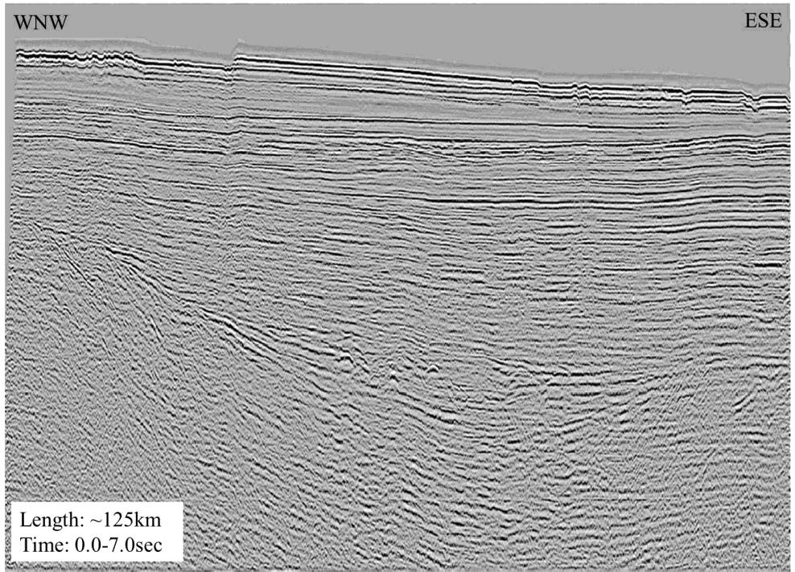

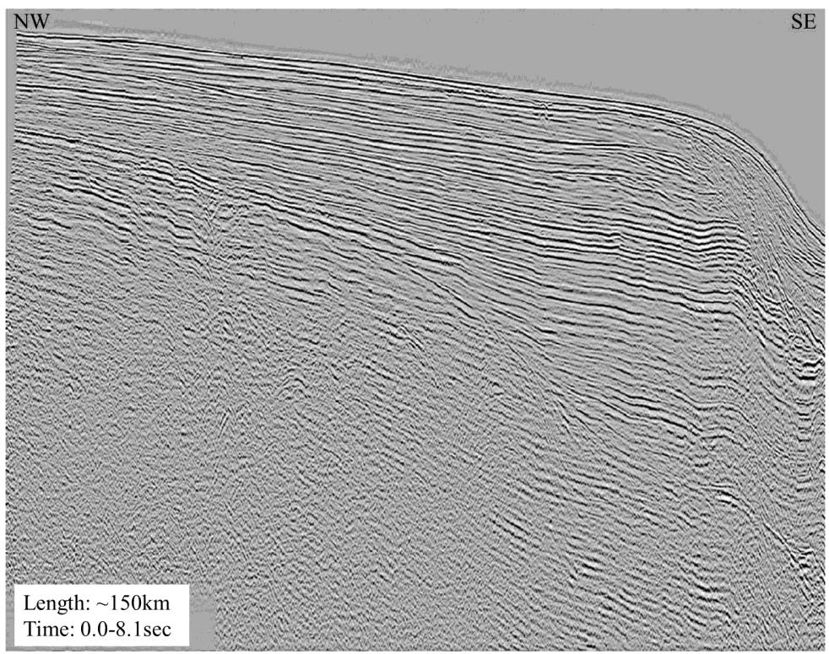

Figure 1. Examples of 2-D seismic reflection profiles showing subsurface sedimentary layers and geologic structures on the Atlantic margin, from legacy Atlantic OCS seismic surveys (courtesy of BOEM.) Approximate depths imaged are 10-12 km (6-7 miles); sections are highly vertically exaggerated (note horizontal scale.)

Extensive marine seismic reflection surveys were carried out over the past half century within the U.S. Exclusive Economic Zone (EEZ) (Figure 2; Triezenberg et al,
2016), as well as globally (e.g. Figure 3, for northwestern Europe). The primary technological innovation since commercial seismic reflection surveys were last recorded on the Atlantic OCS during the 1970’s and 1980’s is the evolution from 2-D to 3-D surveys. Whereas 2-D surveys provide a vertical cross-section through the subsurface, 3- D surveys provide a volumetric image, much as modern medical tomographic imaging does with the human body. While marine 3-D seismic surveys are now commonplace worldwide, (1) only one small commercial 3-D survey was ever collected on the Atlatnic OCS before moratoria were implemented, and (2) both survey designs have relevance in evaluating resource potential on and exploring for petroleum deposits within the essentially frontier province of the Atlantic OCS.

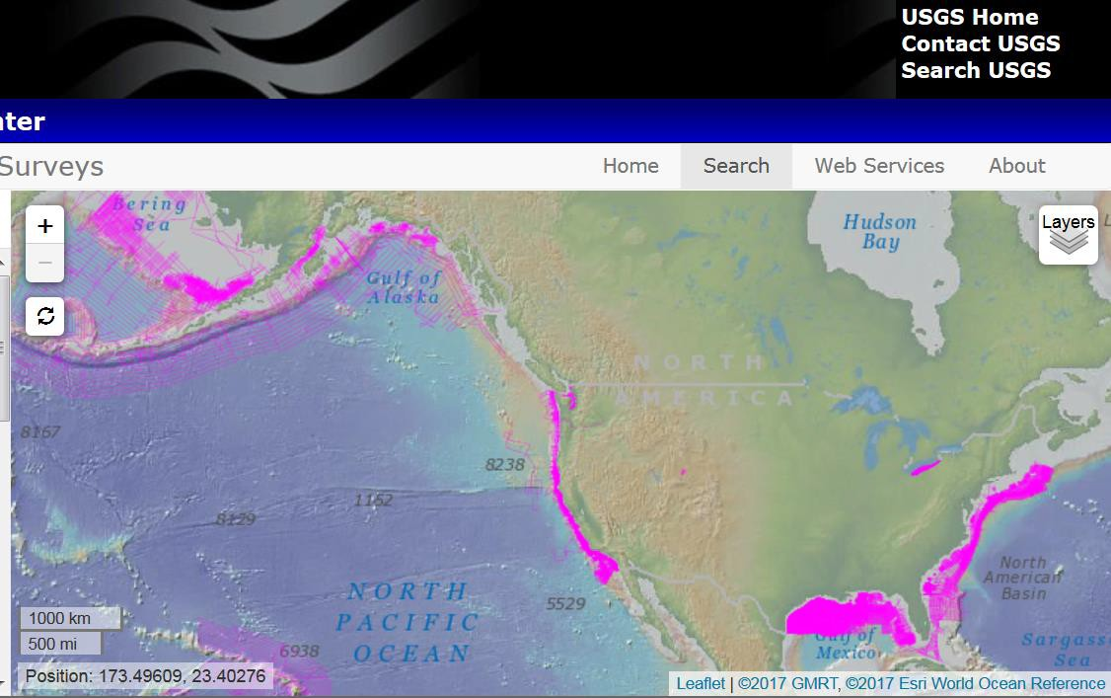

Figure 2. Map of 2-D and 3-D marine seismic reflection surveys in U.S. waters (pink lines), acquired by or contributed to U.S. Department of the Interior agencies, downloaded on 26 July 2017 from the National Archive of Marine Seismic Surveys, Pacific Coastal and Marine Science Center of the U.S. Geological Survey (https://walrus.wr.usgs.gov/namss/search/). 3-D seismic surveys (150) cover >121,000 km2, and 2-D seismic surveys (~32,400 tracklines) cover >2,282,490 line km (Triezenberg et al, 2016). Included are surveys in the Atlantic Ocean, Pacific Ocean, Gulf of Mexico, and territorial waters of Alaska and Hawaii, spanning more than six decades.

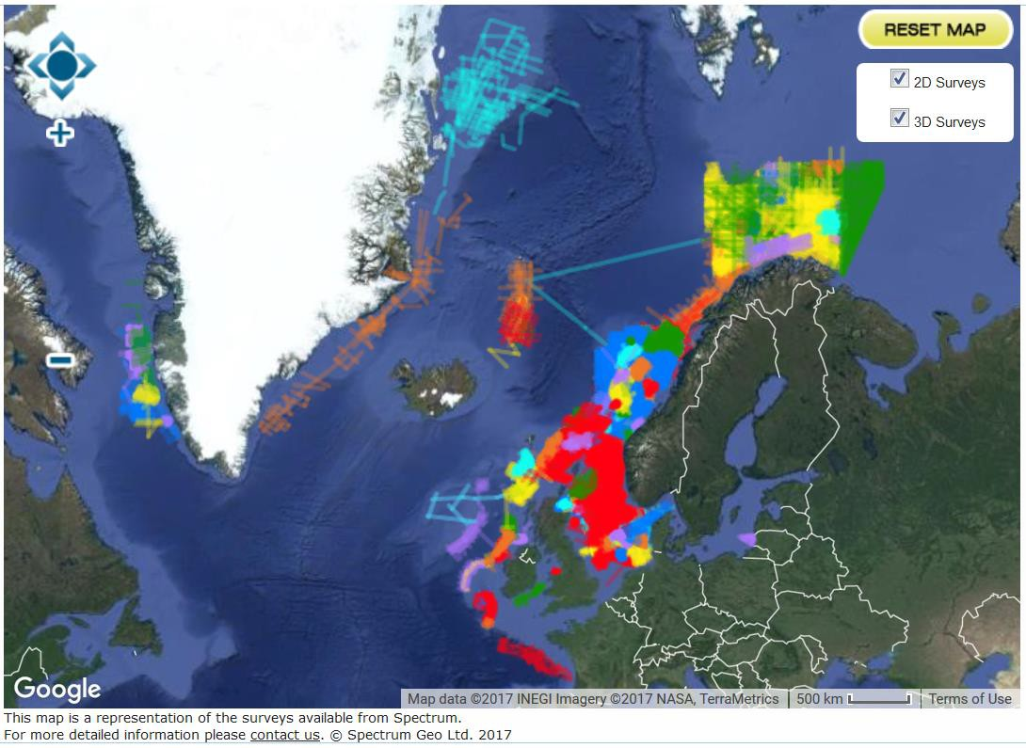

Figure 3. Map of proprietary 2-D and 3-D marine seismic reflection surveys in NW Europe, available from Spectrum Geo Ltd., downloaded on 26 July 2017 from their online interactive seismic data library (http://www.spectrumgeo.com/seismic-data-library/multi-client- library/interactive-map). Each color in a given area represents a different marine seismic reflection survey.

Marine seismic surveys have been carried out in the U.S. and internationally for decades, and represent the single most important tool for evaluating oil and gas potential in the subsurface. These surveys employ acoustic, or sound, energy to interrogate the subsurface of the Earth, in much the same way that a doctor images the interior of a human body with a CAT (computerized axial tomography) scan. In the early days of seismic surveying, the typical success rate for wildcat wells was around 3 in 10. With the advent of 3-D seismic surveys, the success rate is now typically 7 out of 10, greatly changing our ability to evaluate subsurface resources. In most cases, we now have significant confidence in not only the presence of a petroleum resource, but also the estimated volume and consequently the economic value of that resource before ever spudding a well, primarily as a result of seismic technology.

0 1 ,000,000 2,000,000
- -

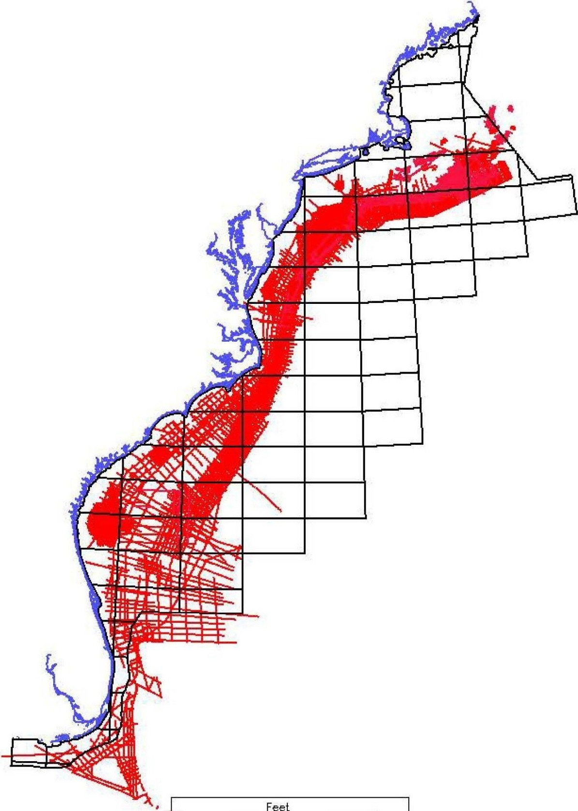
Figure 4. Map of legacy 2-D seismic data on the Atlantic OCS (courtesy of BOEM.) Approximately
380,000 line km (240,000 line miles) of 2-D seismic data were collected in the Atlantic OCS
between 1966 and 1988.

Despite the acquisition of more than 385,000 line km of marine seismic reflection data in the Atlantic OCS during the late 1960’s to the late 1980’s (Figure 4; Post et al, 2012), this province is still considered a frontier basin. Thousands of exploration wells have been drilled onshore along the Atlantic margin of the United
States, but only ~60 such wells have been drilled in the Atlantic OCS. Moreover, as much as 80% of the Atlantic OCS territory that was under consideration for leasing in the
2017-2022 Draft Proposed Plan (Figure 5) has never been the subject of commercial seismic surveying. It is therefore difficult to understand how (1) the Federal Government could be fulfilling its statutory obligation to evaluate fairly the resource potential of, or (2) industry could realistically assess the viability of exploration of the Atlantic OCS in
the absence of new, state-of-the-art seismic reflection surveys. While this region may yet prove to be unprospective for commercial resource development, such a determination could only be informed by new data and analyses.

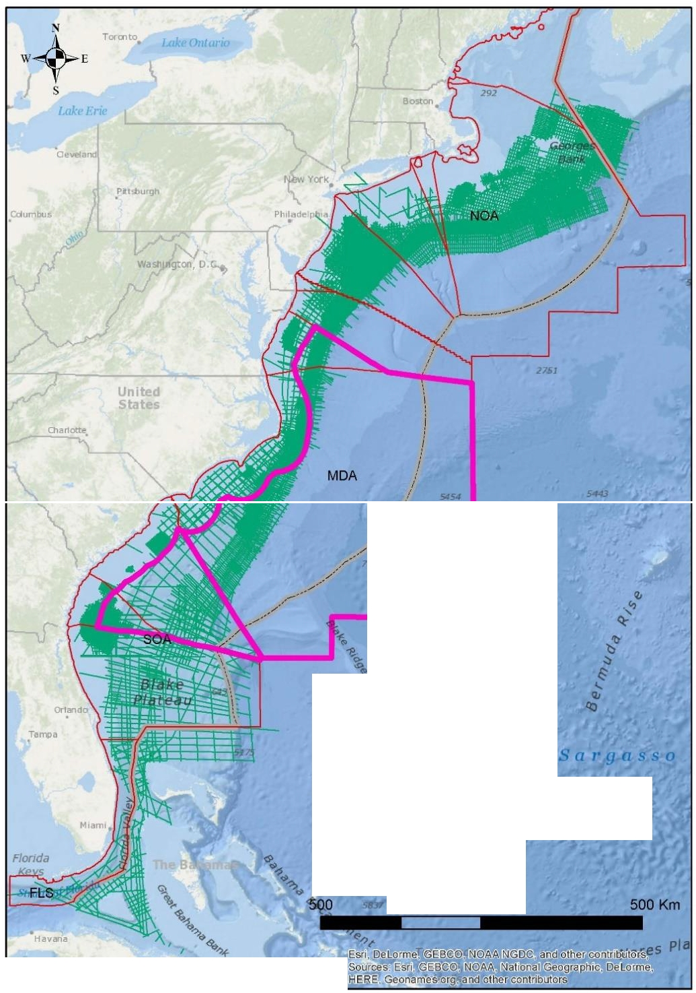

Hatteras
Plain

i
t.egend
1
<! -- EastCoast_allseismic
1::]2017_2022_DPP_Atlantic_Progra,i;1(rea
C]ATL_PLAN
------ Atlantic_200nm_EEZ

250 0

UofSC Tectonics and Geophysics LabI JHKnapp
Cuba

Figure 5. Area within Mid- and South Atlantic OCS Planning Areas originally included (and later removed) in the Bureau of Ocean Energy Management (BOEM) Draft Proposed Plan for 2017-
2022. Red boundary represents 50-mile buffer zone from state waters. Fully 80% of the area which
was under consideration for exploration leases has never been the subject of commercial seismic surveys. (Produced at the Tectonics and Geophysics Lab at UofSC with information from BOEM.)

Compatible Uses of OCS
In the spirit of full disclosure, our research group currently receives federal grant support from both the Bureau of Ocean Energy Management (BOEM) and the National Energy Technology Laboratory of the U.S. Department of Energy (DoE). Our BOEM funding supports evaluation of the seabed and subsurface of offshore areas of South Carolina for establishing wind energy infrastructure (Figure 6). Such studies are critical for assessing the geologic conditions in the shallow subsurface for siting of offshore
wind turbines, and are acquired with similar marine geophysical surveys. Through
funding from DoE, we along with colleagues from a number of organizations are evaluating the offshore geologic storage potential of CO2 as a means of mitigating future fossil fuel carbon emissions (Figure 7). The Atlantic OCS in particular appears to offer significant potential for CO2 storage, in part because previous exploratory drilling has
not compromised potential reservoirs suitable for storage. Analysis of commercial
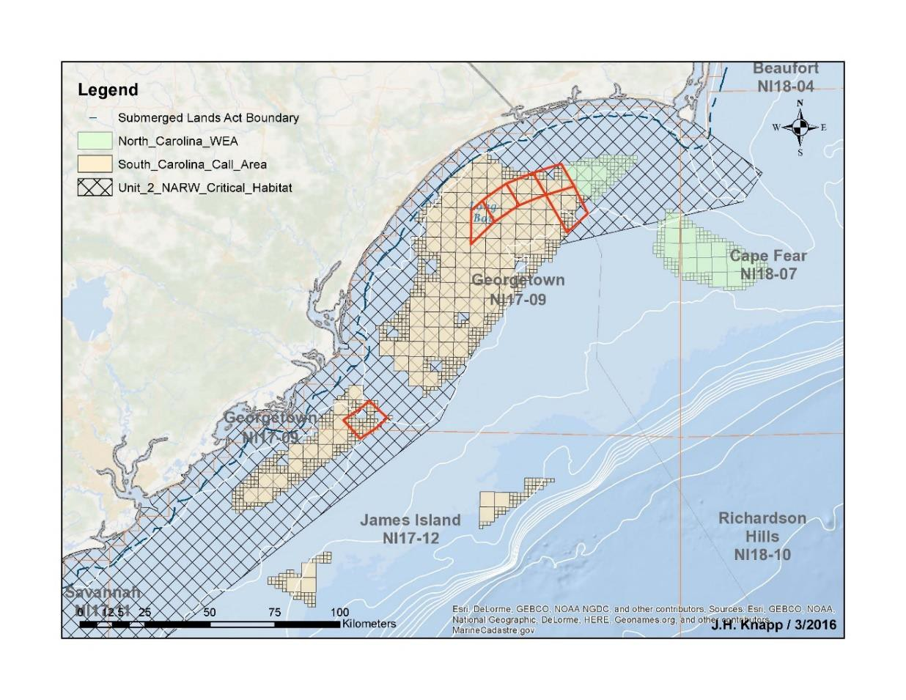
seismic reflection and well data are the only way in which the offshore reservoir resource potential may be adequately evaluated.

Figure 6. Map of offshore wind energy study area (red boxes) funded by the Bureau of Ocean Energy Management, offshore South Carolina. Marine geophysical methods are used to characterize the seabed and subsurface for suitability of offshore wind energy installations. Study is a collaboration between Coastal Carolina University and the University of South Carolina.

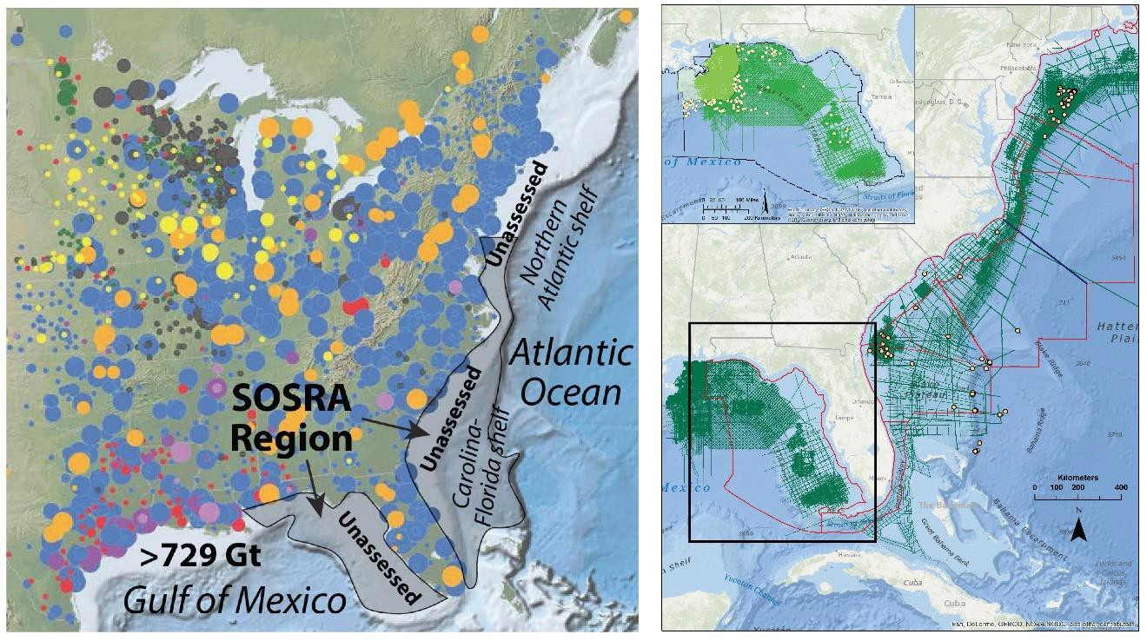
Figure 7. Location map of the Southeast Offshore Storage Resource Assessment (SOSRA) study, funded by the National Energy Technology Laboratory (NETL) of the U.S. Department of Energy, showing (A) map of point sources of CO2 in the eastern United States (NATCARB database) and (B) location of legacy marine seismic reflection and well data used to characterize reservoir storage potential in the offshore. Study area extends from offshore Delaware to offshore Louisiana, and includes collaborators from Virginia Polytechnic Institute, Virginia Department of Mines, Mining, and Energy, Oklahoma State University, the South Carolina Geological Survey, the Alabama Geological Survey, and coordinated by the Southern States Energy Board.

At the request of the former Minerals Management Service (MMS) and subsequently BOEM, the Department of Defense prepared an evaluation of compatibility of offshore oil and gas development with DoD activities (Figure 8). The
2010 analysis concluded that no more than 1% of the entire Federal OCS was unsuitable
for oil and gas development, and an additional 2% was unsuitable for permanent oil and gas surface structures. The 2015 study arrived at similar numbers for areas included within the 2015 Draft Proposed Plan, concluding that more than 96% of the OCS was either unrestricted (67.2%) or had site-specific restrictions (29.5%).

2% 2010 - Entire US OCS 1%

40%

57%

1. Unrestricted

2. Site Specific Stipulations

3. No Permanent Oil & Gas Surface Structures

4. No Oil & Gas Activity

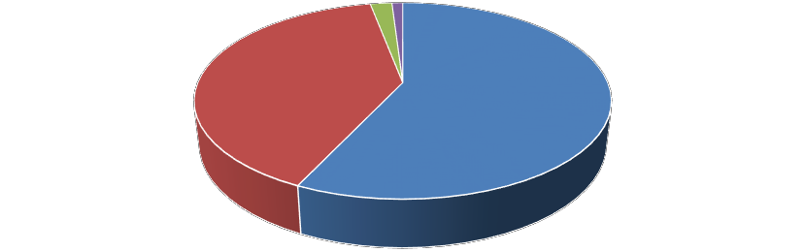
1.6%
2015 - OCS Within 2015 DPP
1.7%

29.5%

67.2%

1. Unrestricted

2. Site Specific Stipulations

3. No Permanent Oil & Gas Surface Structures

4. No Oil & Gas Activity

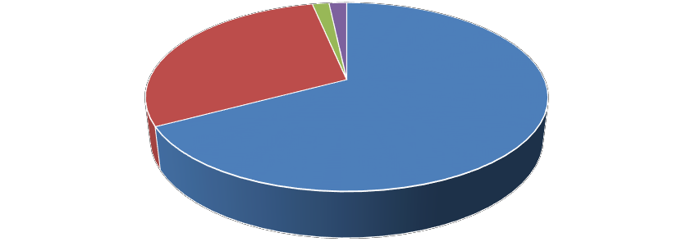
Figure 8. Data from (1) Report on the compatibility of Department of Defense (DoD) activities with oil and gas resource development on the Outer Continental Shelf (OCS) (2010); and (2) DoD Mission Compatibility Planning Assessment: BOEM 2017-2022 Outer Continental Shelf (OCS) Oil and Gas Leasing Draft Proposed Program (2015).

UME (Unusual Mortality Events)
One of the most commonly cited criticisms of marine seismic operations is the putative adverse effect acoustic energy has on marine life, and in particular on marine mammals. Established in 1991, The Working Group on Marine Mammal Unusual Mortality Events under the aegis of the Office of Protected Resources with the National Oceanic and Atmospheric Administration (NOAA) has formally identified a total of 63 marine mammal UMEs in U.S. waters over the last 23 years (Figure 9.) In most cases (29) where a cause has been determined, infections and/or biotoxins were indicated (Figure
9.) Of the 63 UMEs, not a single one has been attributed to marine seismic operations.
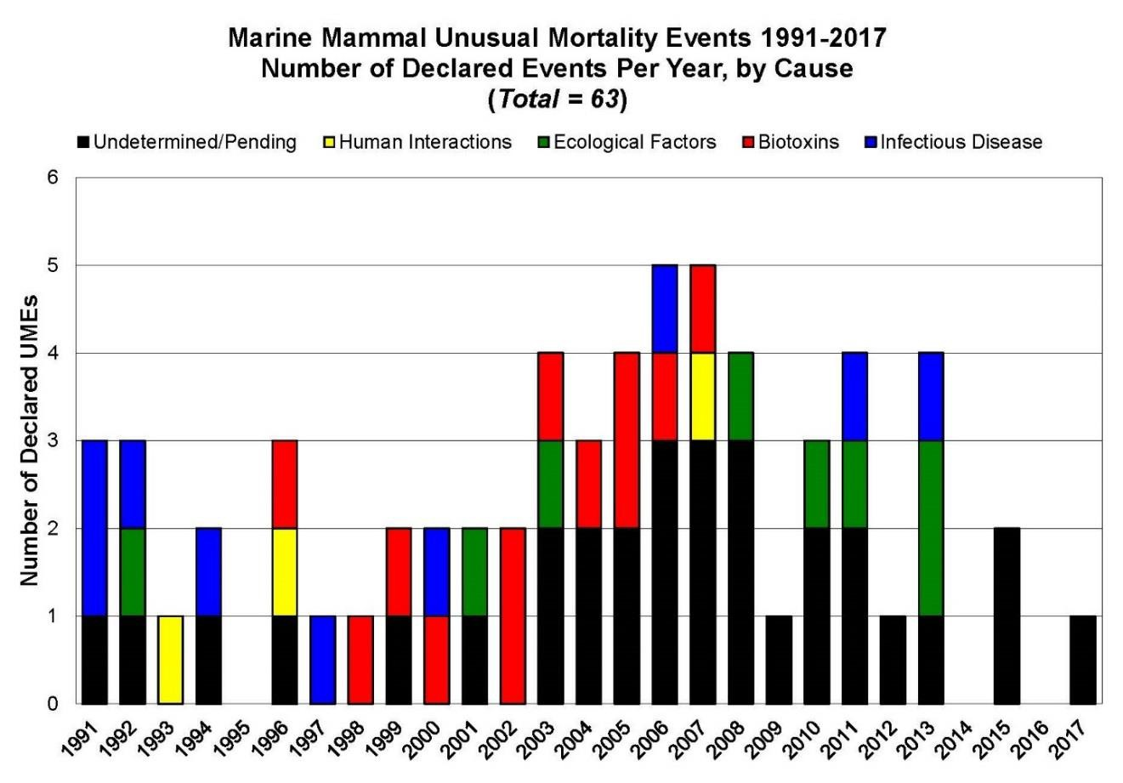
Figure 9. Cause of reported Unusual Mortality Events (UME) in U.S. waters (63 total) between
1991 and 2017 (NOAA Fisheries Office of Protected Resources; downloaded on 26 July 2017 from http://www.nmfs.noaa.gov/pr/health/mmume/). While the cause of a significant number (31) of UME remains “undetermined/pending”, only three have been attributed to “human interactions”, and in no instance has a UME been attributed to marine seismic operations.

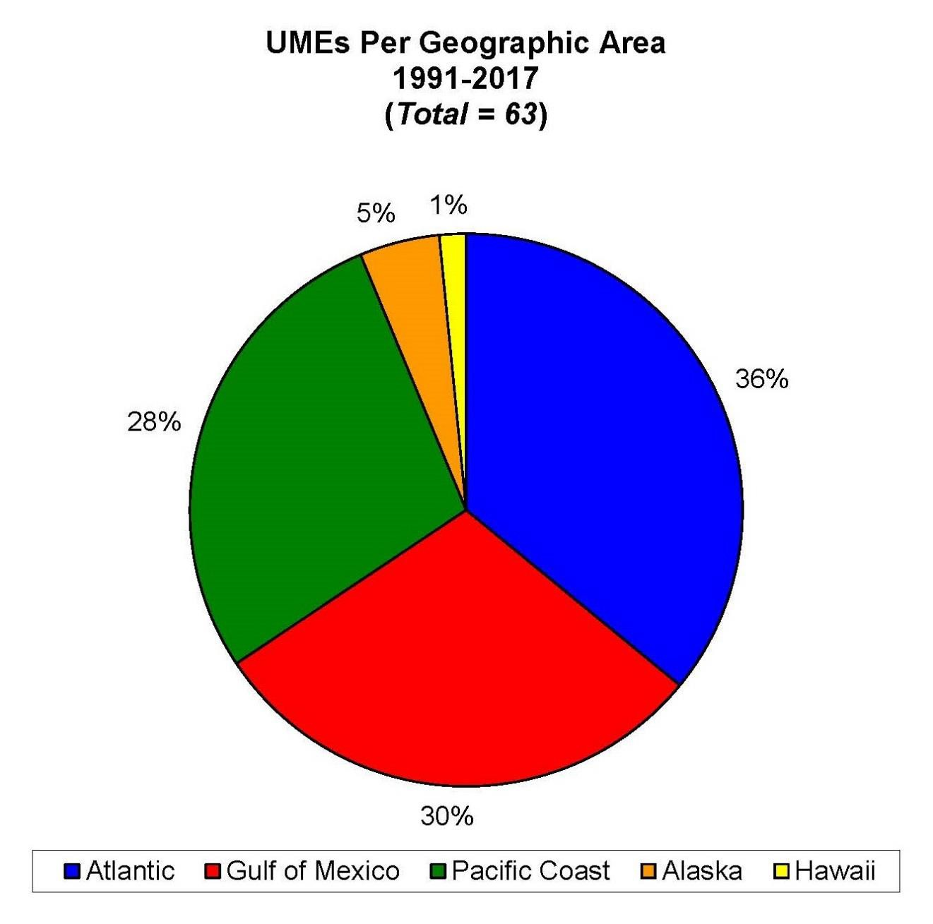
Figure 10. Percentage of reported Unusual Mortality Events (UME) in U.S. waters (63 total) by geographic area between 1991 and 2017 (NOAA Fisheries Office of Protected Resources; downloaded on 26 July 2017 from http://www.nmfs.noaa.gov/pr/health/mmume/). During the observation period, extensive commercial seismic surveys have been conducted in the Gulf of Mexico, but not in the Atlantic or Pacific OCS.

The incidence of UMEs is statistically the same between the Atlantic, Pacific, and Gulf of Mexico regions (Figure 10), during a period when extensive commercial seismic surveys have been conducted in the GOM, but not on the Atlantic and Pacific margins. The two states with the most declared UMEs are California and Florida, neither of which has been the site of commercial marine seismic acquisition during the period in which the records have been compiled. These data, along with others (Figure 11) suggest that the contention that marine seismic surveys result in mass mortality events of marine mammals is likely a chimera.

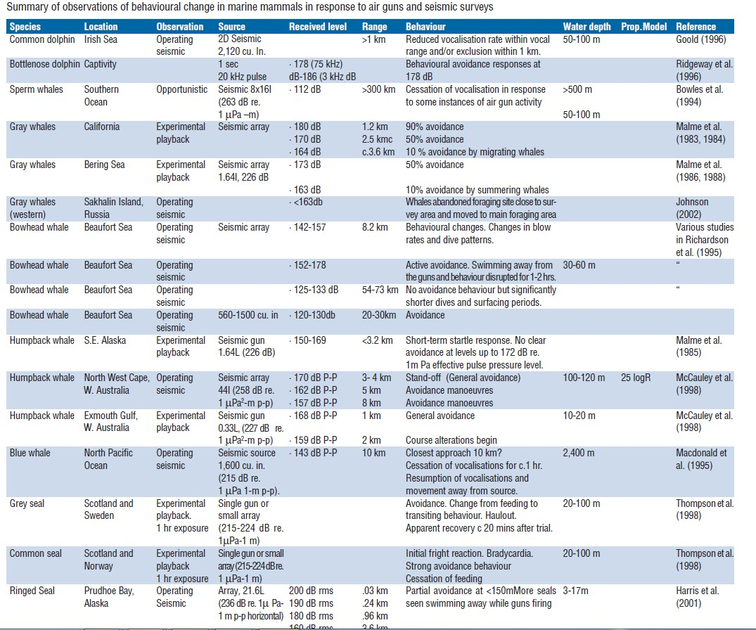

Figure 11. Review of seismic survey effects on marine mammals (from Gordon et al, 2004), suggesting that the most commonly observed response is avoidance.

While not from the peer-reviewed literature, BOEM Chief Environmental Officer William Brown was categoric in his statement on the issue: “To date, there has been no documented scientific evidence of noise from air guns used in geological and geophysical (G&G) seismic activities adversely affecting marine animal populations or coastal communities. This technology has been used for more than 30 years around the world. It is still used in U.S. waters off of the Gulf of Mexico with no known detrimental impact to marine animal populations or to commercial fishing” (Brown, 2014). Brown continued in a follow-on statement (Brown, 2015) that the lack of evidence for adverse population-level effects on marine mammals does not conclusively prove they don’t occur, but “since 1998, BOEM has invested over $50 million on protected species and noise-related research, including marine mammals.” Given the historic level of marine seismic acquisition, both in U.S. waters and globally, one might reasonably be led to the conclusion that the preponderance of data suggests there is no definitive correlation between marine seismic activities and detrimental impacts to marine mammal populations.

Economic Potential of the Atlantic OCS
The most recent estimates by the Bureau of Ocean Energy Management for the resource potential on the Atlantic OCS range from ~3.5-18 Bboe. Using seismic data from pre-1988, these estimates are undoubtedly conservative, and lack the analysis which would be afforded through new, state-of-the-art seismic data. We face a truly historic opportunity to fairly evaluate the energy and mineral resource base of the Atlantic OCS through acquisition of new seismic surveys. In South Carolina, we are working to establish the Atlantic Coast Center for Energy Sustainability through Science and Engineering (ACCESSE). Our vision is to develop a sustainable energy industry based on conventional, unconventional, renewable, and alternative energy for South Carolina and the southeastern region, helping to train a workforce and creating jobs based on locally-derived energy resources. There could be no more important first step than to initiate new seismic surveys on the Atlantic OCS.

Cited References / Sources
Brown, W.Y., 2014, Science notes: The science behind the decision, Bureau of Ocean Energy
Management, 3 p.

Brown, W.Y., 2015, Science notes: Applied science for informed decision making, Bureau of
Ocean Energy Management, 2 p.

Ewing M., Crary, A.P., and Rutherford, H.M., 1937, Geophysical investigations in the emerged and submerged Atlantic Coastal Plain, Part I: Methods and Results, Bull. Geol. Soc. Am., v. 48, p.
753-802.

Gordon, J., Gillespie, D., Potter, J., Frantzis, A., Simmonds, M.P., Swift, R., and Thompson, D.,
2004, A review of the effects of seismic surveys on marine mammals, Marine Technology Society
Journal, v. 37, n. 4, p. 16-34.

Marine Mammal Unusual Mortality Events, Office of Protected Resources, National Marine Fisheries Service, National Oceanographic and Atmospheric Administration, U.S. Department of Commerce (http://www.nmfs.noaa.gov/pr/health/mmume/events.html).

McCauley, R.D., Day, R.D., Swadling, K.M., Fitzgibbon, Q.P., Watson, R.A., and Semmens, J.M.,
2017, Widely used marine seismic survey air gun operations negatively impact zooplankton, Nature Ecology & Evolution, Volume 1; Article Number: 0195, DOI: 10.1038/s41559-017-0195.

National Archive of Marine Seismic Surveys, Pacific Coastal and Marine Science Center, U.S. Geological Survey, U.S. Department of the Interior (https://walrus.wr.usgs.gov/namss/).

Post, P., Klazynski, R., Klocek, E., DeCort, T., Riches, T., Li, K., Elliott, E., and Poling, R., 2012, Assessment of undiscovered technically recoverable oil and gas resources of the Atlantic Outer Continental Shelf 2011 as of January 1, 2009, BOEM 2012-016, 39 p.

Triezenberg, P.J., Hart, P.E., and Childs, J.R., 2016, National Archive of Marine Seismic Surveys (NAMSS): A USGS data website of marine seismic reflection data within the U.S. Exclusive Economic Zone (EEZ): U.S. Geological Survey Data Release, doi: 10

Written Testimony By: Ms. Peg Howell
Testimony to the South Carolina House Ad Hoc Committee on Drilling
Peg Howell, Spokesperson for SODA – Stop Offshore Drilling in the Atlantic
October 26, 2017

Chairmen Hixon and Hiott and Honorable Committee Members, thank you for the opportunity to speak with you today.

My name is Peg Howell. I have a Bachelor of Science degree in Petroleum Engineering and graduated at the top of my class. I was also the first female “Company Man” in the Gulf of Mexico. The Company Man is the person on the rig who is in charge of the drilling operation, something like a plant manager. I have worked for Mobil, Marathon, and Chevron oil companies in the US and in the North Sea. I also hold an MBA from Harvard Business School and have run my own consulting business for 23 years. This picture was taken over 40 years ago, on my first rig. Because I have seen firsthand the impact of the oil and gas industry, I have been asked to be the SODA spokesperson.

SODA – Stop Offshore Drilling in the Atlantic - was formed in February 2015 as an all-volunteer, non-partisan, self-funded, grassroots effort of citizens along the South Carolina coast who share a mission to STOP seismic testing and offshore drilling in the South Atlantic.

SODA is not an environmental group; our sole focus is this one issue. We do not receive monies from any organization or company. No one on the core team is paid for the work they do for SODA.

Our purpose is to provide the facts about the potentially disastrous impact seismic airgun surveys, offshore drilling and its accompanying onshore industrialization will have on our coastal & state economy, health, property, and way of life.

We are comprised of a core team of 10 folks and a local network of well over 2000 South Carolinians. Our core team is an extremely talented collection of local residents with experience as engineers and scientists, a petroleum landman, a minister, a realtor, a former Congressional Chief of Staff, business people, a lawyer, and Federal and state public servants.
We have been meeting at least twice a month since February 2015. We have presented the facts about the Federal seismic and leasing processes to thousands of citizens and elected officials via small- and large-scale meetings, events, and movie showings from DC to Columbia to Atlanta, and all along the South Atlantic coast.

We recognize that you, the SC House Ad Hoc Committee on Drilling, have a daunting task. Over the course of a few meetings, you are charged with understanding the complexity of the energy industry, US supply and demand, and the laws and processes that govern seismic exploration and leasing of the US

continental shelf. You have been specifically charged with becoming familiar with federal offshore drilling regulations and developing a list of suggestions for any potential legislation to be introduced.

Our SODA team recognizes how challenging your work is, so we will present to you the most critical information we have learned about this issue over the last 32 months. In addition, we are available for any follow-up assistance, including research, analysis or fact-checking.

Coastal Opposition Continues to Grow

Let’s begin by looking at the entire Atlantic coast economy, nearly 1.4 million jobs and over $95 billion in gross domestic product rely on a healthy coast and ocean ecosystems, mainly through fishing, tourism and recreation. To expose the Atlantic to offshore drilling and seismic testing is, as our Governor says, “killing the goose that laid the golden egg.”

The opposition to seismic airgun surveys and offshore drilling in the Atlantic is enormous and continues to grow. We have resolutions and letters opposing seismic testing and drilling from:
- 138 East Coast municipalities
- Over 1,200 local, state and federal elected officials
- An alliance representing over 41,000 businesses and 500,000 fishing families from Florida to Maine
- Fishery Management Councils and other commercial and recreational fishing interests, as well as
- Numerous chambers of commerce, tourism boards, and homeowners, restaurant and hotel associations from New Jersey to Florida

You may recognize many in these pictures: Governor Henry McMaster, Horry and Georgetown County Councils (my husband is a Georgetown County Councilman) and a few of the dozen+ coastal mayors who actively oppose offshore oil and gas development. They are Republican and Democrat alike; protecting our coast is not a partisan issue.

The binder in front of me includes resolutions from these organizations as well as comments from South Carolina Congressmen and other elected officials, the US Dept of Defense, and others.

EVERY MUNICIPALITY ALONG THE ENTIRE SOUTH CAROLINA COAST as well as our state capital, COLUMBIA, and the coastal counties of HORRY, GEORGETOWN AND CHARLESTON, HAS PASSED A RESOLUTION OPPOSING OFFSHORE DRILLING AND SEISMIC AIRGUN SURVEYS.

SC Municipalities & Counties opposing offshore drilling and/or seismic airgun surveys
- Atlantic Beach, SC: Passed 9/14/2015 (offshore drilling and seismic blasting)
- Beaufort, SC: Passed 2/10/2015 (offshore drilling and seismic blasting)
- Briarcliffe Acres, SC: Passed 10/19/2015 (offshore drilling and seismic blasting)
- Charleston, SC: Passed 3/24/2015 (offshore drilling and seismic blasting)
- Charleston County, SC: Passed 5/5/2015 (offshore drilling and seismic blasting)
- Columbia, SC: Passed 5/5/2015 (offshore drilling and seismic blasting)
- Edisto Beach, SC: Passed 5/8/2014 (seismic blasting)

- Folly Beach, SC: Passed 3/10/15 (offshore drilling and seismic blasting)
- Georgetown, SC: Passed 4/16/2015 (offshore drilling and seismic blasting)
- Georgetown County, SC: Passed 7/25/2017 (offshore drilling and seismic blasting)
- Hilton Head, SC: Voted to send letter to BOEM 3/25/2015 (offshore drilling); Voted to send letter to SCDHEC 3/19/2015 (seismic blasting)
- Horry County, SC: Passed 8/22/2017 (offshore drilling and seismic blasting)
- Isle of Palms, SC: Passed 2/17/2015 (offshore drilling and seismic blasting)
- James Island, SC: Passed 3/19/2015 (offshore drilling and seismic blasting
- Kiawah Island, SC: Passed 5/5/15 (offshore drilling and seismic blasting)
- McClellanville, SC: Passed 5/4/2015 (offshore drilling and seismic blasting)
- Mt. Pleasant, SC: Passed 5/13/2015 (offshore drilling and seismic blasting)
- Myrtle Beach, SC: Passed 8/11/2015 (offshore drilling and seismic blasting)
- North Myrtle Beach, SC: Passed 8/17/2015 (offshore drilling)
- Pawleys Island, SC: Passed 9/14/2015 (offshore drilling, proclamation)
- Port Royal, SC: Passed 2/11/2015 (offshore drilling and seismic blasting)
- Rockville, SC: Passed 4/20/2015 (offshore drilling and seismic blasting)
- Seabrook Island, SC Mayor and Councilmembers: Voted to send letter 4/28/2015 (Offshore drilling and seismic blasting
- Sullivan's Island, SC: Passed 3/17/2015 (offshore drilling and seismic blasting)
- Surfside Beach, SC: Passed 9/22/2015 (offshore drilling and seismic blasting)

Opposition from business interests
- Business Alliance for Protecting the Atlantic Coast: Sent letter to Interior Secretary Zinke on behalf of more than 41,000 businesses and 500,200 commercial fishing families, urging them not to reconsider the 2017-2022 plan, and opposing offshore drilling and seismic blasting 4/28/17
- Business Alliance for Protecting the Atlantic Coast: Sent letter to President Obama on behalf of more than 35,000 businesses and 500,200 commercial fishing families from Maine to Florida, urging him to permanently protect the Atlantic from offshore oil and gas drilling, and to deny all Atlantic seismic airgun blasting permits 12/13/2016 (offshore drilling and seismic blasting)
- 66 East Coast businesses: Signed letter to President Obama 12/12/2016 (offshore drilling)
- Business Alliance for Protecting the Atlantic Coast: Sent letter to President Obama on behalf of more than 12,000 businesses and 400,000 commercial fishing families 10/27/2016 (offshore drilling and seismic blasting)
- 280 East Coast Businesses: Signed letter to President Obama 2/3/2016 (offshore drilling and seismic blasting)
- 440+ South Carolina Businesses: Signed letter to Governor Haley 12/16/2015 (offshore drilling and seismic blasting)
- 360+ East Coast Businesses: Signed letter to President Obama 2/16/2016 (offshore drilling)
- South Carolina Small Business Chamber of Commerce: Passed Resolution 1/12/2015 (offshore drilling and seismic blasting)

Opposition from fishing groups
- Snook and Gamefish Foundation: Sent letter to BOEM opposing offshore oil exploration in the Atlantic 8/30/2016 (seismic blasting)
- Southern Shrimp Alliance: Sent letter to BOEM opposing offshore oil exploration in the Atlantic 6/24/2016 (seismic blasting)
- 36 commercial and recreational fishing interests in the Mid-Atlantic: Sent letter to the governors of Delaware, Maryland and Virginia, expressing their concerns with offshore drilling and proposed seismic airgun blasting 3/29/2016 (offshore drilling and seismic blasting)
- Mid-Atlantic Fishery Management Council: Updated and strengthened its policies to increase protection for fisheries and fish habitat from energy exploration and development activities for the species and areas the Council is charged with managing 2/17/2016 (Read the full policy)
- South Atlantic Fishery Management Council: Updated and strengthened its policies to increase protection for fisheries and fish habitat from energy exploration and development activities for the species and areas the Council is charged with managing 12/14/2015
- Fisheries Survival Fund: Sent letter to the Mid-Atlantic Fishery Management Council expressing concern 8/7/2015 (offshore drilling and seismic blasting)
- South Atlantic Fishery Management Council: Sent letter to BOEM 4/30/2015 (seismic blasting)
- Gullah/Geechee Fishing Association: Submitted comments to BOEM 3/30/2015 (offshore drilling and seismic blasting)
- Southeastern Fisheries Association: Sent letter to President Obama 12/3/2014 (seismic blasting)
- Billfish Foundation: Sent letter to BOEM 5/7/2014 (seismic blasting)
- International Game Fish Association: Sent letter to BOEM 5/1/2014 (seismic blasting)
- Mid-Atlantic Fishery Management Council: Sent letter to BOEM 5/2/2014 (seismic blasting)

2017-2022 Draft Proposed Program for the OCS Oil and Gas Leasing Program

How did this all begin? Let’s start with a bit of recent history:

Customarily, the US Department of Interior/Bureau of Ocean Energy Management prepares a program for leasing areas in the US OCS (Outer Continental Shelf) every 5 years. One of their first steps is to ask the Governor of each coastal state if the OCS adjacent to their state is to be considered. In 2014, former Governor Nikki Haley, asked the federal government (BOEM) to include the South Carolina coast in the 2017-2022 Draft Proposed Lease Sale.

In January 2015, the Mid and South Atlantic lease sale was scheduled for 2021.
Through a tremendous amount of hard work by thousands of people along the coast, on March 15, 2016, the Atlantic Planning area was pulled out of the proposed program. In January of this year (2017), the permits for seismic surveys in the Atlantic were put on hold.

April 28, 2017: Presidential Executive Order implementing America First offshore energy strategy

President Trump decided to re-open the Atlantic OCS to oil and gas exploration and development as part of his Executive Order on April 28th. The current area being considered is larger than the previous area, now extending from Delaware to mid-coast Florida, and to the 3 nm boundary of state waters.

Do we need to drill in the Atlantic to be “Energy Dominant?”

The President has said that his goal is greater than US “energy independence;” it is “energy dominance.” But aren’t we already “energy dominant?”

The “shale revolution”- onshore oil & gas

The “shale revolution” began in earnest across the US onshore oil patch back roughly in 2008.
This is the combination of hydraulic fracturing (“fracking”) and horizontal drilling that enabled the United States to significantly increase its production of oil and natural gas.

This drilling changed America from “energy dependent” to “energy independent.”

The “shale revolution” brings abundance

Since 2008 we have increased crude oil production by >90 percent and since 2005 natural gas production by >50 percent.

Because of this abundance, in December 2015, Congress passed a law allowing crude oil exports for the first time since the Arab Oil Embargos of the 1970s. The US now exports roughly one million barrels of oil per day (bopd), and is expected to export over 2.25 million bopd by 2020. That’s more than the 1.7 million bopd we currently produce from the GOM.

Because of the growth in LNG (Liquified Natural Gas), the US has also become a net exporter of natural gas -- for the first time in 60 years.

We are now exporting both crude oil and natural gas. Chances are that any oil and gas found off SC’s coast will be exported.

Abundance continues into the future

This is not a short-term phenomenon, but will continue well into the future.

The US Energy Information Agency forecasts that between 2016 and 2040, US consumption will increase only 5% while US production will grow by more than 20%.

The result is a continued surplus of oil and gas supply – without drilling in the Atlantic.

Annual Energy Outlook 2017

The US Energy Information Administration expects the US to be a net energy exporter by 2026, but it appears it could happen sooner than that.

U.S. Oil and Gas Global Dominance

We are already Energy Dominant.
The U.S. is:
- World’s largest natural gas producer (overtaking Russia)
- …and the world’s largest global oil producer (overtaking Saudi Arabia).
- The US doesn’t need the Atlantic’s oil and gas to achieve or maintain our energy dominance.

- We have such abundance onshore, we are exporting record amounts and will do so into the future.
- So, drilling in the Atlantic is not about energy dominance -- it’s about oil companies having access to potential oil and natural gas reserves so they can increase their revenues and profits via exports
- How do the oil companies get to access to the Atlantic reserves? By exploring. The first 2 steps are seismic surveys and obtaining leases in the OCS.

Where things stand now – Seismic

The first step in offshore exploration is running seismic surveys. BOEM issues seismic permits via this Atlantic Geologic and Geophysical process.

We are waiting to hear if the Incidental Hazard Authorizations (IHAs) are going to be issued by National Marine Fisheries Service (NOAA). Then BOEM will decide whether or not to issue the seismic permits.

We oppose seismic airgun surveys

SODA opposes seismic airgun surveys. The risk to marine life is not worth the data, for 4 reasons:
- We don’t get to see the results
- An unprecedented amount of seismic is being requested, and it is not harmless
- It doesn’t definitely find oil and gas deposits
- It is the first step toward drilling.

Expedited Seismic Airgun Blasting Permits
1) We don’t get to see the results

There are 5 permit applications currently under review off the SC coast. Only the seismic companies that collect the data, the oil companies which buy the data, and BOEM, get to see the proprietary results. So, people who say we need to run seismic and then we’ll decide whether or not to support drilling along our coast don’t understand how the process works.

The SC state government, our Governor, and Members of Congress do NOT receive the seismic information. Therefore, they can’t make an accurate cost-benefit analysis.

Unprecedented amount of noise
2) The amount of noise that will be introduced into the ocean is unprecedented, and it is not harmless…

The airgun blasts -- one of the loudest manmade noises in the ocean – are discharged every 10-12 seconds, 24 hrs/day for months at a time. The noise can be heard more than 2,500 miles from the source, approximately the distance from New York to Las Vegas. For marine life, there is no escaping the noise – like a smoke alarm going off in your house continuously for a year or more.

The seismic companies will be running over 90,000 miles of seismic lines across all the Mid- and South Atlantic Planning Areas. Combined, they will run a total of 906 days of seismic within a one-year permit period. This is an unprecedented amount of noise.

When comparing this amount of seismic to all the seismic run from 1968 through 1997, there is no other year in any federal OCS area that ran this much seismic.

Seismic interpretation will NOT “tell you what’s out there”
3) It doesn’t definitely find oil and gas deposits…

It is very important to understand that seismic surveys alone do NOT definitively tell us what is out there. The 5 applications under review are to run 2D seismic. Historically, 2D seismic alone is only successful in finding oil and gas approximately 20-25% of the time. After the requested 2D surveys, seismic companies will be back here asking for permits to run 3D seismic, a second blast of non-stop airgun noise in our ocean. And 3D seismic only increases the odds of finding oil and gas to 40-50% of the time, in true “wildcat” exploration.

If seismic surveys were able to definitively find oil and gas, Royal Dutch Shell would not have spent $7 billion on a dry hole in the Arctic two years ago.

In order to find oil and gas, you will not "know what's out there" until you drill.

What about drilling leases?

The second requirement to explore offshore is to obtain drilling leases from BOEM. This process is underway at the same time as the seismic permitting process.

Expedited BOEM leasing program: 2019-2024

We are currently at the yellow star on the chart – waiting for the DPP (Draft Proposed Program).

The Atlantic may be included or excluded in the DPP. If it is included, there are a few more steps which will take ~9-12 more months (assuming the comment periods aren’t shortened), during which all, some, or none of the Atlantic may be excluded.

The opportunity to pull the Atlantic from the proposed program ends at the red square, then plans for the lease sale begins.

We need Governor McMaster to weigh in. We don’t have a lot of time to have the South Atlantic pulled from this program – only 9-12 months.

So what’s in it for South Carolina?

The question you probably most want to know the answer to is, “What’s in it for SC?”

Offshore drilling advocates claim…

The 3 claims you have already heard from various sources are:
- $3.7 Billion in new revenues will come to South Carolina
- Over 35,000 new jobs will come to South Carolina
- The Port of Georgetown can be the hub for servicing related OCS development.

The estimates of revenues and jobs come from this report that was paid for by the API and the National Ocean Industries Assn (NOIA): The Economic Benefits of Increasing U.S. Access to Offshore Oil and Natural Gas Resources in the Atlantic authored by Quest Offshore Resources, commonly called “the Quest Report.”

The third claim has been disseminated by people associated with the Consumer Energy Alliance and the American Petroleum Institute.

The API/Quest Offshore Report

- Published December 2013
- Economics based on $100/bbl oil and $7/mcf natural gas vs. current prices of $50/bbl and $3/mcf
- Leasing begins in 2018, with 350 leases sold; Production begins in 2026
- 75% of drilling will be in deep water (current breakeven is ~$90/bbl.)
- 690 wells to be drilled between 2018-2035
- The Atlantic contains very small amounts of estimated oil and gas relative to opportunities in the GOM:
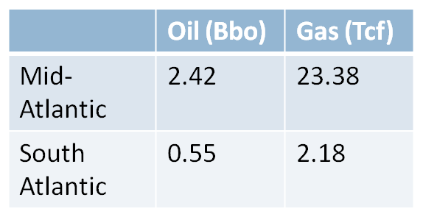

The analysis and claims contained in the Quest report have been refuted for several years, but since you continue to hear them, let me explain the problems with the revenue and jobs numbers:
- Published December 2013
  - As you’ve seen, a lot has happened in the oil and gas industry these last 4 years.
- The Quest Report economics are based on $100/bbl oil and $7/mcf natural gas vs. current prices of $50/bbl and $3/mcf
  - Most significant is the price of oil and gas is less than half what it was when these numbers were calculated
- Quest Report begins leasing in 2018, with 350 leases sold; Production begins in 2026
  - However, the earliest leasing can begin is 2020, and that’s very ambitious, so production wouldn’t likely begin until after 2030.
- Quest Report indicates that 75% of drilling will be in deep water
  - However, it’s highly unlikely that oil companies will be interested in these deep-water leases until the price of oil again reaches ~$100/bbl.
- Quest Report estimates 690 wells to be drilled between 2018-2035
  - This is an unprecedented amount of exploration drilling – at any oil price
- BOEM has estimated very small amounts of oil and gas
  - Which reduces the likelihood of this amount of drilling activity

Look at the map – SC IS EXPECTED TO HOLD VERY LITTLE oil and gas. NC is expected to have much more oil and gas. Their Governor Roy Cooper, has already told BOEM, “not off our coast.”

No offshore revenues to SC

The Quest Report says that $3.7 Billion in New revenues (cumulative to 2035) will come to South Carolina via “Revenue-sharing”
- BUT Pres. Trump has said NO to revenue sharing. With the tax cuts he has proposed, he will need all revenues obtained from the OCS rents, royalties & bonuses to go to the US Treasury.
- Again, these revenues are significantly inflated, based on those assumptions of 690 wells, $100/bbl. oil, etc.

SC Economic Impact: Tourism vs. Oil

One of the most important analyzes SODA has done is a study called Tourism vs. Oil (TVO), developed by three of our experts.

This analysis compares the overly optimistic projections for state revenues included in the Quest Report (the $3.7 Billion) against a very conservative estimate of the South Carolina’s state and local tax revenues from the coastal tourism economy over the same time period. Even with this unbalanced estimate, tourism easily wins by 10 to 1. http://www.drilldownsc.com/#!tvo/c1sav

The TVO analysis shows, in indelibly stark numbers, that it is not in the economic interest of the State of South Carolina or its residents to support drilling in the Atlantic.

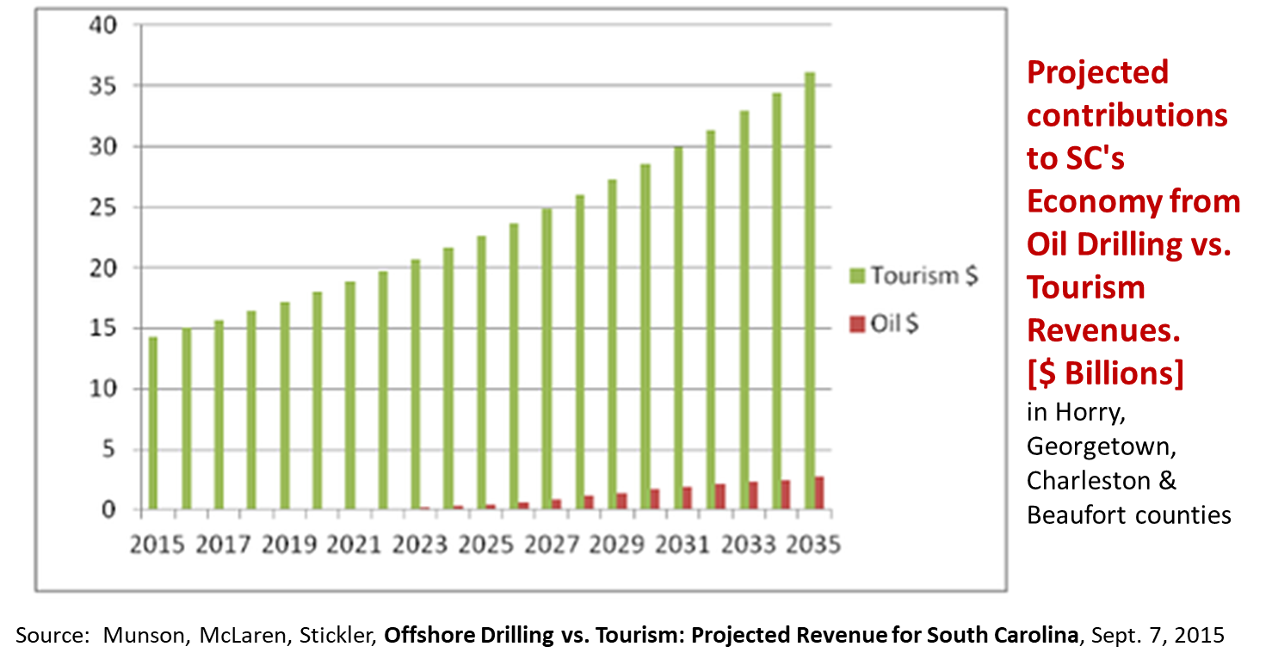

Some have said that oil and gas drilling is safe and can co-exist with tourism, but the records don’t show that…

Everywhere they drill, they spill

Even if the drilling could be conducted safely (and that’s a BIG IF given that the Administration is looking to withdraw some post Deepwater Horizon regulations), there are other aspects of the process that are as dangerous, if not more dangerous, than the drilling itself.

For example, pipelines leak (Santa Barbara, Memorial Day 2015), transporting by tanker has its problems (Galveston, ExxonValdez), and trains carrying oil have derailed (Lac-Megantic disaster in 2013). Just last week a transfer pipeline in Lake Ponchartrain, LA caught on fire killing one and seriously injuring others. And 2 weeks ago, a subsea pipeline spill dumped 670,000 gallons of oil into the GOM, making it the largest single spill since the Deepwater Horizon catastrophe.
Everywhere they drill, they spill.

Jobs, jobs, jobs…?

So, if the state doesn’t benefit from revenues, advocates claim the industry will still bring over 35,000 new jobs in South Carolina by 2035 -- right?

There are a lot of problems with this estimate, but the most important one is that
the oil patch is unique in that the workers are highly trained and very experienced “nomads” who work on rotational schedules. They fly in and work for 2 weeks, then fly home for 2 weeks off. They will not move to SC and not contribute to the local economy on their time off.
These will not be “local” jobs.

Infrastructure will ruin our coastline

And finally, the people of Georgetown City and County do NOT want the Port to become the next Port Fourchon.

- Making the Port of Georgetown the next Port Fourchon will create industrialization and harm to tourism, fishing, health, and the productivity of our coastline
- Georgetown County has passed a resolution against offshore drilling & seismic airgun surveys

Port of Georgetown doesn’t want to be the next Port Fourchon, LA

This is what Port Fourchon looks like. It’s located over 100 miles from Louisiana’s tourism center, New Orleans. The Louisiana coast is not a vacation destination.

Port Fourchon
- Port Fourchon has been in the making for 50+ years
- 1300 acre port - now adding another 4000 acres
- 250 oil field-related companies and LOOP (Louisiana Offshore Oil Port) pipeline

One thing we have in common with Port Fourchon is hurricanes. Hurricanes Katrina and Rita wreaked havoc on the Louisiana coast:
- More than 9 million gallons of oil spilled from damaged offshore and coastal infrastructure
- Over 100 offshore platforms were totally destroyed
- More than 450 seafloor pipeline breaks.
- Six weeks after Rita, Tank Barge DBL 152 struck the unmarked ruins of an offshore oil platform that Rita had demolished. ~2 million gallons of "slurry oil” were dumped. Only 5% of this oil was recovered. The oil footprint covered over 70 square miles.

What’s in it for South Carolina??

- It’s a terrible economic decision
- The good jobs won’t go to South Carolinians
- It’s extremely risky to our coastal economy, our health, our children’s futures and our way of life
- It’s a FOREVER decision

It’s a “FOREVER decision” because once oil companies obtain leases and find commercial quantities of oil and gas, by law, they are entitled to produce from those leases, drill more wells, or sell the property to another operator.

When the oil business comes to town, it is very slow to leave, if ever. And the state cannot make the Feds end the leases.

A “Forever Decision” case example: California’s offshore oil & gas history...

The first Federal OCS lease sale offshore CA was held in 1963. Six years later the first Santa Barbara spill occurred which caused such an uproar against drilling that the US Secretary of the Interior removed federal tracts near Santa Barbara from oil and gas leasing. The state passed immediately instituted a moratorium on drilling in state waters. However, the federal government quickly resumed offshore leasing and continued to hold sales through 1982, when the US Congress finally halted new Federal leasing off California.

A second large Santa Barbara oil spill happened just before Memorial Day weekend 2015, when an underground pipeline that transports oil from an offshore platform to refineries ruptured, spilling 142,000 gallons of crude oil into a coastal state park. The spill, caused by corrosion in a pipeline that did not have automatic shutoff valves, closed nearby beaches for two months, killed hundreds of animals, including birds, sea lions, and dolphins, and cost $96 million to clean up.

Despite the long-term ban on new leasing in federal waters, drilling and production have continued on these leases - from 26 platforms and approx. 200 miles of pipelines. By law, as long as federal OCS wells are producing commercial quantities of petroleum, oil companies may continue to produce from those leases, drill more wells, or sell the property to another operator.
In the California OCS waters, oil companies have produced – and spilled - from these OCS leases and pipelines for over 50 years – more than 40 years after the Santa Barbara spill.

The point of reviewing this history is to emphasize that when the oil business comes to town, it is very slow to leave, if ever. And the state cannot make the Feds end the leases.

Why oppose Atlantic offshore oil and gas exploration and development?

- The U.S. doesn’t need it
- It’s a high risk/no reward decision for South Carolina
- It’s a FOREVER decision
- made by the Feds
- our precious reserves are exported to foreign countries
- profits go to the oil and gas industry
- harms our coast, our health & our economy
They get all the benefits and we take all the risk!

Our requests

We need your help. These are our requests of the Committee and the House:

- Recommend the General Assembly pass a state-wide resolution against offshore drilling and seismic airgun surveying in the Atlantic
- Recommend that proposed state legislation relating to offshore drilling, seismic surveys and infrastructure be put aside
- Request that Governor McMaster, Senators Graham and Scott, and our Congressmen submit comments to BOEM and to DOI Secretary Zinke indicating that the state of SC does not want to participate in offshore drilling or seismic surveys off our coast
- Recommend to the Governor that DHEC deny coastal zone consistency certifications for seismic surveys off our coast and deny permits for onshore infrastructure which supports offshore drilling and seismic surveys along our coast
- Use this turning point in SC’s energy policy to move away from fossil fuel and accelerate development of clean, renewable energy that won’t harm our coastal or upstate economy

We don’t need the reserves in the Atlantic now and for the foreseeable future. So, it all comes down to thinking about who those reserves and this decision belongs to – us or our children and their children?

Let’s take the time and resources we would have spent to fight or promote offshore drilling and put it instead into developing cleaner, renewable energy supplies.

Let’s work together to preserve and protect the Atlantic Ocean and our coast so it will still be as magnificent for future generations as it is today. And let’s hope that future generations will be inspired by our legacy.

Thank you for the opportunity to speak with you today. I’m happy to take your questions.

Written Testimony By: OCEANA

SEISMIC FOR OFFSHORE WIND V. SEISMIC FOR OIL AND GAS

Overview

Seismic surveys are conducted both for offshore fossil fuel exploration and for offshore wind development. The fossil fuel industry uses seismic surveys to search for offshore oil and natural
. gas deposits while the offshore wind industry conducts them prior to the construction phase of an offshore wind farm. However, seismic surveys for offshore wind are much less harmful for three primary reasons.

• Seismic testing for offshore wind does not involve the use of seismic airguns, the most disruptive and potentially harmful seismic technology for marine life.

• Seismic testing for offshore wind occurs over a much smaller area and is conducted after a site for a potential wind farm has already been identified, while seismic testing for fossil fuels involves spanning the ocean to search for deposits of oil and natural gas.

• Seismic testing for offshore wind involves introducing far less sound energy into the marine environment since seismic surveys for offshore wind need only penetrate a few yards deep into the seabed.

Seismic Testing for Oil and Natural Gas

Seismic testing for fossil fuels involves the use of airguns, which are towed behind ships and shoot blasts of compressed air at 250 decibels through the water and miles into the seabed to search for oil and gas deposits. These air guns generate intense pulses of sound, almost as loud as explosives, which go off every ten seconds, 24 hours a day, for days to weeks on end. The resulting pressure wave field transmits downward, miles past the seafloor and into the hydrocarbon layer of Earth's crust, and is then reflected back up towards the ship.
Hydrophones are used to record sound signals reflected from structures within the rock. Navigators compute the position of both the sound source and each hydrophone group in order to locate pockets of oil and natural gas.

Two-dimensional and three-dimensional surveys are the two main types of seismic testing conducted for fossil fuels. The 2-D surveys are used to identify prospective oil and gas formations while the 3-D, which provide better detail, are used to target the best hydrocarbon potential within a specific area or formation. The 3-D surveys require a greater number of

airguns and, despite being significantly more expensive than the 2-D, are preferred by industry because of the higher quality data.

Seismic Testing for Offshore Wind

Unlike seismic surveys for fossil fuels, seismic testing for offshore wind does not involve the use of seismic airguns which must be powerful enough to penetrate deep into the Earth's crust to reveal potential oil and gas deposits. Rather, seismic surveys for offshore wind are conducted
to acquire information about the local seafloor and thus need only penetrate a few yards, rather than miles, Into the seafloor. More specifically, seismic surveys for offshore wind are utilized to identify submerged items that could be hazardous during construction, information pertaining to the presence of archaeological resources, and to gather data for bathymetric charts that map the underwater terrain. The intensity of the sound generated from these seismic surveys depends on the type of technology that is used but none of the technologies used for offshore wind are as intense as seismic airguns, which is the most disruptive and potentially harmful seismic technology to marine life.

Size of Study Area

The starkest difference between seismic surveys conducted for fossil fuels and those conducted for offshore wind is the difference in the size of the area that is seismically surveyed. Currently, the U.S. Department of the Interior (DOl) is deciding if seismic airgun testing should be allowed to search for oil and gas in the Atlantic Ocean. The proposed area for seismic testing spans
along the coasts of seven states, froin Delaware to Florida. Multiple companies have expressed
interest in conducting seismic surveys throughout this region to determine which areas show promising hydrocarbon deposits.

Alternatively, the leasing and siting process for offshore wind involves comparatively small regions of the outer continental shelf that are organized into defined wind energy areas, thus limiting potential negative effects of seismic testing to a smaller region. In fact, DOl's planning
area for seismic testing for fossil fuels in the Atlantic Ocean makes approximately 854,779 km2
available for companies to conduct seismic testing.1 A single offshore wind proposed lease
area, on the other hand,is around 700 km 211, less than 0.1% of the size of the Atlantic slated for seismic testing for fossil fuels.

Potential Wildlife Impacts

According to DOl's own assessments, the impacts to marine life from seismic testing for fossil fuels stand to be more severe than those for offshore wind, due to the high sound Intensity from seismic airguns. Arrays of multiple airguns can produce blasts up to 250 dB In order to
ensure penetration of the seabed to search for hydrocarbon deposits. Levels of 180 dB or greater pose a potential for injury to marine mammals and the blasts are sufficiently loud and constant that they can Injure or disturb vital behaviors in fish, dolphins, whales, and sea turtles.

These impacts can include temporary and permanent hearing loss, abandonment of habitat, the disruption of vital behaviors such as mating and feeding, and even beach standings and deaths.111 •

The frequency emitted from seismic testing for offshore wind is also much less harmful to marine life. The frequency of sound waves from seismic surveys is measured as the number of pulses per second, or Hertz (Hz). Airguns used during seismic testing for fossil fuels emit low frequency pulses since only low frequency sounds can penetrate the earth deep enough to reveal potential deposits in the hydrocarbon layer. Seismic airguns' operating frequency varies, with most energy at 0.2 kHz,well within the hearing range of marine mammals, sea turtles, and
fish. Many seismic surveys for offshore wind, on the other hand, operate at 100kHz or higher which sea turtles and fish will not hear.1'

Seismic surveys for offshore wind are not without potential wildlife impacts, but the technologies used and the conditions under which the surveys are conducted will not cause nearly the same impacts as seismic testing for fossil fuels. While there has been less comprehensive scientific review of the potential wildlife effects of seismic surveys for offshore wind, it is still noteworthy that surveys for offshore wind, unlike those for fossil fuels, do not involve the use of airguns for deep seabed penetration. This is due to the fact that renewable energy facilities are placed yards, rather than miles, deep into the seabed. Seismic surveys for offshore wind therefore introduce far less energy, and thus far less sound, into the environment than seismic surveys for fossil fuels.

Conclusion

While seismic surveys are conducted for both offshore fossil fuel exploration and offshore wind site characterization, not all seismic technologies are created equal. Unlike seismic surveys for offshore wind, the seismic testing conducted to search for oil and natural gas involves the use
of airguns that shoot loud blasts of compressed air, the intense noise from which can have
profoundly serious effects on marine species. Furthermore, seismic testing for fossil fuels is slated to take place along most of the East Coast, from Delaware to Central Florida, thus having more opportunities to seriously impact more species across a greater distance than offshore wind, the seismic testing for which occurs in concentrated lease areas.

1 BOEM, (2012), Atlantic OCS Proposed Geological and Geophysical Activities Mid and South Atlantic Planning
Areas Draft Programmatic Environmental Impact Statement, Vol I: Chapter 1-8.
ii BOEM Office of Renewable Programs. (2012). Commercial Wind Lease Issuance and Site Assessment Activities on the Atlantic OCS Offshore Rhode Island and Massachusetts Environmental Assessment.
iii BOEM. (2012). Atlantic OCS Proposed Geological and Geophysical Activities Mid and South Atlantic Planning
Areas Draft Programmatic Environmental Impact Statement, Vol I: Chapter 1-8,

ivld,

Written Testimony By: South Carolina Beach Advocates
August 14, 2017

The Honorable William M. Hixon Chair, Ad Hoc Committee on Drilling South Carolina House of Representatives
416A Blatt Building
Columbia, SC 29201

Dear Chairman Hixon:

The South Carolina Beach Advocates oppose seismic testing and drilling for oil and gas off our coast. The South Carolina Beach Advocates’ Board of Directors is made up of the Mayors and Administrators of South Carolina beach communities. We are standing together to protect our coastal communities, their economies, and their environments.

According to Stop Offshore Drilling in the Atlantic (SODA), South Carolina’s tourism industry, driven by coastal communities, contributes billions of dollars more than potential contributions from oil revenues. Difficulties in offshore oil drilling make it a dangerous, accident prone industry with the potential for future spills that would impact South Carolina’s beaches and result in cumulative impacts to our state’s coastal ecosystems.

In addition, decades of oil extraction has exacerbated sea level rise in Louisiana to the point that some barrier islands have completely disappeared. South Carolina’s coastal communities are already challenged to plan for projected levels of rising sea level. We must not encourage additional anthropogenic influences that will intensify already rising seas.

Finally, South Carolina’s beach communities are particularly concerned about the infrastructure required to transport oil onshore and process it (nearshore pipelines and dirty processing facilities/refineries). Where along our coast would such invasive infrastructure reside, and at what cost?

We can be available to participate in committee hearings, to provide materials or testify on the value of South Carolina’s beaches that produce billions of dollars in tourism revenue each year.

Thank you for your time. Please contact me at the number or email address below if we may assist you or participate in the August 22 hearing.

Sincerely,
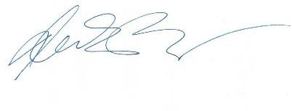

Nicole Elko, Ph.D.
Executive Director, South Carolina Beach Advocates

Pending House Legislation:

A number of bills were introduced during the 2017-2018 Legislative Session that are currently under review by the Legislature. House Bill 4307 would NOT approve a plan or permit application to construct infrastructure used to facilitate the transportation of offshore oil into the land and waters of this State. This legislation was referred to the House Agriculture Committee.
House Bill 4334 would approve a plan or permit application to construct infrastructure used to facilitate the transportation of offshore oil into the land and waters of this State. This legislation was referred to the House Agriculture Committee.
House Bill 4460 is a Concurrent Resolution to memorialize the United States Congress and urge the members to not allow seismic survey or acquisitions off the coast of South Carolina. This legislation was referred to the Committee on Initiations and Memorial Resolutions.
House Bill 4788 is a House Resolution to express the opposition of the South Carolina House of Representatives to offshore drilling activities off of South Carolina precious coast. This legislation was referred to the Committee on Initiations and Memorial Resolutions.
House Bill 4835 is a Concurrent Resolution to express the support of the South Carolina General Assembly to offshore drilling activities off the South Carolina’s coast and the potential economic and environmental benefits of domestic energy production for the State. This legislation was referred to the Committee on Initiations and Memorial Resolutions.
House Bill 4887 is a Concurrent Resolution to express the support of the South Carolina General Assembly to offshore drilling activities off the South Carolina’s coast and the potential economic and environmental benefits of domestic energy production for the State. This legislation was referred to the House Agriculture Committee.
House Bill 4892 is a House Resolution to memorialize President Donald Trump and the members of the South Carolina Congressional Delegation to take action to end offshore oil and gas exploration and drilling in the coastal water of the United States. This legislation was referred to the House Agriculture Committee.
House Bill 4896 is a Concurrent Resolution to memorialize the United States Congress and urge the member to prohibit seismic survey or offshore oil and gas drilling off the coast of South Carolina. This legislation was referred to the House Agriculture Committee.

Conclusion:
The Committee recognizes that there are strong and passionate arguments for and against offshore drilling. The Committee also understands that this is not a process that will be implemented overnight. The process of allowing South Carolina to be a part of leasing and development on the Outer Continental Shelf is a process that will take years. The Committee also understands that South Carolina only has a say in the waters that are within three nautical miles from its coast. The Committee did not reach a unanimous decision on seismic surveying or offshore drilling; therefore, the Committee feels it is their duty to fully debate the pending legislation through the committee process.

References:

^{i} Department of Interior Order No. 3350 (2017). Retrieved from: https://www.doi.gov/sites/doi.gov/files/press-release/secretarial-order-3350-offshore-508.pdf

