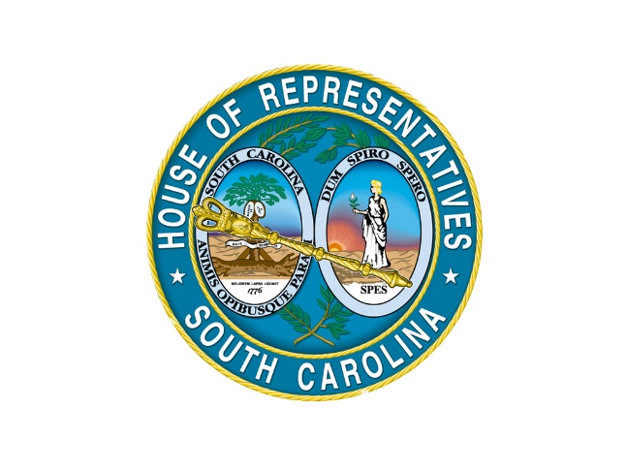

House Education and Public Works Committee
Subcommittee Assignments
2023-2024

Chair: Shannon Erickson
First Vice Chair: Jeffrey A. “Jeff” Bradley
Second Vice Chair: Terry Alexander

K-12 Higher Education Early Childhood
Jeff Bradley (Chair) Tim McGinnis (Chair) Stewart Jones (Chair)
Terry Alexander April Cromer Jeff Bradley
Kambrell Garvin Tom Hartnett Jermaine Johnson
Bill Hager Jay Kilmartin
Kathy Landing Michael Rivers
David Vaughan Deon Tedder

Public Safety Transportation Motor Vehicles
Paula Calhoon (Chair) Adam Morgan (Chair) Doug Gilliam (Chair)
April Cromer Terry Alexander Kambrell Garvin
Stewart Jones Tom Hartnett Bill Hager
Jay Kilmartin Jermaine Johnson Kathy Landing
Deon Tedder David Vaughan Michael Rivers

Staff: Pierce McNair—Director of Research
Macey Webb—Staff Attorney
Ginger Lee—Executive Assistant

