Agency Name: Department of Transportation
Statutory Authority: 57-9-10
Document Number: 4311
Proposed in State Register Volume and Issue: 36/10
House Committee: Education and Public Works Committee
Senate Committee: Transportation Committee
120 Day Review Expiration Date for Automatic Approval: 05/08/2013
Final in State Register Volume and Issue: 37/5
Status: Final
Subject: Sign Requirements for Petitions to Close Road

History: 4311

By Date Action Description Jt. Res. No. Expiration Date
- 10/26/2012 Proposed Reg Published in SR
- 01/08/2013 Received by Lt. Gov & Speaker 05/08/2013
H 01/08/2013 Referred to Committee
S 01/08/2013 Referred to Committee
S 02/06/2013 Resolution Introduced to Approve 354
H 04/24/2013 Resolution Introduced to Approve 4027
- 05/08/2013 Approved by: Expiration Date
- 05/24/2013 Effective Date unless otherwise
provided for in the Regulation

Document No. 4311
DEPARTMENT OF TRANSPORTATION
CHAPTER 63
Statutory Authority: 1976 Code Section 57-9-10

63-1000. Sign Requirements for Petitions to Close Road

Synopsis:

The South Carolina Department of Transportation seeks to promulgate Regulation 63-1000, Sign Requirements for Petitions to Close Road. These new regulations are being proposed to comply with the 2012 amendment to Section 57-9-10 requiring the promulgation of regulations to establish the minimum mandatory size, language and specific positioning of signs to give notice of petitions to close any street, road or highway.

Notice of Drafting was published in the State Register on September 28, 2012.

Instructions:

63-1000. Print as shown below.

Text:

63-1000. Sign Requirements for Petitions to Close Road.

A. Costs. Signs required by parties petitioning to abandon or close any street, road or highway pursuant to Section 57-9-10 must be fabricated and posted by the petitioning party. All costs for the fabrication and placement of the signs shall be the responsibility of the petitioner.

B. Minimum Size. The sign shall have a minimum width of 30 inches, a minimum height of 36 inches and shall comply with the general requirements for sign materials set forth in the Federal Highway Administration’s Manual on Uniform Traffic Control Devices (MUTCD).

C. Design and Content. The sign shall be in substantial compliance with the illustration and table shown below. A detailed layout is available from the South Carolina Department of Transportation by contacting the Director of Traffic Engineering.

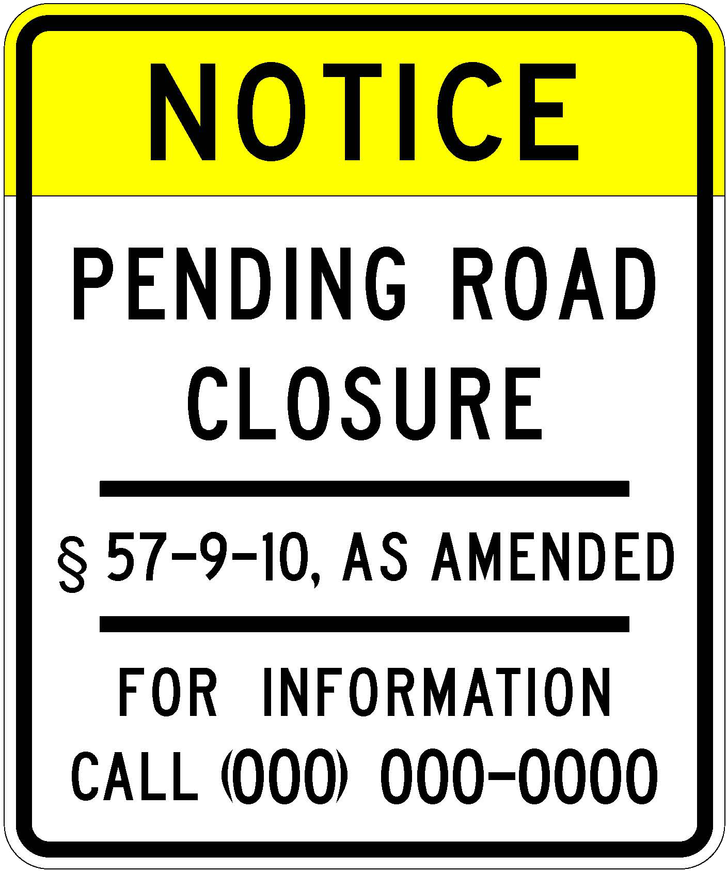

SIGN ELEMENT | LEGEND COLOR | BACKGROUND COLOR | LEGEND SIZE | LEGEND FONT | BORDER INSET
BORDER | BLACK | YELLOW/WHITE | 0.625” | N/A | .5/1.875”
NOTICE | BLACK | YELLOW | 4“ | HWY D | N/A
PENDING RD | BLACK | WHITE | 3” | HWY D | N/A
CLOSURE | BLACK | WHITE | 3” | HWY D | N/A
DIVIDER LINE | BLACK | WHITE | 0.625” | N/A | 4”
§57-9-10 | BLACK | WHITE | 2” | HWY D | N/A
DIVIDER LINE | BLACK | WHITE | 0.625” | N/A | 4”
FOR INFORMATION | BLACK | WHITE | 2” | HWY D | N/A
CALL | BLACK | WHITE | 2” | HWY D | N/A
(000) 000-0000 | BLACK | WHITE | 2.25” | HWY D | N/A

D. Contact number. The petitioning party shall provide a phone number, shown on the sign layout as (000) 000-0000, for the public to call for the purpose of obtaining additional information about the proposed road closure. The phone number shall be either the petitioning party’s local or toll free number, or that of their legal counsel. A representative shall be available during normal weekday business hours, 9:00 am to 5:00 pm, to provide information and answers to inquiries, or a mechanism shall be in place to allow a person to leave a message which will be returned at a convenient time for both parties.

E. Installation. Each sign shall be installed on a single u-channel or square tube breakaway post. The signs shall be installed in compliance with the requirements of MUTCD. For rural roadways where no sidewalk is present, the signs shall be erected within the public right-of-way, but no less than 6 feet horizontally from the edge of pavement. The vertical distance from the edge of pavement to the bottom of the sign (mounting height) shall be a minimum of 5 feet. For roadways having curb and gutter and sidewalk, the signs shall be erected no less than 2 feet horizontally from the face of the curb. In this situation, the mounting height shall be no less than 7 feet.

F. Positioning. If the entire road is to be closed, one sign shall be erected within 100 feet of each terminal end on the right shoulder of the road in the direction of traffic and facing traffic entering the portion the petitioner proposes to close. If only a portion of the road is proposed to be closed, signs shall be erected at the beginning and ending points to be described in the petition and shall be oriented as detailed previously. Additional signs shall also be erected along the roadway where any public road intersects the affected portion. Such additional signs shall be erected within 100 feet of the intersection in both directions on the right shoulder of the road in the direction of traffic and facing traffic departing from the intersection.

G. Permission. Prior to installation of any signs, the petitioning party must submit a request for approval to encroach upon the public right-of-way to the governmental entity having authority over the road. Such request shall include a detailed description or diagram of the proposed sign locations. The petitioner shall also be responsible for locating any existing utilities prior to driving any sign posts.

H. Removal. Upon the court ruling on the road closure petition, the petitioner shall remove all signs erected under these regulations at its expense.

Fiscal Impact Statement:

There will be no increased costs incurred by the State or any of its political subdivisions.

Statement of Rationale:

The purpose of amending Regulation 63-1000 is to comply with the amendment to Section 57-9-10 requiring that the South Carolina Department of Transportation promulgate regulations which establish the minimum mandatory size, language and specific positioning of signs to be posted by parties petitioning to close a street, road or highway.

