South Carolina

Drycleaning Restoration Trust Fund

Program Status Report

January 15, 2007

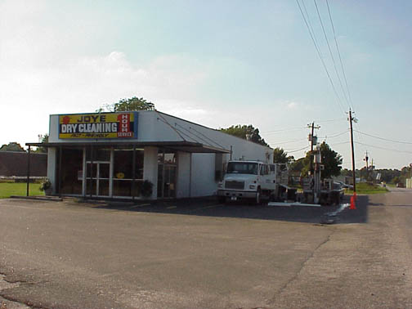
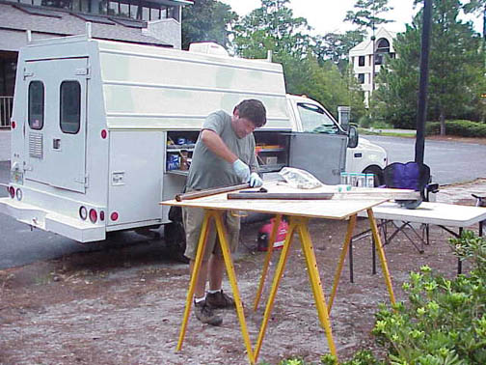

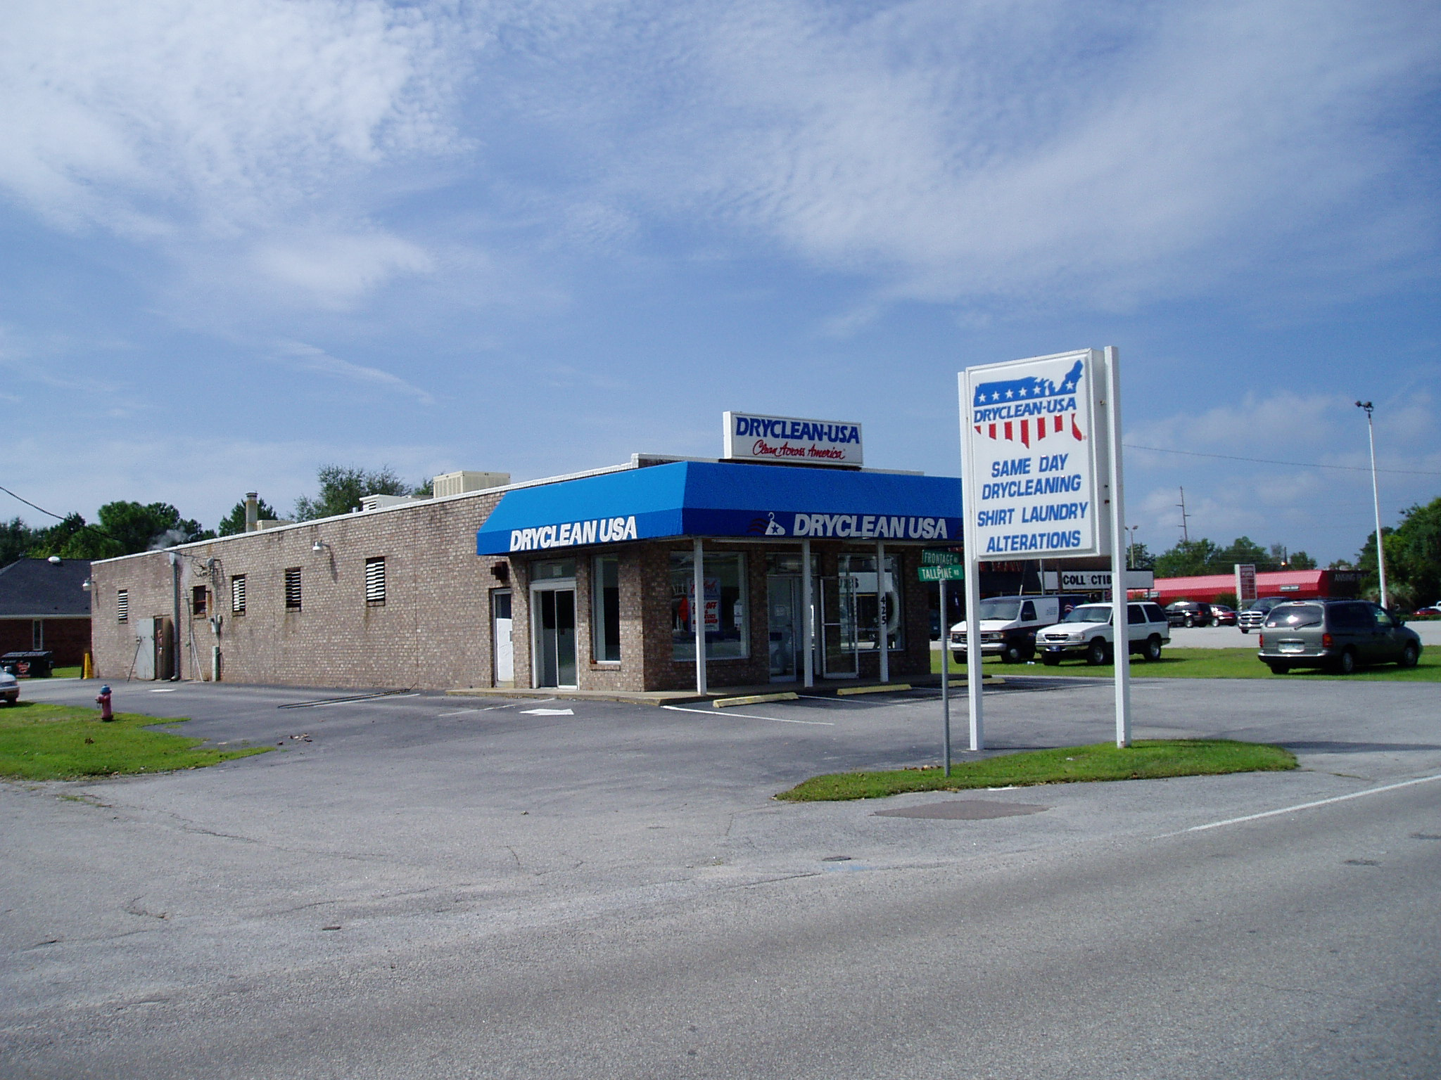



South Carolina Department of Health and Environmental Control

Bureau of Land and Waste Management
Site Assessment and Remediation Division

South Carolina Drycleaning Restoration Trust Fund
Program Status Report
January 15, 2007

TABLE OF CONTENTS page

1. Introduction 3-5
2. Fund Status and Five-Year Funding Projection 6-10
3. Public Participation in the Drycleaning Program 11
4. Prioritization 12
5. SC Drycleaning Restoration Trust Fund Sites, listed by County 13-23
6. List of Acronyms 24
7. List of Certified Environmental Contractors (Current 12/15/06) 25-27

1. Introduction

This report is provided to the South Carolina General Assembly as part of the requirement of Article 4 of Title 44, Chapter 56 of the 1976 Code of Laws, Section 44-56-430 Part C. It contains the financial obligations as well as a 5-year budget projection as required.

In 1995, the South Carolina General Assembly created the Fund to address environmental contamination resulting from drycleaning activities in South Carolina. The Fund was formed at the urging of the drycleaning industry to protect small drycleaners from the potentially devastating financial responsibility of environmental problems at their facilities. Many of these problems date back numerous years and have resulted from operational and disposal practices that were common before the industry was environmentally regulated. Since small businesses rarely have the financial capital to deal with such issues, problems of contamination were often not addressed.

Several hundred drycleaners initially joined the Fund, but not every drycleaner in South Carolina participated. Drycleaners who used petroleum-based solvents were given a one-time opportunity in 1995 to opt-out of the Fund. These businesses are not required to pay the annual fees or solvent taxes paid by participating drycleaners, but by not participating, they are also not allowed to reap the benefits of the Fund if contamination is ever discovered on their property. Over the years, some of these original “opt-outs” have since chosen to participate in the Fund.
When the Fund was created, it was known that contamination would likely be found, but the extent of the problem has proven to be larger than initially understood. Since field investigations of the highest priority drycleaning sites began, contamination plumes have been found in groundwater at drycleaners across South Carolina. In addition, public and private water supply systems as well as some streams and other surface water bodies have been impacted by contamination. In short, drycleaning-related environmental contamination has been found on almost every site investigated to date.
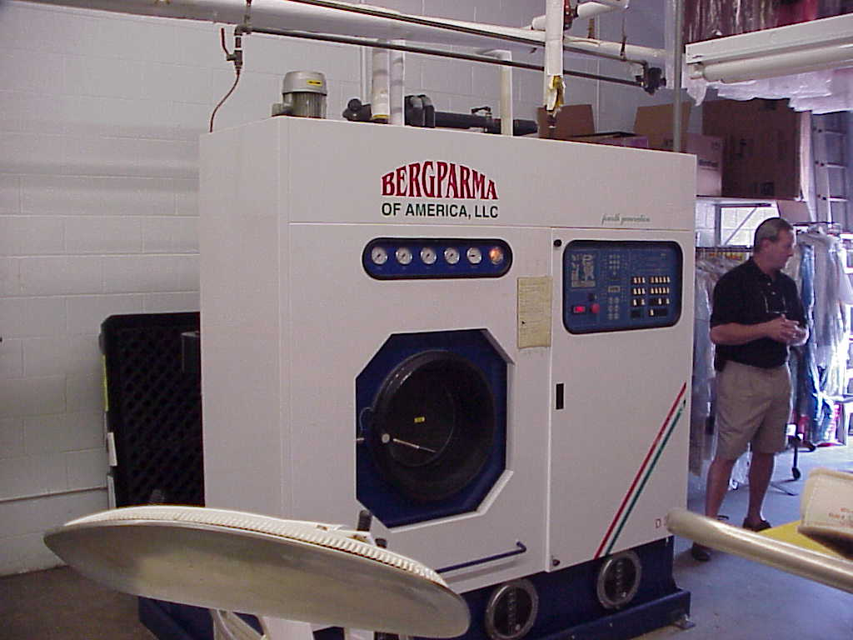
A newer dry-to-dry model machine with built-in containment.
There are several reasons for the presence of solvents in the soil and groundwater around drycleaning facilities. The most commonly used drycleaning solvents, perchloroethylene (PCE, or “perc,” an industrial chemical) and various compounds derived from petroleum (Stoddard solvent), easily pass through many materials, including the concrete floors common at drycleaning plants. Most of the older drycleaning transfer machines, which require solvent-laden clothes to be moved from the machine to a dryer, were a source of release to the environment. Regulations now require that the floors in drycleaning plants be sealed with epoxy paint or other impermeable surface. Newer dry-to-dry drycleaning machines, pictured above, are designed to both wash and dry clothes in the same machine, thus avoiding drips and spills occurring during the transfer of clothes from the washer to the dryer.

Other releases came from waste by-products created by the filtering and distillation processes necessary for re-use of solvent in the drycleaning plant. These wastes contain small amounts of solvent and are now collected by hazardous waste disposal companies. Before the disposal companies began operating in the late 1980’s, the wastes were commonly discarded directly onto the ground, into the sewer system, or into leaky dumpsters. Also, since older drycleaning machines vent solvent vapors to the outside, solvents would condense in cool weather and collect on nearby exposed soil.

A spotting station, used for removal of stubborn stains with concentrated PCE prior to drycleaning. Release of PCE from this type of station is another potential route for drycleaning solvents to enter the environment. | 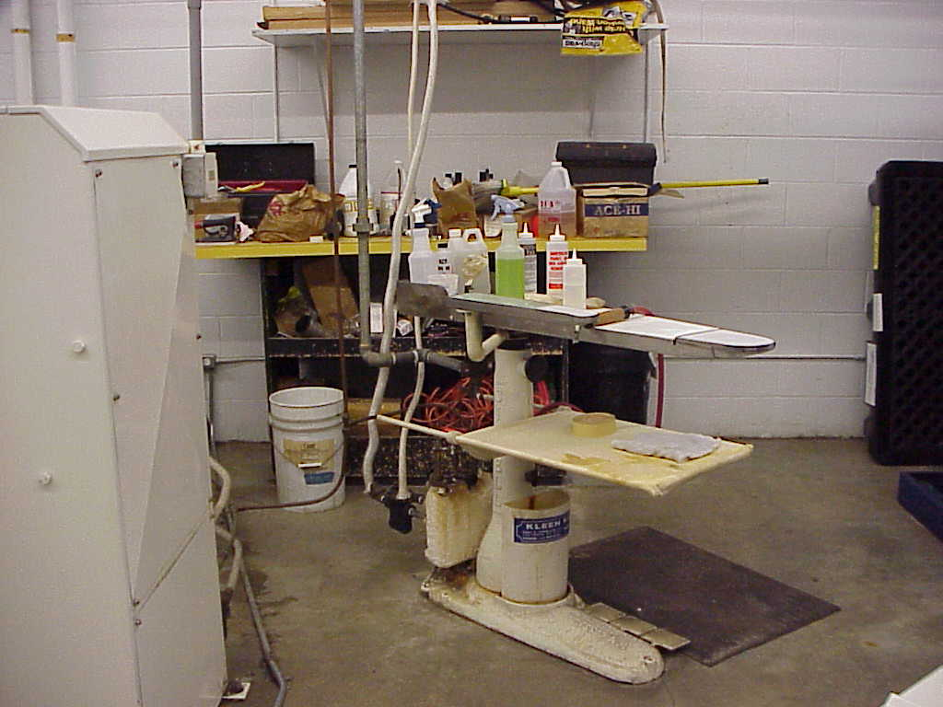

Since the solvents do not break down quickly in the environment, small releases can eventually accumulate into a significant source of contamination under the drycleaning plant. Solvent trapped in the soil beneath a drycleaning facility can be a continuing source of groundwater and soil contamination for many years. As a result, a drycleaning plant may be an ongoing source of contamination long after it has stopped operating or has implemented containment measures to prevent further releases.

Since the Fund is limited in size, it cannot immediately address the environmental problems at every participating site. Two primary mechanisms have been implemented to ensure the sites that present the most significant health impacts are addressed first and that there is enough money in the Fund to continue the work into the future. The first is a priority list (further details in Section 4), based on health impacts, that is created from detailed information gathered on each participating drycleaning site. The second mechanism was implemented in 2004 when the South Carolina General Assembly amended the Act to provide for additional money to come into the Fund. These additional sources of funds come from the 1% environmental surcharge on drycleaning sales and from annual fees on new or delinquent drycleaners that are required to participate in the Fund.

One of the most positive program outcomes is the enhancement of environmentally sustainable business practices by participating drycleaners. The Act requires participating drycleaning operators to certify to DHEC that they are handling their drycleaning solvents in an environmentally responsible manner. As a result, drycleaners participating in the Fund have maintained or implemented containment measures that do not allow solvents to be released to the soil or groundwater. While this will not remove contamination that has already been released into the environment, these measures will greatly reduce the probability of future releases therefore lessoning the impact that the drycleaning solvents have on the environment.

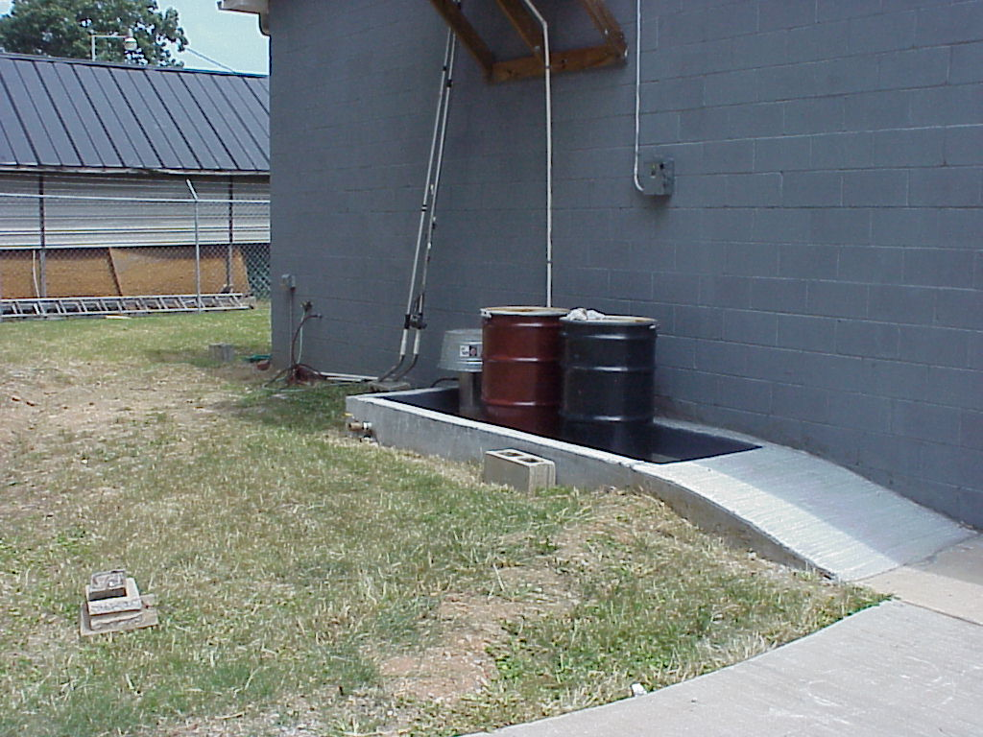
Contained waste storage behind a drycleaning facility.
2. Fund Status and Five-Year Funding Projection

Funding Source
The South Carolina Department of Health and Environmental Control (DHEC) is responsible for administering the South Carolina Drycleaning Restoration Trust Fund (the Fund). The South Carolina Department of Revenue (DOR) is responsible for drycleaner registration and collection of money into the Fund.

Revenue for the Fund has historically been derived from two sources: 1) Registered facilities pay yearly fees into the Fund based on their number of employees; and 2) A surcharge is assessed on every gallon of drycleaning solvent purchased for use in the state. The annual fees are assessed on a sliding scale that depends on the number of employees at each drycleaning business. Surcharges are not collected from drycleaners that registered with DOR as opting out of the Fund.

As a result of declining revenues to the Fund (Figure 1), a legislative change enacted in May 2004 added a 1% sales tax on drycleaning as a third source of revenue. Imposition of the 1% tax began on July 1, 2004 (Fiscal Year 2005, FY05). With the addition of the 1% tax, revenue into the Fund increased from $655,000 in FY04 to $1,284,000 in FY05 and to $1,610,701 in FY06.

The historical total income into the Fund through July 1, 2006 is $10,142,180, and historical total expenditures through July 1, 2006 have been $8,106,809 (Figure 2). For the first three years, the only expenses to the Fund were minor amounts necessary to cover DHEC’s expenses while regulations and procedures were developed. Expenses increased slightly over the next two years as fieldwork was conducted to obtain information necessary to prioritize the large number of sites that had applied to become eligible for the Fund. By FY01, expenditures started increasing as assessment activities began on several sites and remediation systems were implemented. By early FY04, the Fund balance had dropped to a point that work had to be suspended on most sites. With the addition of the sales tax as a revenue source, DHEC has begun assessing and remediating sites once again.

Funding Needs
There are 272 drycleaning plants that have registered into the Fund as of July 1, 2006. Not all of these plants are still operating. In addition, there are 182 former drycleaning plants that stopped operating prior to 1995 (when the original legislation was enacted) that are also eligible for the Fund. Altogether, there are 454 known drycleaning sites that may use Fund monies. As of November 27, 2006 only new drycleaning facilities may apply for eligibility to the Fund. Petroleum users were allowed to withdraw from Fund eligibility in 1995. Otherwise, they were required to register with the Department of Revenue and pay into the Fund.

It is estimated that $147 million will be required over the lifetime of the Fund to assess and clean up eligible sites. This amount may be considerably under-estimated because it is based on assumptions that future sites will not require the level of funding expended thus far and has not been adjusted for inflation. The actual amount may be higher by the time all drycleaning sites are cleaned up. This figure includes estimates of $59 million for assessment costs and $88 million for remediation costs including funds needed for long-term operations and maintenance of remedies installed at drycleaning plants.

Assessment Costs
Assessment costs are incurred during activities to delineate the nature and extent of contamination. A large portion of the assessment costs at drycleaning plants is due to the expense of investigating groundwater contamination. To date, completed assessments at drycleaning sites have costs ranging between $51,000 and $477,000. The average cost of assessing each site is $182,000. It is anticipated that the average cost will drop at least 10% due to increased efficiencies of the program as experience is gained with more sites. It is also assumed that some lower priority sites will be less expensive to evaluate because it is probable that the contamination will be less extensive than has been found at the higher priority sites.

Assuming the average assessment cost can be decreased to $161,000, it will require at least $59 million for assessment costs to investigate the sites.

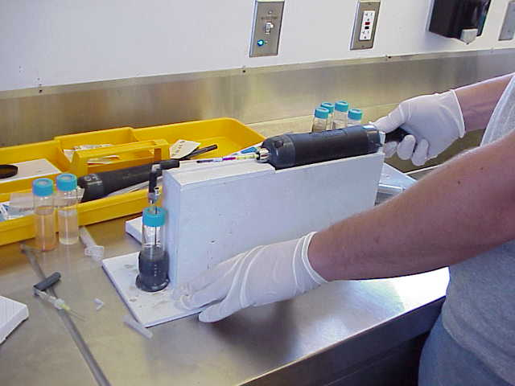 | One of the most common field assessment methods is the Color-Tec Screening Procedure. During the initial phases of assessment, water or soil from the site is collected into a small vial and heated. The air in the vial is then tested for the presence of hydrocarbon compounds. Such real-time assessment in the field allows for faster and more economical delineation of a contaminant plume.

Remediation Costs
Once the sites are investigated, they usually require some type of remedy in order to meet the clean-up standards. Of the sites investigated to date, approximately 75% will require a full remediation system. Even if a full remediation system is not needed because the levels of contamination are below clean-up standards, approximately 20% of the sites will likely require a few years of monitoring to verify that the contamination has stabilized or is decreasing. It is likely that less than 5% of all sites investigated will not need any follow-up expenditure for either remediation or long-term monitoring.

The costs of the installed remedial systems have averaged $457,000 per site, including all costs of installation and the projected costs of operation and maintenance (O&M) for the number of years that will be required until the clean-up goals are met.

For cost estimating purposes it is assumed that 75% of the sites will need a full remedy. It is also assumed that the average cost of remediation can be reduced 30% (to $320,000) because lower priority sites should not have the same extent of contamination as the higher-priority sites. Most of the remaining sites will require monitoring to ensure the contamination is adequately addressed. Based on these assumptions, $88 million will be needed for remediation costs over the lifetime of the Fund.

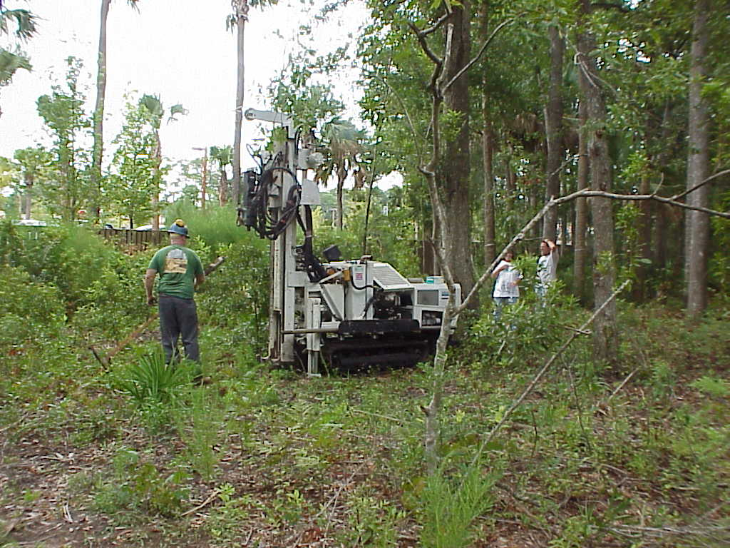 | 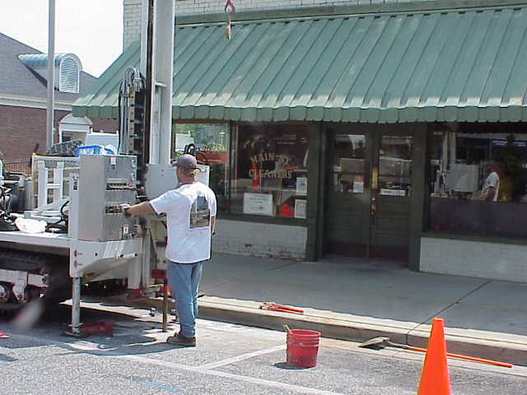
Direct-push (DP) methods have allowed Fund contractors to rapidly delineate contaminant plumes on most sites. This technology requires use of a small drill rig that pushes and hammers a metal core barrel into the ground. Soil and groundwater samples can be acquired by DP technology for rapid screening of contaminants in the field and eventual laboratory analysis. Unlike groundwater monitoring wells, which are installed and can be re-sampled many times, DP wells are designed to be temporary and inexpensive and are usually abandoned the same day they are drilled.

Five-Year Funding Projection
As of December 1, 2006, DHEC has commitments for assessment and remediation totaling $962,422, leaving an uncommitted balance of $994,491. Existing funds and new revenue are anticipated to be committed in 2007 for priority sites.

To complete the funding projection, the income into the Fund was estimated over the next five fiscal years. The historical trend shows income declining steadily from a high in 1997 until the sales tax was implemented (Figure 1). Using trend analysis, the projected income to the Fund will decline over the next five years to a level of $1,120,545 in FY11 (Figure 3). It is possible, however, that the funding level will stabilize and the decreasing trend will not be realized over the next five years.

Figure 3 also includes a five-year projection of expenditures. This projection indicates that expenditures in years 2007 through 2010 will exceed the income into the Fund. However, by the year 2011 the projection indicates that income and expenditures will be equivalent.

Table 1: Income and expenditures for the Fund, 1996-2006.
Data for 2007-2011 (in italics) are projected.
3. Public Participation in the Drycleaning Program

One of the goals of the Drycleaning Restoration Trust Fund Program is to encourage public participation in the remedy selection process. Community involvement in the program is important for several reasons. Primarily, it gives local residents an opportunity to have input into choosing a remedial strategy and allows them to address any concerns that they may have about the site. People living near a site may be aware of conditions that could influence the effectiveness of the available remedies. On several occasions, sharing of such important information has substantially aided DHEC’s understanding of the site and has steered the remedy choice.

Once appropriate analytical information has been collected on a drycleaning site, a contractor is assigned to review the various technologies that may be effective for remediation. A Feasibility Study (FS) from the contractor provides an in-depth evaluation of the site characteristics and information on the remedies that can be used. Some remedies are eliminated early in the process as impractical for the site. The others are developed further with detailed information on implementation strategies and cost estimates. While the FS will usually point to one or two remedies as clear-cut choices, public input is sought before final selection of a remedy.

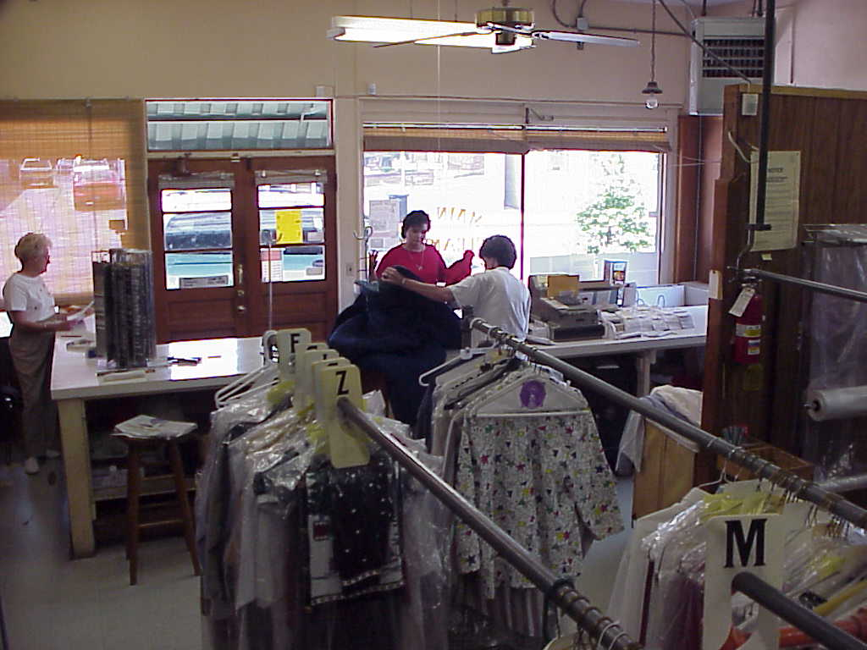
Front counter area inside Main Street Cleaners, Marion.

Information about the site and its upcoming remediation is distributed to the public via a legal notice in the local newspaper and letters to area residents, local government officials, and locally-elected members of the S.C. General Assembly. A public meeting is scheduled for a location near the drycleaning site, and the time and place are advertised in the legal notice and individual letters. At the meeting, a DHEC spokesperson presents an overview of site conditions and explains the potential remedies that have been considered. An open forum with a question-and-answer session follows this presentation. A court reporter compiles an official transcript of the meeting, and people are encouraged to call the program’s toll-free telephone number (1-866-343-2379) if they have further questions.
4. Prioritization

Drycleaners that have registered with DOR are not eligible for the Fund until a completed eligibility application is submitted to DHEC. The eligibility application documents such information as which solvent(s) is used at the site, how long the drycleaner has been in operation, and how the waste products from the cleaning process are disposed. The applicant (usually the drycleaning business owner or land owner) certifies in the application that the drycleaning plant meets all of the eligibility criteria specified in the law. DHEC assigns a priority ranking to the site using information provided in the eligibility application.
The priority rank is determined by a scoring system that emphasizes potential threats to human health that can occur from drycleaning solvent contamination. The scoring system makes assumptions about the potential human exposures to contamination from a site. One common assumption used in scoring the sites is that nearby people use private wells as their source of drinking water if public water lines do not serve the area. Other assumptions are based on site-specific information about the age of the plant, the types of solvents used, regional geology, and surrounding land use. Unless a particular exposure pathway from the site is known to be nonexistent, it is assumed that a potential threat is present via that mechanism. In late 2006, an Expanded Initial Assessment (EIA) Procedure was implemented to gather information to replace the assumptions and get a “real” idea as to the extent of the health and environmental effects at each site. The EIA process will be stepped up in 2007.
Section 5 is a listing of all sites that are potentially eligible for the Fund along with their priority ranking. The lower numbers (i.e., 1, 2, 3, etc.) are assigned to the sites that are most likely to have the greatest health effect, thus site #1 is the highest priority site in the state and is thought to be the site most likely to affect the largest number of people. Some of the sites do not yet have a priority ranking. This is primarily because the drycleaner has registered with DOR (and is thus potentially eligible for the Fund) but has not filed an eligibility application with DHEC. The legislation that was passed in 2004 allowed more applications to the Fund, and DHEC is still in the process of evaluating those new applications.

Once eligibility determinations have been made on the new sites, field surveys will be made on all sites that have come into the Fund and prioritization will be conducted on all un-ranked sites. It is anticipated that the field surveys of the new sites will be completed in the summer of 2007 with prioritization finished by late 2007. Once completed, a new priority list will be available for public viewing on the DHEC website listed below:  http://www.scdhec.gov/lwm/html/dryclean.html. | 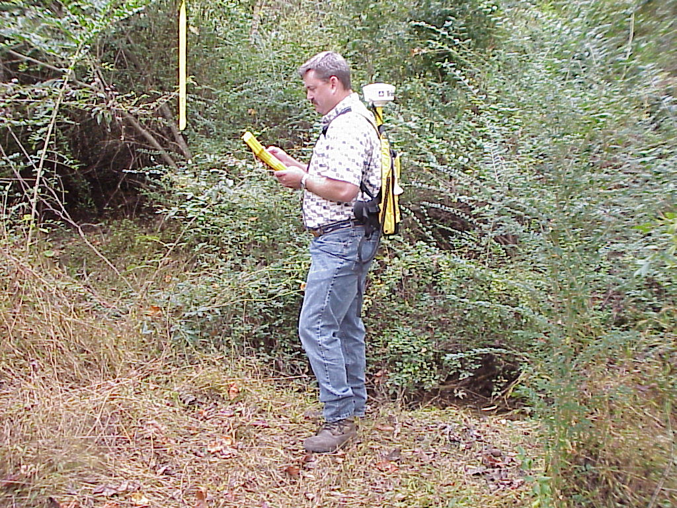
5. SC Drycleaning Restoration Trust Fund Sites, listed by County

Appendix: South Carolina Drycleaning Restoration Trust Fund Site List
This list is arranged by county. For a listing in order of priority, please refer to the website address http://www.scdhec.gov/lwm/html/dryclean.html. Inclusion of sites on this list does not make a site Eligible for the Fund. Scores have been assigned to sites regardless of their Fund Eligibility Status.
ABBEVILLE COUNTY |  |  | PRIORITY
Abbeville Deluxe Cleaners Inc | 403 S Main St | Abbeville | 211
Fmr. Farmers Cleaners | 303 Poplar Street | Abbeville | 209
AIKEN COUNTY
Fmr. Carlyn Services | 217-A Edgefield Rd | North Augusta | 250
Force Cleaners/One Hour Cleanerizing | 417 Georgia Ave | North Augusta | 50
Sundance Cleaners | 1416 Whiskey Rd | Aiken | 90
Colonial Cleaners Inc | 706 Old Edgefield Rd | North Augusta | 258
Belvedere Cleaners | 502 Clearwater Rd | Belvedere | 27
Warneke Cleaners Inc | 113 Newberry St SW | Aiken | 129
Osbon Laundry & Cleaners | 136 Pendleton St SW | Aiken | ***
Fmr. Quick As A Wink Cleaners | 153 Pendleton St | Aiken | 363
Sundance Cleaners | 403 H Silver Bluff Rd | Aiken | 208
Oxford Cleaners | 165 Market Place Dr | North Augusta | 237
ANDERSON COUNTY
Fmr. Modern Cleaners | 106 Manning St | Anderson | 331
Riggins Garment Care Inc | 215 E Main St | Williamston | 336
My Cleaners & Laundry Inc. | 2910 Abbeville Hwy | Anderson | 28
Modern Dry Cleaners Inc | 3307 Cinema Ave | Anderson | 127
Deluxe Cleaners | 19 Mill St | Williamston | 44
Riggins Garment Care Inc | 1903 N Main St | Anderson | 387
Belton One Hour Cleaners Inc | 420 S Main St | Belton | 188
Superior Dry Cleaners | 301 E Benson St | Anderson | 310
Modern Dry Cleaners Inc | 113 Whitehall Rd | Anderson | 109
Professional Cleaners | 1504 E Greenville St | Anderson | 283
Soft Touch Cleaners Inc. | 2130 E Greenville St | Anderson | ***
Foothills Drycleaning | 11026 Anderson Hwy. | Piedmont | ***
BAMBERG COUNTY
Fmr. Superior Cleaners | 322 South Main Street | Bamberg | 38
Colonial Cleaners | 197 Magnolia Street | Denmark | 1
Superior Cleaners | 2293 Main Hwy | Bamberg | 137
Fmr. Thompson Cleaners | 47 Bell St | Bamberg | 20
D&V Cleaners | 3070 Main Hwy. | Bamberg | 7
BARNWELL COUNTY
Edwards Professional Cleaners | 4444 Rosemary Street | Williston | 24
Color Craft Cleaners | 9008 Marlboro Ave | Barnwell | 29
Pressing Club, The | 1619 Allen St | Barnwell | ***
BEAUFORT COUNTY
Fmr. Dryclean USA Coastal, Inc. | 1349 Ribault Rd | Port Royal | 173
Fmr. Dryclean USA Coastal, Inc. | 7 Pope Ave/Coligny Plaza | Hilton Head | 150
Fmr. Dryclean USA (Market Place) | 11 Palmetto Bay Rd | Hilton Head | 19
Fmr Advance Cleaners/Dryclean USA | 55 New Orleans Rd | Hilton Head | 107
Dryclean USA Coastal Inc | 70 Pope Ave | Hilton Head | 85
Dryclean USA Coastal #316 | 302 B Pineland Mall | Hilton Head | 2
Dryclean USA Coastal #315 | 16 Palmetto Bay Rd | Hilton Head | 94
Dryclean USA Coastal #312 | 7 Robert Smalls Pkwy Ste 5 | Beaufort | 146
Tucker Dry Cleaners Inc | 1905 Boundary St | Beaufort | 332
Dryclean USA Coastal #311 | 136 A Sea Island Pkwy | Ladys Island | 56
Fmr. Custom Cleaners | 123 Mathews Dr | Hilton Head | 12
Oxford Cleaners | 780-A Parris Island Gateway | Port Royal | 55
Clothes Press Cleaners | 47 A Goethe Rd | Bluffton | 45
The Clothes Press | 373 Red Cedar St. | Bluffton | 57
BERKELEY COUNTY
Kawasaki Cleaners | 205 N Goose Creek Blvd, Suite B-8 | Goose Creek | 31
Fmr. One Hr. Martinizing | 104 South Highway 52 | Moncks Corner | 65
Kawasaki Dry Cleaners | 625 Red Bank Rd | Goose Creek | 88
Plantation Cleaners | 1316 Redbank Rd, Suite #1 | Goose Creek | 157
Yeamans Hall Drycleaner | 1306 Yeamans Hall Rd | Hanahan | 352
Gethers Cleaners | 206 N Hwy 52 | Moncks Corner | 58
Heritage Cleaners | 221 N Hwy 52 | Moncks Corner | 97
Dryclean USA Coastal #304 | 211 Saint James Ave | Goose Creek | 325
Tommy's Cleaners | 431 A St James St | Goose Creek | 123
CALHOUN COUNTY
City Dry Cleaners | 1505 Bridge St | Saint Matthews | 33
CHARLESTON COUNTY
East Bay Cleaners | 480 E Bay St | Charleston | 362
Fmr. D&B One Hour Martinizing, Inc. | 14 Carriage Lane | Charleston | 255
Fmr. Dryclean USA Coastal, Inc. | 509 A Hwy 176 | Goose Creek | ***
Fmr. Dryclean USA Coastal, Inc. | 5634 Rivers Ave | North Charleston | 341
Fmr. Dryclean USA | 520 Folly Rd | Charleston | 303
Fmr. Dryclean USA Coastal, Inc. | 65 Windermere Blvd | Charleston | 287
Fmr. Dryclean USA Coastal, Inc. | 3328 Rivers Ave | Charleston | 376
Fmr. Dryclean USA Coastal, Inc. | 410 Coleman Blvd | Mount Pleasant | 53
Fmr. Dryclean USA Coastal, Inc. | 316 East Bay St | Charleston | 335
James Island Cleaners | 1739 Maybank Hwy | Charleston | 272
Classic Cleaners | 2665 Ashley Phosphate Rd | North Charleston | 398
Centerville Cleaners | 852 Folly Rd | James Island | 125
Dryclean USA Coastal #310 | 1643 B Savannah Hwy | Charleston | 316
Dryclean USA Coastal #309 | 230 Mathis Ferry Rd | Mount Pleasant | 163
Dryclean USA Coastal #306 | 1518 Hwy 17 North | Mount Pleasant | 189
Dryclean USA Coastal #305 | 425 Johnnie Dodds Blvd | Mount Pleasant | 3
Fmr. Dryclean USA Coastal Inc | 811 Coleman Blvd | Mount Pleasant | 99
Dryclean USA Coastal Inc | 96 Wentworth St | Charleston | 170
Fmr One Hour Valet | 1235 Savannah Hwy | Charleston | 300
Tip Top Cleaners | 4727 Mixon Ave | North Charleston | 319
Kim's Cleaners/Fmr One Hour Valet | 3655 Rivers Avenue | North Charleston | 46
Kings Valet Cleaners | 1970 Ashley River Rd | Charleston | 305
Pelican Cleaners | 1521 Palm Blvd | Isle Of Palms | 185
Fmr. Chris' Drycleaning | 761 Coleman Blvd | Mount Pleasant | ***
Old Towne Cleaners Inc #4 | 2140 Savannah Hwy | Charleston | 126
Old Towne Cleaners Inc #3 | 5405 Dorchester Rd | North Charleston | 155
One Hour Valet | 8510-A Rivers Ave | North Charleston | 323
Pressing Club Cleaners | 1664 Hwy 171 Unit A | Charleston | 195
Swinton Dry Cleaners & Laundry | 106 Spring St | Charleston | ***
Coastal Carolina Cleaners | 875 Houston Northcutt Blvd. | Mount Pleasant | 30
Charleston Cleaners | 3219 Maybank Hwy, | Johns Island | 16
Sandy's Cleaners | 9625 Highway 78 | Ladson | 266
Village Cleaners | 2161 Hwy 17 N, Unit D | Mount Pleasant | 22
Diamond Cleaners | 1947 Maybank Hwy | Charleston | 308
Smith Family Cleaners | 1015 Harborview Rd | Charleston | 212
Smith Family Cleaners | 336 Folly Rd | Charleston | 253
Tip Top Cleaners | 5647 Rivers Ave | North Charleston | 338
Charleston Dry Cleaners And Laundry | 525 E Bay St | Charleston | 143
Fmr. Barrineau's 1 Hr Martinizing | 730 Rutledge Ave | Charleston | 13
Dry Clean World | 1954 Ashley River Road, Ste. A | Charleston | 147
White Point Services | 2960 Rivers Ave | Charleston | 219
Fmr. One Hour Valet | 2004 Ashley River Rd | Charleston | 100
Old Towne Cleaners | 4400 Dorchester Rd, Ste 101 | North Charleston | 32
Rae's Cleaners | 1644 Highway 17 N | Mount Pleasant | 41
Lighthouse Cleaners | 65 Sycamore Ave | Charleston | ***
Island Cleaners | 2770-H Maybank Hwy | Johns Island | 114
CHEROKEE COUNTY
Blanton's Cleaners | 403 Elm St | Gaffney | 154
CHESTERFIELD COUNTY
Professional Cleaners | 1131 W Greene St | Cheraw | 34
Chesterfield Cleaners | 165 W Main St | Chesterfield | ***
Pageland Cleaners | 122 N Maple St | Pageland | ***
Shree Hari Cleaners | 206 N Maple Street | Pageland | ***
COLLETON COUNTY
Andersons One Hour Cleaners | 197 Ireland Creek Dr | Walterboro | 17
Sentry Cleaners Of Walterboro | 215 Robertson Blvd | Walterboro | 69
DARLINGTON COUNTY
60 Minute Cleaners | 635 W Carolina Ave | Hartsville | 49
Whte Swan Fmr One Hour Martinizing | 409 Pearl St | Darlington | 25
DORCHESTER COUNTY
Davis Dry Cleaning | 604 Bacons Bridge Rd | Summerville | 54
Davis Dry Cleaners | 10050 Dorchester Rd | Summerville | 96
Dry Clean Express/Fmr Lenz Cleaners | 5101 Ashley Phosphate Rd, Suite 100 | North Charleston | 281
Lenz Dry Cleaners And Laundry | 1625 N Main St, Suite 101 | Summerville | 121
Dryclean USA Coastal Inc | 9998 A Dorchester Rd | Summerville | 118
Davis Modernize Of Summerville Inc | 523 N Main St | Summerville | 196
Davis Modernize Of Summerville Inc | 100 Miles Rd | Summerville | 365
Knightsville Dry Cleaners | 1580 Central Ave | Summerville | 6
Dukes Dry Cleaners | 5678 Memorial Blvd | Saint George | 91
Brady's Cleaners | 1115 A Central Ave | Summerville | 215
EDGEFIELD COUNTY
Beason's Cleaners | 70 Calhoun St | Johnston | 190
FAIRFIELD COUNTY
Carolina Cleaners Inc | 223 S Congress St | Winnsboro | 210
Becknell Cleaners | 201 N Congress St | Winnsboro | 40
FLORENCE COUNTY
Florence Steam Laundry | 374 West Darlington St | Florence | 106
Florence Steam Laundry | 1933 West Palmetto St | Florence | 200
Fmr. One Hour Martinizing | 1105 E Palmetto St | Florence | 139
Fmr. White Swan Laundry, Inc. | 324 West Evans Street | Florence | 179
Superior Cleaners & Laundry Inc | 124 Dansing Street | Lake City | 78
Cleanery, The | 2241 W Palmetto St | Florence | 63
One Hour Martinizing Company No 1 | 832 S Irby St | Florence | 66
One Hour Martinizing Company No 3 | 1700 2Nd Loop Rd | Florence | 4
One Hour Martinizing Company No 2 | 1701 W Palmetto St | Florence | 183
White Swan Dry Cleaners | 223 Cherokee Rd | Florence | 76
Custom Cleaners | 1619 W Palmetto St | Florence | 218
West Gate Cleaners | 2131 Hoffmeyer Rd | Florence | 132
White Swan Dry Cleaners | 310 N Irby Street | Florence | 169
Fmr. Hubbards Cleaners | 204 Graham St | Florence | 52
K & M Dry Cleaners | 510 2Nd Loop Rd | Florence | 61
Sunshine Dry Cleaners | 1210 S Cashua Dr | Florence | 5
GEORGETOWN COUNTY
Fmr. Georgetown Laundry Inc | 1109 N Fraser | Georgetown | 290
Island Cleaners | 10225 Ocean Hwy Unit 382 | Pawleys Island | 172
Andrews Cleaners | 2 E Main St | Andrews | 11
Landys Cleaners Inc | 119 N Fraser St | Georgetown | 134
Curry's Professional Dry Cleaners | 1506 Highmarket St | Georgetown | 14
Curry's Plantation Cleaners | 1243 N Fraser St | Georgetown | 9
Georgetown Laundry Inc | 1230 Church St | Georgetown | 10
GREENVILLE COUNTY
Poinsett & Housecall Cleaners | 114 E Stone Ave | Greenville | 249
Fmr Dryclean USA Of SC, Inc | 3245 Wade Hampton Blvd | Taylors | 101
Dryclean USA Of SC, Inc | 3402 W Blue Ridge Dr | Greenville | 216
Fmr. Sunshine Cleaners | 1704 B Laurens Rd | Greenville | 194
Fmr Dryclean USA Of SC, Inc | 114-A W Butler St | Mauldin | 98
Fmr Dryclean USA Of SC, Inc | 1430 Pelham Rd | Greenville | 168
Fmr. Leawood Cleaners & Laundry | 1223 Poinsett Hwy | Greenville | 262
Fmr Dryclean USA of SC, Inc | 5 Legrand Blvd | Greenville | 167
J & A Laundry Service | 633 N Main St | Simpsonville | 145
Fmr Dryclean USA of SC, Inc | 3601 E North St | Greenville | 342
Fmr Dryclean USA of SC, Inc | 810 Pendleton St | Greenville | 366
Fmr Dryclean USA of SC, Inc | 2402 Laurens Rd | Greenville | 320
Fmr. Lafayette Scientific Cleaners | 300 Mills Ave | Greenville | 317
Fmr. Mayhew Laboratories, Inc. | 231 Augusta St | Greenville | 296
Fmr. Gregorys Laundry & Cleaners Inc | 812 Laurens Rd | Greenville | 156
Fmr. Leawood Cleaners & Laundry | 2427 Old Buncombe Rd | Greenville | ***
Fmr. Wells Cleaners | 1602 Poinsett Hwy | Greenville | 264
Fmr. Gallery Cleaners | 3110 Wade Hampton Blvd | Greenville | 324
Fmr. Phenix Supply Co. Warehouse | 417 Westfield Street | Greenville | 21
Carpenter Cleaners | 115 East College St | Simpsonville | 202
Bell Laundry & Cleaners | 1414 E Washington St | Greenville | 242
Gregory Bros/Fmr Polk-Milliken Clnrs. | 2702 E North St | Greenville | 284
Sunshine Cleaners & Laundry Inc | 1800 Laurens Rd | Greenville | 227
J&A Laundry Service Inc. | 3021 Augusta St | Greenville | 71
Cleaners Americas Finest Inc, The | 1536 Laurens Rd | Greenville | 279
Powdersville Cleaners Inc | 3504 Earle E Morris Hwy | Greenville | 292
B & C Cleaners | 201 Wade Hampton Blvd | Greenville | 241
DC Express/Fmr. John Butler Cleaners | 1710 Easley Bridge Road | Greenville | 321
Hillcrest Cleaners | 689 SE Main St | Simpsonville | 294
Church Street Kleaners | 860 S Church St | Greenville | 238
Mayhew Laboratories Inc | 7 Bradshaw St | Greenville | 277
Prestige Cleaners #415 | 2100 Augusta Rd | Greenville | 397
Fmr. Prestige Cleaners 416 | 299 S Pleasantburg Ave | Greenville | 119
Prestige Cleaners | 520 Rutherford St | Greenville | 198
Quick As A Wink #403 | 101 S Buncombe Rd | Greer | 178
Quick As A Wink #404 | 14 Roper Mountain Rd | Greenville | 153
Quick As A Wink #412 | 1118 N Pleasantburg Dr | Greenville | 82
Quick As A Wink #402 | 510 Haywood Rd | Greenville | 160
Fmr Quick As A Wink #413 | 2616 Old Anderson Rd | Greenville | 116
Quick As A Wink #411 | 1906 Augusta Rd | Greenville | 192
Quick As A Wink #407 | 3566 Pelham Rd | Greenville | 93
Budget Cleaners | 496 S Pleasantburg Dr | Greenville | 222
Gaults Cleaners | 200 Jones St | Fountain Inn | ***
Overbrook Laundry and Cleaners Inc | 1505 E North St | Greenville | 140
Leawood Cleaners & Laundry | 1521 N Pleasantburg Dr | Greenville | 102
Allens University Cleaners | 5000 Old Bumcombe Rd, Suite 10 | Greenville | ***
Crescent Cleaners | 717 E Stone Ave | Greenville | 263
Gregory's Laundry & Cleaners | 2017 Augusta Rd | Greenville | 226
U.S. 1.99 Cleaners Mc Cleaners Inc | 3715 E North St, Suite N | Greenville | 124
Crossroads Cleaners | 1255 Rutherford Rd | Greenville | 135
Lafayette Scientific Cleaners | 1707 Augusta Rd | Greenville | 112
L & K Dry Cleaners | 401 N Main St | Mauldin | 73
Brashier Polk Cleaners Inc | 201 A W Butler Ave | Mauldin | 136
Fmr. Brashier Cleaners | 25 College St | Greenville | 276
Monarch Cleaners | 1312 Stallings Rd | Greenville | 236
Brashier Polk Cleaners Inc | 21 Orchard Park Dr | Greenville | 68
Brashier Polk Cleaners Inc | 1170 A Woodruff Rd | Greenville | 110
Lake Forest Cleaners | 1316 N Pleasantburg Dr | Greenville | 72
Quick As A Wink #401 | 2500 Wade Hampton Blvd | Greenville | 265
Ideal Uniform Service Inc | 14 Patterson St | Greenville | 295
Master's Mark Cleaners | 2135 Old Spartanburg Rd | Greer | 217
Master's Mark Cleaners | 1604 Woodruff Rd | Greenville | 180
Master's Mark Cleaners | 1701 Poinsett Hwy | Greenville | 270
Lane's Cleaners | 2131 Woodruff Rd | Greenville | 207
Monarch Cleaners | 2801 Wade Hampton Blvd | Taylors | 346
Choi's Cleaners | 3436 Hwy 153 | Greenville | 228
Fabricare Of Greenville | 405 The Pkwy Ste 600 | Greer | 345
One Price Drycleaning | 310 N Main St | Mauldin | 64
Om Cleaners | 2607 Woodruff Rd, Ste H | Simpsonville | 282
Oxford Cleaners | 654 Fairview Rd, Ste A | Simpsonville | 257
Lee's Cleaners | 601 N Main St | Greenville | 278
Master's Mark Cleaners | 676 Fairview Road | Simpsonville | 333
Park Cleaners | 2830 Wade Hampton Blvd. | Taylors | 83
Park Cleaners | 699 Fairview Road, Suite D | Simpsonville | 301
Milestone Cleaners | 3641 Pelham Road | Greenville | ***
GREENWOOD COUNTY
Fmr. Greenwood One Hour Cleaners | 105 Main St | Greenwood | 247
Fmr. Greenwood One Hour Cleaners | Greenwood Plaza | Greenwood | 285
Fmr. Greenwood One Hour Cleaners 1 | 118 East Court Street | Greenwood | 328
Greenwood One Hour Cleaners 2 | 916 Montague St | Greenwood | 337
Emerald City Laundry & Cleaners | 705 S Main St | Greenwood | 171
Pro Cleaners Of Greenwood | 1826 Bypass 72 Ne | Greenwood | 274
HAMPTON COUNTY
Estill Dry Cleaners | 50 Clarke Ave | Estill | 70
Phillip's Dry Cleaners | 288 Railroad Avenue | Estill | 111
HORRY COUNTY
Northgate Cleaners | 3578 Northgate Blvd | Myrtle Beach | 259
National Linen | 725 Broadway | Myrtle Beach | 361
Frm. Conway Cleaners, Inc. | 209 Beaty Street | Conway | 311
Fmr. Dryclean USA Coastal, Inc. | 801 South Kings Hwy | Myrtle Beach | 357
Dryclean USA Coastal, Inc. | 2302 A North Kings Hwy | Myrtle Beach | 399
Salley Cleaners Inc | 1510 N Main St | Conway | 261
Royal Cleaners- South | 612 Broadway | Myrtle Beach | 175
Regal Cleaners | 5401 Hwy 544 Braves Village | Myrtle Beach | 260
Sunshine Cleaners | 202 Hwy 17 North | North Myrtle Beach | 231
Surfside Cleaners Inc | 822 Surside Dr | Surfside Beach | 229
Ocean Cleaners | 3326 Hwy 17 S | North Myrtle Beach | 187
Little River Cleaners Inc | 1670 Hwy 17 Unit D | Little River | 62
Conway Cleaners | 1510 Third Ave | Conway | 273
Sunny Cleaners | 9674 North Kings Hwy | Myrtle Beach | 326
Howard's Dry Cleaners | 3401 North Kings Hwy Ste B | Myrtle Beach | 368
Swan Cleaners | 2286 Glenns Bay Road | Myrtle Beach | ***
Sand Dollar Cleaners | 2138 Hwy 17 | Garden City | 26
Techno Cleaners | 5023 Dick Pond Road | Myrtle Beach | 67
$2.50 Cleaners | 510 E Hwy 17 N | Surfside Beach | ***
J&L Cleaners | 801 S Main St | Aynor | 89
Coastal Cleaners | 156 Gardner Lacy Rd. | Myrtle Beach | 18
JASPER COUNTY
Quality Cleaners And Laundry, Inc | 203 W Main St | Ridgeland | 15
Superior Cleaners | 22549 Whyte Hardee Blvd. | Jasper | 239
KERSHAW COUNTY
Hazelwood Cleaners #3 | 828 Hwy 601 S | Lugoff | 8
Hazelwood Cleaners #1 | 529 E Dekalb St | Camden | 105
LANCASTER COUNTY
Quick As A Wink #464 | 330 S Main St | Lancaster | 329
Neat N Clean Dry Cleaners | 1317 W Hwy 9 Bypass | Lancaster | 246
Davis Dry Cleaners | 120 W Gay St | Lancaster | 306
Fmr Dryclean USA of SC, Inc | 500 W Meeting St | Lancaster | ***
Heath Springs Dry Cleaners | 108 N Main St | Heath Springs | ***
LAURENS COUNTY
Stephens Self Serve | 554 North Harper St | Laurens | 230
Stephens Cleaners & Laundry Inc | 103 S. Harper St | Laurens | 271
Master Dry Cleaners & Laundry | 213 E Main St | Laurens | ***
Fmr. Sunshine Cleaners & Laundry | 102 W Florida St | Clinton | 117
LEE COUNTY
Quality Cleaners | 507 S Main St | Bishopville | ***
One Hour Martinizing/Crown Cleaners | 742 St Andrews Rd | Columbia | 267
Bryan's Clnrs | 425 W Main St | Lexington | 152
Palmetto Fine Cleaners | 2250 Sunset Blvd | West Columbia | 243
Becknell's Westside Cleaners | 607 Meeting St | West Columbia | 289
Bryans Cleaners 480 | 1243 Lake Murray Blvd | Irmo | 144
Deluxe Cleaners | 205 Q Columbia Ave | Lexington | 79
Lexington Dry Cleaning | 5504 Sunset Blvd | Lexington | 268
Eagle Cleaners | 6801 St Andrews Rd | Columbia | 177
Fmr. One Hour Martinizing | 1621 Airport Blvd | West Columbia | 256
Skips One Hour Cleaner | 1312 Sunset Blvd | West Columbia | 224
Lexington Dry Cleaning | 7333 St Andrews Rd | Irmo | 214
Lexington Dry Cleaning | 510 Columbia Ave | Lexington | 165
Fmr. US $1.75 Cleaners | 6169 St Andrews Rd | Columbia | 288
Shealy's Cleaners | 154 Fulmer St | Batesburg | ***
Tripps Fine Cleaners | 6020 St Andrews Rd | Columbia | 181
One Hour Kleen Kare | 919 Knox Abbott Dr | Cayce | 248
One Hour Kleen Kare | 519 N Lake Dr | Lexington | 234
Dutch Cleaners Inc | 533 St Andrews Rd | Columbia | 307
Kleen Kare Cleaners | 6179 St Andrews Rd | Columbia | 252
Carolina Drycleaners | 441 Sunset Blvd | West Columbia | ***
Fmr. Kleen Kare Cleaners | 2223 Augusta Rd | West Columbia | ***
Zebra Cleaners | 2361-G Augusta Hwy | Lexington | 75
MARION COUNTY
Fmr. Joye Cleaners | Gapway St @ Highway 76 | Mullins | 87
Dixie Laundry & Dry Cleaning | 164 E Front St | Mullins | 95
Main Street Cleaners Inc | 208 N Main St | Marion | 36
Joye One Hour Cleaners | 1017 Godbold Ave | Marion | 35
Joye Dry Cleaning | 801A S Main St | Mullins | 74
Quality Cleaners & Alterations | 316 South Main Street | Mullins | 122
NEWBERRY COUNTY
Country Clean Of Newberry | 1322 College St | Newberry | 84
Country Clean Of Newberry Inc | 1220 Wilson Rd | Newberry | 159
Prosperity Dry Cleaners | 126 Grace St | Prosperity | 23
OCONEE COUNTY
Keowee Kleaners Inc | 508 By Pass 123 | Seneca | 269
Tri City Cleaners & Laundry Inc | 515 E North 1St St | Seneca | 225
Keowee Kleaners | 120 Windsor St | Westminster | 298
Quality Vip Drycleaners & Laundry | Hwy 28, West Plaza Shopping Center | West Union | 221
ORANGEBURG COUNTY
Fmr Rhoad's Cleaners | 1555 Russell St | Orangeburg | 174
Fmr Rhoad's Cleaners | 475 Stonewall Jackson Blvd | Orangeburg | 349
Fmr. One Hour Martinizing 2 | 1195 St Mathews Rd | Orangeburg | 339
Kirkland Cleaners | 1193 Henley St | Orangeburg | 213
One Hour Martinizing 2 | 1395 Saint Matthews Rd | Orangeburg | 350
Rhoad's Cleaners | 1650 Russell St | Orangeburg | 395
Rhoad's Cleaners | 360 Stonewall Jackson Blvd | Orangeburg | 340
Weathers Cleaners | 212 Whittaker Pkwy | Orangeburg | 149
L & S Coin Laundromat Inc | 2004 Columbia Rd | Orangeburg | 312
PICKENS COUNTY |  |  | PRIORITY
Fmr Dryclean USA Of Sc, Inc | 1815 Bypass 123 | Easley | 203
Fmr. Easley One Hour Cleaners | 139 Anderson Hwy Suite 250 | Clemson | ***
One Hour Martinizing | 6101 Calhoun Mem Hwy Suite N | Easley | 322
Alexander Cleaners | 210 E Main | Easley | 199
Easley One Hour Cleaners Inc | 139 Anderson Hwy Suite 260 | Clemson | 275
Palmetto Cleaners | 919A Anderson Dr | Liberty | 184
Grace Cleaners | 5119-D Calhoun Memorial Hwy | Easley | 291
RICHLAND COUNTY
Fmr. Ed Robinson Laundry & Cleaners | 1000 Block Gervais St. | Columbia | 371
Fmr. Ed Robinson Laundry & Cleaners | 2231 Main St | Columbia | 372
Fmr. Ed Robinson Laundry & Cleaners | Dutch Square Mall | Columbia | 233
Fmr. Lexington Dry Cleaning | 3504 River Dr | Columbia | 223
Master Cleaners Inc | 1907 Blossom St | Columbia | 396
Fmr. Burnettes Cleaners | 7400 Block Two Notch Rd | Columbia | 280
Fmr. Splash Laundromat | 9221 - 15 Two Notch Rd | Columbia | 138
Ed Robinson Cleaners | 3023 Millwood Ave | Columbia | 356
Fmr Sunshine Laundry And Cleaners | 1500 Woodrow St | Columbia | 86
Fmr. Sunshine Laundry And Cleaners | 601 Main St | Columbia | 191
Trip's Fine Cleaners | 830 Harden St | Columbia | 297
Schoonys Dry Cleaners | 3010 Rosewood Dr | Columbia | 378
Ed Robinson Laundry & Dry Cleaning Inc | 2551 Forest Dr | Columbia | 355
Burnettes Cleaners Inc | 7045 Parklane Rd | Columbia | 254
Burnettes Cleaners Inc | 10120 Two Notch Rd | Columbia | 244
Burnettes Cleaners Inc | 623 Beltline Blvd | Columbia | 205
Classic Cleaners | 2900 Leesburg Rd Ste A | Columbia | 197
Arnold's Cleaners | 1601 Leesburg Rd | Columbia | 344
Palmetto Fine Cleaners/Fmr Burnettes Cln | 1718 Broad River Rd | Columbia | 293
Master Cleaners Inc | 1908 Blossom St | Columbia | 141
Fmr Rosenblum Cleaners (Lexington Dc) | 5319 Forest Dr | Columbia | 334
Burnettes Cleaners Inc | 5213 Trenholm Rd | Columbia | 164
Colonial Cleaners | 9810 Two Notch Rd | Columbia | 162
Bryans Cleaners 487 | 9380 Two Notch Rd | Columbia | 115
Fmr. Cedar Chest Cleaners | 3315 Broad River Rd, Suite 110 | Columbia | ***
Lexington Dry Cleaning | 6041 Garners Ferry Rd | Columbia | 369
Lexington Dry Cleaning | 7228 Parklane Rd | Columbia | 240
Lexington Dry Cleaning | 2336 Decker Blvd | Columbia | 302
Sunshine Cleaners And Laundry | 425 Assembly St | Columbia | 364
Michael's Enterprises Of Columbia Inc | 1749 Decker Blvd | Columbia | 161
Columbia's Cleaners | 6320 Garners Ferry Rd | Columbia | 251
Arnolds Professional Cleaners | 2601 Main St | Columbia | 370
Arnold's Professional Garment Care | 101 Sunbelt Blvd | Columbia | 158
Arnolds Professional Garment Care Inc | 2601 Rosewood Dr | Columbia | 394
Arnolds Professional Garment Care Inc | 3104 Broad River Rd | Columbia | 232
Royal Cleaners | 1637 Main St | Columbia | 92
Deluxe Cleaners | 3007 Broad River Rd | Columbia | 313
Trip's Fine Cleaners | 3301 Forest Dr | Columbia | 343
Fmr Patrones Cleaners | 633 Main St | Columbia | 128
Trip's Fine Cleaners | 1339 Broad River Rd | Columbia | 286
Zip Kleen Inc | 1320 Main St | Columbia | 151
Fmr. Richard's Carriage Cleaners | 2601 Two Notch Rd | Columbia | 42
$2.50 Cleaners | 4558 C Forest Dr | Columbia | 77
Burnettes Cleaners Inc | 4419 Hardscrabble Rd. | Columbia | 37
2.45 Cleaners | 9139 Two Notch Rd. | Columbia | 130
Kleen Kare Cleaners | 4011 N Main St | Columbia | ***
US $1.95 Cleaners | 7358-A Two Notch Rd | Columbia | ***
SALUDA COUNTY
Fmr. Henrys Cleaners & Self Service | 102 S Jefferson St | Saluda | 113
SPARTANBURG COUNTY
Fmr. Thomas & Sons Inc | 478 Union St | Spartanburg | 245
Fmr Dryclean USA of SC, Inc | 307 S Church St | Spartanburg | 384
Fmr Dryclean USA of SC, Inc | 346 E Main St | Spartanburg | 393
Dryclean USA of SC, Inc | 138 Fernwood Dr | Spartanburg | 379
Fmr Dryclean USA of SC, Inc | 517 West Main St | Spartanburg | 383
Fmr Dryclean USA of SC, Inc | 1011 Union St | Spartanburg | 133
Fmr Dryclean USA of SC, Inc | 1000 N Pine St | Spartanburg | 375
Fmr Dryclean USA of SC, Inc | Broadwalk Plaza | Spartanburg | ***
Fmr. Fowler Bros. Cleaners,Inc. | 558 S Church St | Spartanburg | 193
B & B Cleaners | 219 S Alabama Ave | Chesnee | 392
Fowler Cleaners | 625 S Church St | Spartanburg | 353
Inman Laundry And Cleaners, Inc | 4 Blackwell St | Inman | 131
Camelot Cleaners | 1600 John B White Blvd | Spartanburg | 381
Fmr Tom & Steve Dry Cleaners | 308 South Main Street | Woodruff | ***
Hayes Cleaners | 201 S Alabama Ave | Chesnee | 391
Quick As A Wink #432 | 975 Beaumont Ave | Spartanburg | 390
Yaggie Cleaners Inc | 1752 E Main St | Spartanburg | 374
One Hour Martinizing #435 | 115 E Blackstock Rd | Spartanburg | 388
Quick As A Wink #431 | 243 Reidville Rd | Spartanburg | 330
Quick As A Wink #463 | 201 N Granard St | Gaffney | 347
Quick As A Wink #436 | 1325 Union St | Spartanburg | 318
One Hour Martinizing #438 | 1065 Fernwood-Glendale Rd | Spartanburg | 309
Quick As A Wink #437 | 1621 Asheville Hwy | Spartanburg | 315
Quick As A Wink #434 | 2415 Reidville Rd | Spartanburg | 359
Custom Cleaners | 184 N Dean St | Spartanburg | 389
Fowler Brother Cleaner & Laundry | 3281 Reidville Rd | Spartanburg | 166
New Method Cleaners | 520 E Cleveland St | Spartanburg | 382
Thomas & Sons Inc | 276 S Church St | Spartanburg | 386
Fmr. Converse Cleaners | 1200 E Main St, Suite 5 | Spartanburg | 327
Bell Laundry & Cleaners | 448 Marion Ave | Spartanburg | 385
Fmr. City Cleaners | 229 W Main St | Spartanburg | 59
Mike's Cleaners | 3079 Boiling Springs Rd | Boiling Springs | 373
Fmr. Fowler Bros Cleaners | 8006 Greenville Hwy | Spartanburg | 103
Master's Mark Cleaners | 2799 Reidville Rd | Spartanburg | 351
Master's Mark Cleaners | 1949 E Main St | Spartanburg | 348
Master's Mark Cleaners | 2105 E Main St | Duncan | 354
New J&S Cleaners | 8686 Asheville Hwy | Spartanburg | 299
Piedmont Group Inc, The | 130 Venture Blvd | Spartanburg | ***
SUMTER COUNTY
Sumter Laundry & Cleaners Inc | 370 Miller Rd | Sumter | 47
Polar Bear Cleaners Inc | 1087 Alice Drive | Sumter | 48
Tom and Mary's Put & Take Cleaners | 1784 Peach Orchard Rd | Sumter | 142
Little Cleaners | 717 Bultman Dr. | Sumter | 81
Plaza Cleaners/Fmr Sumter Clnrs | 456 Guignard Dr | Sumter | 186
Sumter Laundry & Cleaners Inc | 230 N Lafayette | Sumter | 108
UNION COUNTY
Sunshine Dry Cleaners Inc | 625 S Pinckney St | Union | 314
Modern Cleaners | 222 N Pinckney St | Union | 206
YORK COUNTY
Fmr Dryclean USA Of SC, Inc | 529 Cherry Rd | Rock Hill | 358
Campbells Cleaners | 112 Academy St | Fort Mill | 120
Norgetown Cleaners | 2036 Cherry Rd | Rock Hill | 377
Crown Cleaners | 725 Cherry Rd Suite 178 | Rock Hill | 360
Sawyers Dry Cleaning & Laundry Inc | 325 South Cherry Rd | Rock Hill | 104
Stanton Cleaning Inc | 126 S Main St | Clover | 220
Quick As A Wink #462 | 2103 Cherry Rd | Rock Hill | 304
Quick As A Wink #461 | 423 Saluda St | Rock Hill | 380
One Hour Martinizing | 1045 Camden Ave | Rock Hill | 367
Sixty Minute Cleaners | 1160 Cherry Rd | Rock Hill | 235
Whitesides/Grayson Dry Cleaners | 205 S Main St | Clover | 182
S&S Classic Cleaners | 2562 W Main St | Rock Hill | 148
Sun Cleaners | 100 Fort Mill Square | Fort Mill | 80
Newport Cleaners | 5168 Old York Rd | Rock Hill | 39
Classic Cleaners | 933 Cross Rd Plaza | Fort Mill | 51
Long's Cleaners | 1764 Herlong Village Dr | Rock Hill | 176
Heckle Dry Cleaners | 733 Heckle Blvd., #101 | Rock Hill | ***
Springdale Dry Cleaners | 2260 Cross Pointe Square, Suite 118 | Rock Hill | 204
Fmr Carson Classic Cleaners | 4052 Charlotte Hwy. | Lake Wylie | 60
A priority of *** indicates the site has not been ranked or has not met all eligibility requirements.
6. List of Acronyms

Act South Carolina Drycleaning Restoration Trust Fund Act of 2004

DCE Dichloroethylene

DHEC South Carolina Department of Health and Environmental Control

DOR South Carolina Department of Revenue

DP Direct-Push

FS Feasibility Study

Fund South Carolina Drycleaning Restoration Trust Fund

FY Fiscal Year

MW Monitoring Well

PCE Perchloroethylene (tetrachloroethylene), or “perc”

ppb parts per billion

ROD Record of Decision

TCE Trichloroethylene

UST Underground Storage Tank

VC Vinyl Chloride
7. List of Certified Environmental Contractors (Current 12/15/06)

Bunnell-Lammons Engineering, Inc.
6004 Ponders Ct
Greenville, SC 29615
(864) 288-1265
Contact: Thomas L. Lammons
DC5090, exp. 2/8/07

HSA Engineers & Scientists
23 B Sheridan Park Circle
Bluffton, SC 29910
(843) 815-5120
Contact: Robert C. Young
DC5074, exp. 2/8/07

ATC Associates, Inc.
400 Northeast Dr, Suite Q
Columbia, SC 29203
(803) 735-0003
Contact: Frederick Lyke
DC5131, exp. 2/28/07

CBM Environmental Services, Inc.
3440 Lakemont Blvd.
Fort Mill, SC 29708
(803) 548-5989
Contact: Kurt Blevins
DC5054, exp. 2/28/07

Duncan Environmental Assoc., Inc.
10817-C Two Notch Rd
Elgin, SC 29045
(803)788-4333
Contact: Jan Reynolds
DC5132, exp. 2/28/07

Emerald, Inc.
P.O. Box 3050
Sumter, SC 29151
(803) 773-5454
Contact: Ronny L. Lowder
DC5101, exp. 2/28/07

Environmental Resources Management
498 Wando Park Blvd., Suite 100
Mt. Pleasant, SC 29464
(843) 856-4270
Contact: Todd Moody
DC5126, exp. 2/28/07

Fletcher Group
148 River St, Suite 220
Greenville, SC 29601
(864) 421-9999
Contact: Kathy Webb
DC5079, exp. 2/28/07

Force & Associates, Inc.
147 Vera Road, Suite F
Lexington, SC 29072
(803) 359-3200
Contact: Greg Force
DC5099, exp. 2/28/07

Gage Group, Inc.
521 Clemson Road
Columbia, SC 29229
(803) 741-9000
Contact: Chuck Clymer
DC5125, exp. 2/28/07

Groundwater & Environmental Serv., Inc.
121 Centrum Dr, Suite 2
Irmo, SC 29063
(803) 749-4080
Contact: Richard Gillespie
DC5130, exp. 2/28/07

HRP Associates, Inc.
7001-J Pelham Road
Greenville, SC 29615
(864) 289-0311
Contact: Tad Goetcheus
DC5087, exp. 2/28/07

J. Dunaway & Company, Inc.
3035-1 McNaughton Dr.
Columbia, SC 29203
(803) 736-3800
Contact: Brad Hubbard
DC5127, exp. 2/28/07

Mid-Atlantic Associates, Inc.
P.O. Box 669004
Charlotte, NC 28266
(704) 398-9112
Contact: John Reuscher
DC5114, exp. 2/28/07

Rogers & Callcott Engineers, Inc.
P.O. Box 5655
Greenville, SC 29606
(864) 232-1556
Contact: George Y. Maalouf
DC5072, exp. 2/28/07

Schnabel Engineering South , LLC
104 Corporate Blvd. Suite 420
West Columbia, SC 29169
(803) 796-6240
Contact: Raymond L. Knox
DC5129, exp. 2/28/07

WESI Consulting Company
2411 Oak Street, Suite 108
Myrtle Beach, SC 29577
(843) 448-2009
Contact: Tim Mettlen
DC5128, exp. 2/28/07

S&ME, Inc.
155 Tradd St
Spartanburg, SC 29301
(864) 574-2360
Contact: Stanford Lummus
DC5078, exp. 8/22/07

General Engineering & Environmental, LLC
PO Box 30712, 2040 Savage Rd
Charleston, SC 29417
(843) 769-7378
Contact: Sam Jones
DC5070, exp. 10/7/07

Ecology and Environment, Inc.
1950 Commonwealth Lane
Tallahassee, FL 32303
(850) 574-1400
Contact: Perry Kelso
DC5102, exp. 10/11/07

ARM Environmental Services, Inc.
PO Box 50285
Columbia, SC 29250
(803) 783-3314
Contact: Andrew Wilson
DC5081, exp. 10/12/07

Southeastern Environmental
323 Main Street
Conway, SC 29526
(843) 248-3533
Contact: Bruce Newell
DC5117, exp. 11/1/07

Excalibur Environmental Services, Inc.
403 Cotton Hall Ct
Simpsonville, SC 29680
(864) 967-9744
Contact: Brad Morris
DC5094, exp. 11/9/07

Ground Engineering Solutions
3534 Rutherford Rd
Taylors, SC 29687
(864) 292-2901
Contact: Craig Eady
DC5133, exp. 11/28/07

Dick Environmental Services, LLC
PO Box 30
Charleston, SC 29412
(904) 363-0911 x228
Contact: Franklin (Trip) Snelson
DC5134, exp. 12/22/07

North Wind, Inc.
1459 Stuart Engals Blvd, Suite 301
Mt. Pleasant, SC 29464
(843) 375-0467
Contact: Ronald Paulling
DC5135, exp. 12/30/07

Earth Tech, Inc.
10 Patewood Drive, Bldg 6, Ste 500
Greenville, SC 29615
(864) 234-8925
Contact: Walter Gerald
DC6061, exp. 1/10/08

ECS, Ltd.
8702-A Red Oak Blvd
Charlotte, NC 28217
(704) 525-5152
Contact: Stephen Gosselin
DC6136, exp. 1/25/08

Terraine, Inc.
4002 Sutherland Ave
Knoxville, TN 37919
(865) 558-0400
Contact: James Young
DC6137, exp. 1/25/08

Greenleaf Environmental Services
4335 South Lee St, Suite D
Buford, GA 30518
(678) 714-8420
Contact: Dale Carpenter
DC6138, exp. 5/28/08

