NO. 30

JOURNAL

of the

HOUSE OF REPRESENTATIVES

of the

STATE OF SOUTH CAROLINA

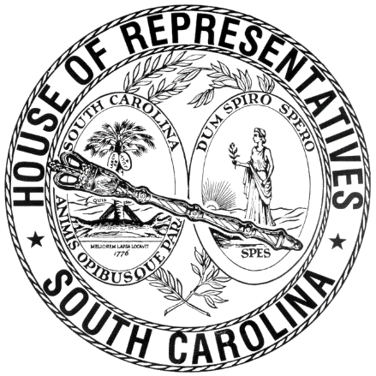

REGULAR SESSION BEGINNING TUESDAY, JANUARY 12, 2021
________

FRIDAY, MARCH 5, 2021
(LOCAL SESSION)

Indicates Matter Stricken
Indicates New Matter

The House assembled at 10:00 a.m.
Deliberations were opened with prayer by Rev. Charles E. Seastrunk, Jr., as follows:

Our thought for today is from Isaiah 45:7: “I form light and create darkness, I make weal and create woe; I the Lord do all these things.”
Let us pray. Almighty and merciful God, You have made us in Your image to do the work set aside for the people of this State. Grant these Representatives and staff the will and desire to carry out their duties. Keep them safe in Your love and favor as they go into the weekend and give them rest and a time for family and friends. Bless our defenders of freedom and first responders. Remember our World, Nation, President, State, Governor, Speaker, staff, and all who serve in these Halls of Government. Heal the wounds, those seen and those hidden, of our men and women who suffer and sacrifice for our freedom. Lord, in Your Mercy, hear our prayers. Amen.

After corrections to the Journal of the proceedings of yesterday, the SPEAKER ordered it confirmed.

SENT TO THE SENATE
The following Bills were taken up, read the third time, and ordered sent to the Senate:

H. 3011 -- Reps. West, G. M. Smith, Simrill, B. Newton, Wooten, McGarry, Bryant, Haddon, Long, Pope, Gilliam, Caskey, Hosey, Oremus, Hardee, Yow, Atkinson and Martin: A BILL TO AMEND SECTION 56-5-1810, CODE OF LAWS OF SOUTH CAROLINA, 1976, RELATING TO REQUIRING A MOTOR VEHICLE TO BE DRIVEN UPON THE RIGHT HALF OF A ROADWAY, SO AS TO PROVIDE RESTRICTIONS ON DRIVING A MOTOR VEHICLE ON A ROADWAY HAVING AT LEAST TWO LANES ALLOWING MOVEMENT IN THE SAME DIRECTION, PROVIDE A PENALTY, AND DIRECT THE DEPARTMENT OF TRANSPORTATION TO PLACE SIGNS ALONG THE INTERSTATE HIGHWAYS DIRECTING SLOWER TRAFFIC TO MOVE RIGHT.
H. 3805 -- Reps. B. Cox, Erickson, Davis, Allison, Wooten, McGarry, Hill, Pope, Caskey, McCabe, Oremus, T. Moore, W. Newton, Ligon, Blackwell, R. Williams, Jefferson, Hixon, Taylor, S. Williams and Matthews: A BILL TO AMEND THE CODE OF LAWS OF SOUTH CAROLINA, 1976, BY ADDING ARTICLE 147 TO CHAPTER 3, TITLE 56 SO AS TO PROVIDE THE DEPARTMENT OF MOTOR VEHICLES MAY ISSUE VARIOUS MILITARY SPECIAL LICENSE PLATES; AND TO REPEAL ARTICLES 7, 8, 14, 15, 16, 33, 38, 43, 53, 55, 56, 57, 59, 63, 68, 74, 84, 88, 99, 101, 102, 103, 104, 106, 107, 110, 111, 112, 115, 116, 117, 129, 131, 132, 143, and 144, CHAPTER 3 OF TITLE 56, RELATING TO THE ISSUANCE OF "WARTIME DISABLED VETERAN SPECIAL LICENSE PLATES", FREE VEHICULAR REGISTRATION FOR FORMER PRISONERS OF WAR, THE ISSUANCE OF SPECIAL LICENSE PLATES FOR MEMBERS OF THE UNITED STATES MILITARY RESERVES AND NATIONAL GUARD, MEDAL OF HONOR RECIPIENTS, PURPLE HEART RECIPIENTS, MEMBERS OF THE AMERICAN LEGION, RETIRED MEMBERS OF THE UNITED STATES ARMED FORCES, AND NORMANDY INVASION AND PEARL HARBOR SURVIVORS, THE ISSUANCE OF MEMBERS OF THE UNITED STATES ARMED SERVICES, UNITED STATES NAVAL ACADEMY, UNITED STATES AIR FORCE ACADEMY, SUPPORT OUR TROOPS, KOREAN WAR VETERANS, VIETNAM VETERANS, MARINE CORPS LEAGUE, WORLD WAR II VETERANS, GOLD STAR FAMILY OPERATION DESERT STORM-DESERT SHIELD, OPERATION ENDURING FREEDOM VETERAN, OPERATION IRAQI FREEDOM VETERAN, SILVER STAR, BRONZE STAR, UNITED STATES, NAVY CHIEF PETTY OFFICER, UNITED STATES MARINE CORPS, DISTINGUISHED SERVICE MEDAL, DISTINGUISHED SERVICE CROSS, DEPARTMENT OF NAVY, PARENTS AND SPOUSES OF ACTIVE-DUTY OVERSEAS VETERANS, ACTIVE DUTY MEMBERS OF THE UNITED STATES ARMED FORCES, COMBAT-RELATED DISABLED VETERAN, RECIPIENTS OF THE DISTINGUISHED FLYING CROSS, PALMETTO CROSS, AND LEGION OF MERIT SPECIAL LICENSE PLATES.

ADJOURNMENT
At 10:30 p.m. the House, in accordance with the ruling of the SPEAKER, adjourned to meet at 12:00 noon, Tuesday, March 9.
***

H. 3011 1
H. 3805 2

