NO. 34

JOURNAL

of the

HOUSE OF REPRESENTATIVES

of the

STATE OF SOUTH CAROLINA

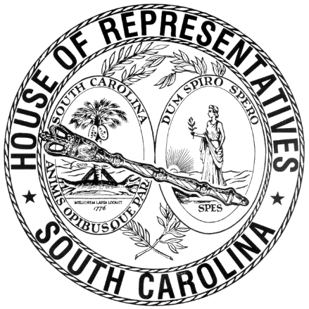

REGULAR SESSION BEGINNING TUESDAY, JANUARY 12, 2021
________

FRIDAY, MARCH 12, 2021
(LOCAL SESSION)

Indicates Matter Stricken
Indicates New Matter

The House assembled at 10:00 a.m.
Deliberations were opened with prayer by Rev. Charles E. Seastrunk, Jr., as follows:

Our thought for today is from Psalm 50:7: “Hear, O my people, and I will speak--I am God, your God.”
Let us pray. Almighty God, open the eyes and ears of Your people so they can see You as our God. Provide these Representatives and staff with blessings and peace. Give to them a restful and safe weekend with family and friends. Continue Your blessings on our World, Nation, President, State, Governor, Speaker, staff, and all who contribute to make the system work. Heal the wounds, those seen and those hidden, of our men and women who suffer and sacrifice for our freedom. Lord, in Your Mercy, hear our prayers. Amen.

Pursuant to Rule 6.3, the House of Representatives was led in the Pledge of Allegiance to the Flag of the United States of America by the SPEAKER.

After corrections to the Journal of the proceedings of yesterday, the SPEAKER ordered it confirmed.

SENT TO THE SENATE
The following Bills were taken up, read the third time, and ordered sent to the Senate:

H. 3308 -- Reps. Huggins, Hill, Forrest, Caskey and Hixon: A BILL TO AMEND SECTION 50-21-870, CODE OF LAWS OF SOUTH CAROLINA, 1976, RELATING TO PERSONAL WATERCRAFT AND BOATING SAFETY, SO AS TO INCREASE DISTANCE LIMITS BETWEEN A WATERCRAFT OPERATING IN EXCESS OF IDLE SPEED UPON CERTAIN WATERS OF THIS STATE AND A MOORED OR ANCHORED VESSEL, WHARF, DOCK, BULKHEAD, PIER, OR PERSON IN THE WATER.

H. 3772 -- Reps. Bernstein, G. M. Smith, Stavrinakis, Herbkersman, Rutherford, Elliott, Collins, W. Newton, Bannister, M. M. Smith, Brittain, Murray, Gilliard, Hewitt, Fry, Erickson, Bradley, Martin, Kirby, Davis, Kimmons, Garvin and Alexander: A BILL TO AMEND THE CODE OF LAWS OF SOUTH CAROLINA, 1976, BY ADDING SECTION 61-4-280 SO AS TO ALLOW A RETAIL DEALER LICENSED TO SELL BEER AND WINE IN THIS STATE TO USE A DELIVERY SERVICE, OR ITS OWN EMPLOYEES OR INDEPENDENT CONTRACTORS TO FACILITATE THE DELIVERY OF CERTAIN BEER AND WINE, TO PROVIDE FOR A DELIVERY LICENSE, TO SPECIFY CERTAIN DELIVERY PROHIBITIONS AND OTHER REQUIREMENTS FOR THE DELIVERY OF SUCH BEER AND WINE.

H. 3575 -- Reps. Fry, Collins, Elliott, Kirby, Forrest, W. Newton, McGarry, B. Newton, Caskey, Hosey, Herbkersman, Martin, M. M. Smith, Wheeler, Brittain, Hewitt, Erickson, Bradley, Henderson-Myers, Stavrinakis, Davis and Kimmons: A BILL TO AMEND THE CODE OF LAWS OF SOUTH CAROLINA, 1976, BY ADDING SECTION 61-4-45 SO AS TO ALLOW A QUALIFYING RETAILER TO OFFER CURBSIDE DELIVERY OR PICKUP SERVICE OF BEER OR WINE AND TO PROVIDE LIMITATIONS; AND TO AMEND SECTION 61-2-170, RELATING TO DRIVE-THROUGH OR CURB SERVICE OF ALCOHOLIC BEVERAGES, SO AS TO MAKE CONFORMING CHANGES.

ADJOURNMENT
At 10:35 a.m. the House, in accordance with the ruling of the SPEAKER, adjourned to meet at 12:00 noon, Tuesday, March 16.
***

H. 3308 1
H. 3575 2
H. 3772 1

