NO. 57

JOURNAL

of the

HOUSE OF REPRESENTATIVES

of the

STATE OF SOUTH CAROLINA

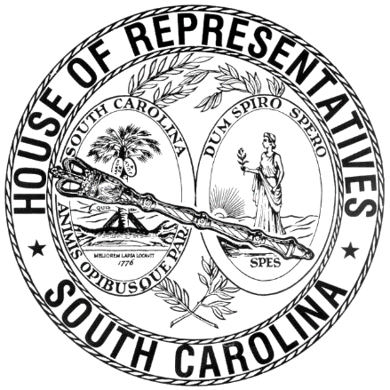

REGULAR SESSION BEGINNING TUESDAY, JANUARY 12, 2021
________

FRIDAY, APRIL 30, 2021
(LOCAL SESSION)

Indicates Matter Stricken
Indicates New Matter

The House assembled at 10:00 a.m.
Deliberations were opened with prayer by Rev. Charles E. Seastrunk, Jr., as follows:

Our thought for today is from Luke 22:26: “The greatest among you must become like one who serves.”
Let us pray. Bless are You, O Lord God, ruler of heaven and earth. Day by day You shower us with Your blessings. As You have raised us to new life, give us glad and generous hearts that are ready to praise You and to respond to those in need. Be with our defenders of freedom and first responders as they care for us. Let Your light shine on our World, Nation, President, State, Governor, Speaker, staff, and all who labor in these Halls of Government. Grant these people a safe and restful weekend. Heal the wounds, those seen and those hidden, of our brave men and women who suffer and sacrifice for our freedom. Lord, in Your Mercy, hear our prayers. Amen.

After corrections to the Journal of the proceedings of yesterday, the SPEAKER ordered it confirmed.

RETURNED TO THE SENATE WITH AMENDMENTS
The following Bill was taken up, read the third time, and ordered returned to the Senate with amendments:

S. 304 -- Senators Climer and Fanning: A BILL TO AMEND THE 1976 SOUTH CAROLINA CODE OF LAWS BY ADDING SECTION 58-27-1060, SO AS TO PROVIDE WHEN A PERSON OR CORPORATION USING AN ELECTRIC VEHICLE CHARGING STATION IS NOT AN ELECTRIC UTILITY, AND TO FURTHER PROVIDE THAT ANY INCREASE IN CUSTOMER DEMAND OR ENERGY CONSUMPTION ASSOCIATED WITH TRANSPORTATION ELECTRIFICATION SHALL NOT CONSTITUTE REVENUES FOR AN ELECTRICAL UTILITY.

ORDERED ENROLLED FOR RATIFICATION
The following Bill was read the third time, passed and, having received three readings in both Houses, it was ordered that the title be changed to that of an Act, and that it be enrolled for ratification:

S. 607 -- Senators Hembree and Hutto: A BILL TO AMEND SECTION 59-40-75, CODE OF LAWS OF SOUTH CAROLINA, 1976, RELATING TO THE REMOVAL OF CHARTER SCHOOL DISTRICT BOARD MEMBERS FOR CAUSE OR DUE TO INCAPACITY, SO AS TO REVISE THE BASES FOR REMOVAL, TO PROVIDE RESULTING MEMBERSHIP VACANCIES MUST BE FILLED PURSUANT TO CERTAIN BYLAWS OF THE CHARTER SCHOOL, AND TO REMOVE THE SOUTH CAROLINA CHARTER SCHOOL DISTRICT FROM THESE PROVISIONS.

SENT TO THE SENATE
The following Bills were taken up, read the third time, and ordered sent to the Senate:

H. 3006 -- Reps. Brawley, Robinson, Cobb-Hunter, Haddon, Henegan, Hosey, J. L. Johnson, Govan, King, Gilliard, Murray, McDaniel, Henderson-Myers and Garvin: A BILL TO AMEND THE CODE OF LAWS OF SOUTH CAROLINA, 1976, BY ADDING SECTION 59-63-785 SO AS TO PROVIDE PUBLIC SCHOOLS AND PUBLIC SCHOOL DISTRICTS MAY NOT USE DEBT COLLECTION AGENCIES TO COLLECT OR ATTEMPT TO COLLECT OUTSTANDING DEBTS ON STUDENT SCHOOL LUNCH OR BREAKFAST ACCOUNTS, TO PROVIDE PUBLIC SCHOOLS AND PUBLIC SCHOOL DISTRICTS MAY NOT ASSESS OR COLLECT ANY INTEREST, FEES, OR OTHER SUCH MONETARY PENALTIES FOR OUTSTANDING DEBTS FOR STUDENT SCHOOL LUNCH OR BREAKFAST ACCOUNTS, AND TO PROVIDE THE PROVISIONS OF THIS ACT APPLY TO DEBTS ON STUDENT LUNCH AND BREAKFAST ACCOUNTS OUTSTANDING ON THE EFFECTIVE DATE OF THIS ACT AND INCURRED AFTER THE EFFECTIVE DATE OF THIS ACT.

H. 4269 -- Rep. Gilliam: A BILL TO AMEND SECTION 7-7-510, CODE OF LAWS OF SOUTH CAROLINA, 1976, RELATING TO THE DESIGNATION OF VOTING PRECINCTS IN UNION COUNTY, SO AS TO MERGE THE MONARCH BOX 1 PRECINCT WITH THE MONARCH BOX 2 PRECINCT WITH THE RESULTING COMBINED PRECINCT TO BE KNOWN AS THE MONARCH PRECINCT, TO ELIMINATE THE EAST BUFFALO VOTING PRECINCT, AND TO UPDATE THE MAP NUMBER ON WHICH THE NAMES OF THESE PRECINCTS MAY BE FOUND AND MAINTAINED BY THE REVENUE AND FISCAL AFFAIRS OFFICE.

ADJOURNMENT
At 10:45 a.m. the House, in accordance with the ruling of the SPEAKER, adjourned to meet at 12:00 noon, Tuesday, May 4.
***

H. 3006 2
H. 4269 2

S. 304 1
S. 607 2

