NO. 30

JOURNAL

of the

HOUSE OF REPRESENTATIVES

of the

STATE OF SOUTH CAROLINA

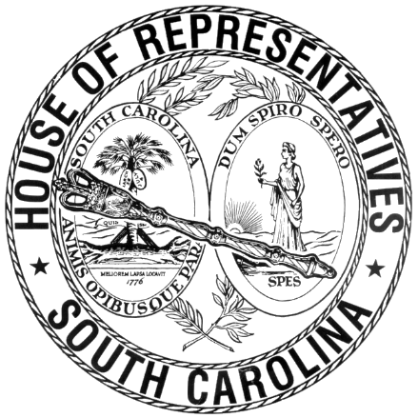

REGULAR SESSION BEGINNING TUESDAY, JANUARY 14, 2025

**________**

FRIDAY, MARCH 7, 2025

(LOCAL SESSION)

~~Indicates Matter Stricken~~

Indicates New Matter

The House assembled at 10:00 a.m.

Deliberations were opened with prayer by Rev. Charles E. Seastrunk Jr. as follows:

Our thought for today is from 1Corinthians 12:4: “To each is given the manifestation of the Spirit for the common good.”

Let us pray. Spirit of God, decent upon our hearts, keep us in Your love and care. Provide these Your people the best in the sessions as they carry out their duties. Keep our defenders of freedom and first responders in Your love and care. Bless those at home as we ask God’s grace to keep them in Your care. God of power and might, give us the faith to go out into the World and rely on Your presence to love, save and bless these Your people. Bless our World, Nation, President, State, Governor Speaker, Staff, and our Armed Forces, especially those with hidden wounds. Lord, in Your mercy, hear our prayers. Amen.

After corrections to the Journal of the proceedings of yesterday, the SPEAKER ordered it confirmed.

**SENT TO THE SENATE**

The following Bills were taken up, read the third time, and ordered sent to the Senate:

H. 4002 -- Reps. Burns and Bannister: A BILL TO DEVOLVE ALL OF THE POWERS, DUTIES, RESPONSIBILITIES, ASSETS, AND LIABILITIES OF THE GREATER GREENVILLE SANITATION DISTRICT TO THE GOVERNING BODY OF GREENVILLE COUNTY; AND TO REPEAL ACT 1543 OF 1968, AS AMENDED, RELATING TO THE CREATION OF THE GREATER GREENVILLE SANITATION DISTRICT.

H. 3497 -- Reps. W. Newton, Wooten, Pope, Chapman, Forrest, Kirby, Ligon, Bailey, M. M. Smith, B. L. Cox, Holman, Oremus, Sanders, Willis, Brewer, Hiott, Hixon, Caskey, Henderson-Myers, Wickensimer, Yow, Mitchell, Bamberg, Hart and Garvin: A BILL TO AMEND THE SOUTH CAROLINA CODE OF LAWS BY AMENDING SECTION 38-90-20, RELATING TO INSURANCE LICENSURE, SO AS TO ALLOW AN INSURANCE COMPANY TO PROVIDE LIQUOR LIABILITY INSURANCE; BY AMENDING SECTION 61-2-60, RELATING TO THE PROMULGATION OF ALCOHOL REGULATIONS, SO AS TO AUTHORIZE REGULATIONS REGARDING ALCOHOL SERVER TRAINING POSITIONS; BY AMENDING SECTION 61-2-145, RELATING TO REQUIRED LIQUOR LIABILITY INSURANCE COVERAGE, SO AS TO ESTABLISH A LIQUOR LIABILITY MITIGATION PROGRAM; BY ADDING CHAPTER 3 TO TITLE 61 SO AS TO ESTABLISH AN ALCOHOL SERVER TRAINING PROGRAM; AND BY AMENDING SECTION 61-6-2220, RELATING TO ALCOHOL SALES, SO AS TO PROHIBIT A PERSON FROM KNOWINGLY SELLING ALCOHOL TO AN INTOXICATED PERSON.

**ADJOURNMENT**

At 10:25 a.m. the House, in accordance with the ruling of the SPEAKER, adjourned to meet at 1:00 p.m, Monday, March 10.

***

H. 3497 1

H. 4002 1