**NO. 45**

**JOURNAL**

**OF THE**

**SENATE**

**OF THE**

**STATE OF SOUTH CAROLINA**

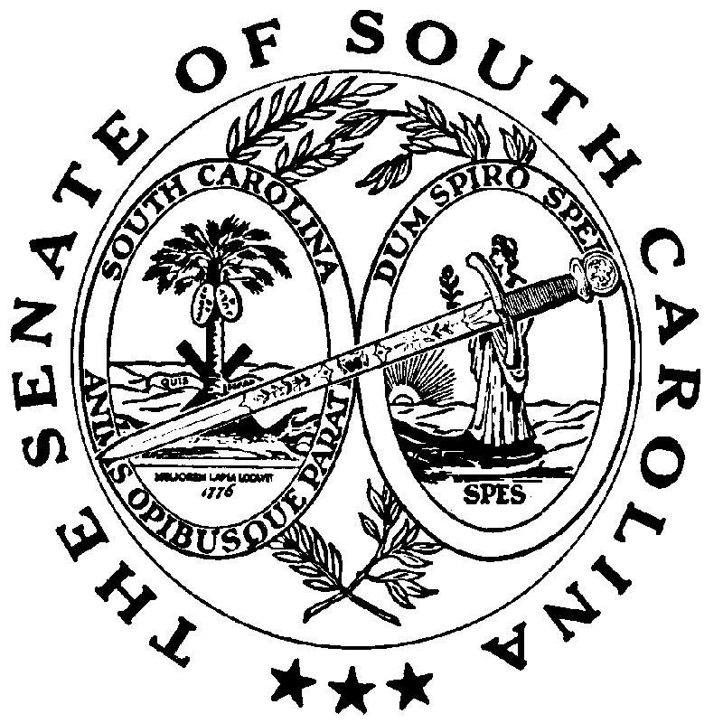

**REGULAR SESSION BEGINNING TUESDAY, JANUARY 14, 2025**

**_________**

**FRIDAY, MARCH 28, 2025**

Friday, March 28, 2025

(Local Session)

~~Indicates Matter Stricken~~

Indicates New Matter

The Senate assembled at 11:00 A.M., the hour to which it stood adjourned, and was called to order by the ACTING PRESIDENT, Senator MASSEY.

**CO-SPONSOR ADDED**

The following co-sponsors was added to the respective Bill:

S. 199 Sen. Rice

MOTION ADOPTED

On motion of Senators SABB, ADAMS, ALEXANDER, ALLEN, BENNETT, BLACKMON, CAMPSEN, CASH, CHAPLIN, CLIMER, CORBIN, CROMER, DAVIS, DEVINE, ELLIOTT, FERNANDEZ, GAMBRELL, GARRETT, GOLDFINCH, GRAHAM, GROOMS, HEMBREE, HUTTO, JACKSON, JOHNSON, KENNEDY, KIMBRELL, LEBER, MARTIN, MASSEY, MATTHEWS, NUTT, OTT, PEELER, RANKIN, REICHENBACH, RICE, STUBB, SUTTON, TEDDER, TURNER, VERDIN, WALKER, WILLIAMS, YOUNG and ZELL, with unanimous consent, the Senate stood adjourned out of respect to the memory of Mr. Gedney Main Howe III of Charleston, S.C. Gedney was a graduate of the University of South Carolina and earned his law degree from the University of South Carolina School of Law. He was the lead attorney at the law offices of Gedney M. Howe III P.A. in Charleston. One of his proudest accomplishments was the restoration of 16 Meeting Street, formerly known as Calhoun Mansion. Gedney was a generous man who helped those in need and developed many cherished friendships in his lifetime. Gedney was a loving father and doting grandfather who will be dearly missed.

ADJOURNMENT

At 11:03 A.M., on motion of Senator OTT, the Senate adjourned to meet next Tuesday, April 1, 2025, at 12:00 P.M.

* * *